**Machine learning**

<https://www.coursera.org/learn/machine-learning>

Andrew Ng / Stanford University / Coursera

**Content**

- Introduction - 4

- Linear regression with one variable - 4

Cost function 4

Gradient descent 6

(Batch) Gradient descent for linear regression 7

- Linear regression with multiple variables - 7

Hypothesis, cost function, gradient descent 7

Normalization 8

Polynomial regression 9

Normal equation 9

- Logistic regression - 10

Hypothesis representation 10

Decision boundary 11

Cost function 11

Gradient descent 12

Optimization 13

Multi-class classification: One vs all 13

- Regularization - 14

Overfitting 14

Cost function 15

Linear regression 15

Normal ecuation 15

Logistic regression 15

- Neural networks - 16

Motivations 16

Model (hypothesis) representation 17

Examples and intuition 19

Multi-class classification 20

Cost function and Backpropagation 20

Unrolling parameters from matrices into vectors 23

Gradient checking 24

Random initialization 25

Putting all together 25

- Advice for machine learning - 27

Evaluating an hypothesis 27

Model selection problem 27

Diagnosing bias vs variance 28

Learning curve 29

Neural network architecture 30

Deciding what to do 30

Error analysis 30

Large data sets 32

- Support Vector Machines - 33

Optimization objective (cost function) 33

Large margin intuition (SVM) 35

Mathematics behind Large Margin Classification 35

Kernels 36

Using SVM 39

- Unsupervised learning - 40

Clustering 40

K-means algorithm 41

Optimization objective 42

Random initialization 42

Number of clusters 43

Dimensionality reduction 43

Applying PCA 45

Anomaly detection 46

Density estimation 46

Building an anomaly detection system 48

Multivariate Gaussian distribution 50

Recommender systems 52

Content based recommendations 52

Collaborative filtering (or Low rank matrix factorization) 53

Large scale machine learning 56

Gradient descent with large datasets 56

Stochastic Gradient descent 56

Mini-batch gradient descent 57

Stochastic Gradient descent convergence 58

Online learning 59

Map Reduce 60

Photo OCR 61

Description and pipeline 61

Sliding windows 62

Artificial data synthesis 63

Ceiling analysis 64

# - Introduction -

**Machine learning:** Field of study that gives computers the ability to learn without being explicitly programmed. A computer program learns from experience E with respect to some task T and some performance measure P, if T, as measured by P improves with E.

Software environment used in this course: Octave (free) or MATLAB.

**Main machine learning algorithms:**

- Supervised learning

Most common. We teach the computer by giving the algorithm a data set (training set) in which the "right answers" are given. A learning algorithm can deal with an infinite number of features/attributes with which make predictions. To deal with this infinite amount without running out of memory we use an algorithm called Support Vector Machine. Two types of problems:

- Regression problem (predicts continuous valued output)

- Classification problem (discrete valued output).

- Unsupervised learning (or clustering)

We don't give the right answer to the algorithm, it learns by itself. Used to organize large computer clusters.

- Reinforcement learning

- Recommender systems

Main topics:

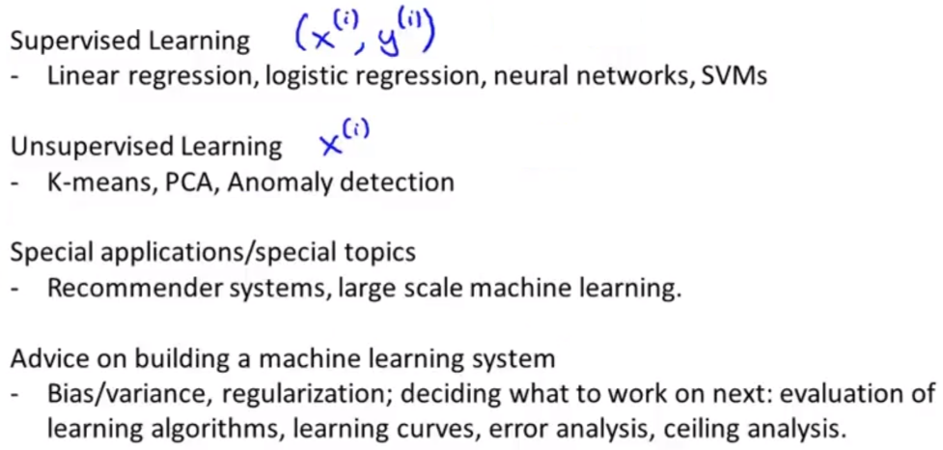

# - Linear regression with one variable -

## Cost function

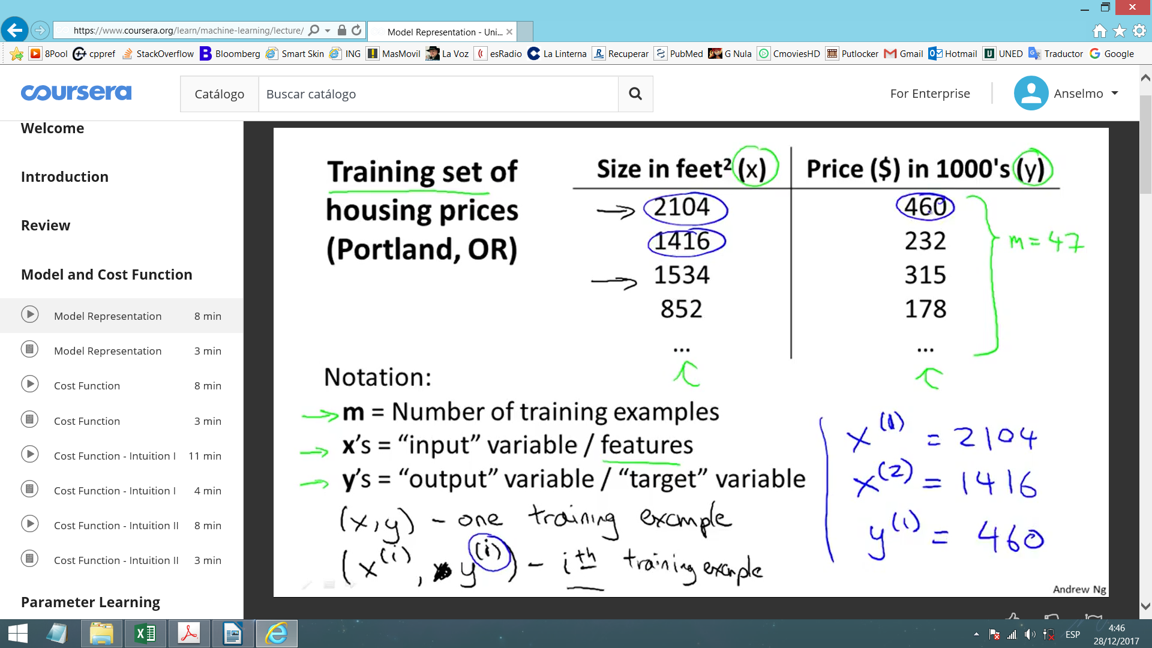This is a learning algorithm for supervised learning.

In learning algorithms, we give a training set (x(i), y(i)) to a learning algorithm and it produces a function (h) that, given an input (x), offers an output (y).

Here, h (hypothesis) will be a linear function (straight line), so it is represented as:

θ0: Ordinate in the origin θ1: Slope

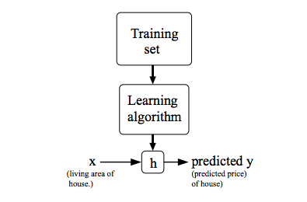Given the training set (house prices function of surfaces), choose θ0 and θ1 so that hθ(x) is close to y for our training examples (x, y).

This is a minimization problem. We want this expression to be small:

$${\left(h_{θ}\left(x\right)−y\right)}^{2}$$

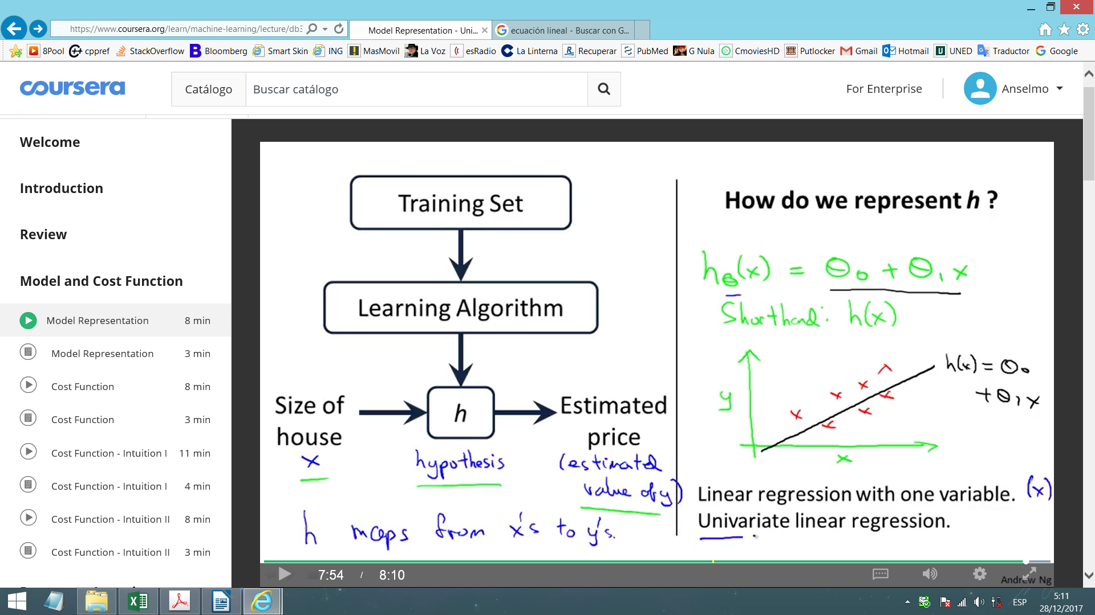To do this with the training set, we use this expression:

$$\frac{1}{2m}\sum_{1}^{m}{{\left(h_{θ}\left(x^{\left(i\right)}\right)−y^{\left(i\right)}\right)}^{2}}$$

m: Number of elements in the training set.

$\frac{1}{2m}$: Used to calculate the average and multiplied by 1/2 to make the math easier.

Minimize over θ0 and θ1. Find the values for θ0 and θ1 (parameters) that minimize the expression. This J(θ0, θ1) is the **Square error cost function**. It's the most commonly used in regression problems, but there are alternative cost functions.

For fixed θ0 and θ1, hθ(x) is function of x. And J(θ1, θ0) is function of parameters θ0 and θ1.

----------------------------------------------------------------------------------------------------------------

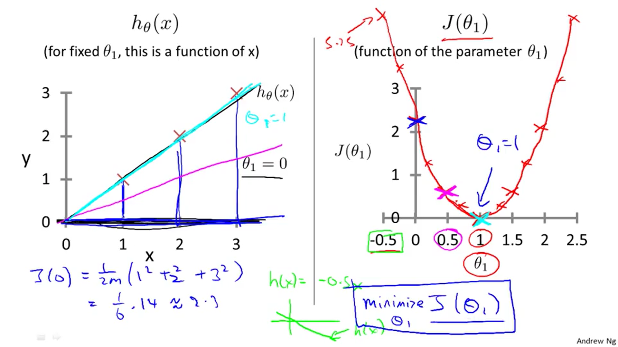Simplest example:

We have hθ(x) = θ1x, whose chart is (x, y) for a given θ1.

There is a cost function J(θ1) whose chart is (θ, J(θ)).

We draw this last chart, and the value of θ1 nearer to J(θ1) = 0 will be the correct value.

Note: Every (hθ(x(i))-y(i))2 is the square vertical distance between (x(i), y(i)) and the chart (given θ1).

----------------------------------------------------------------------------------------------------------------

Doing the same as the simplest example, but with J(θ0, θ1), we obtain:

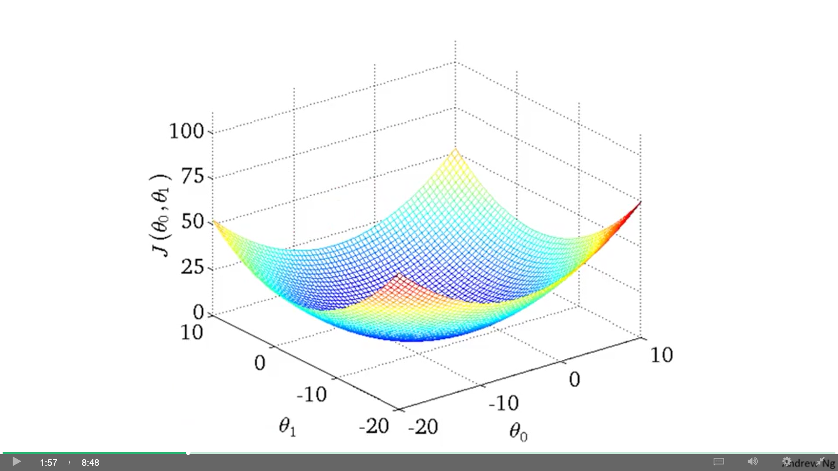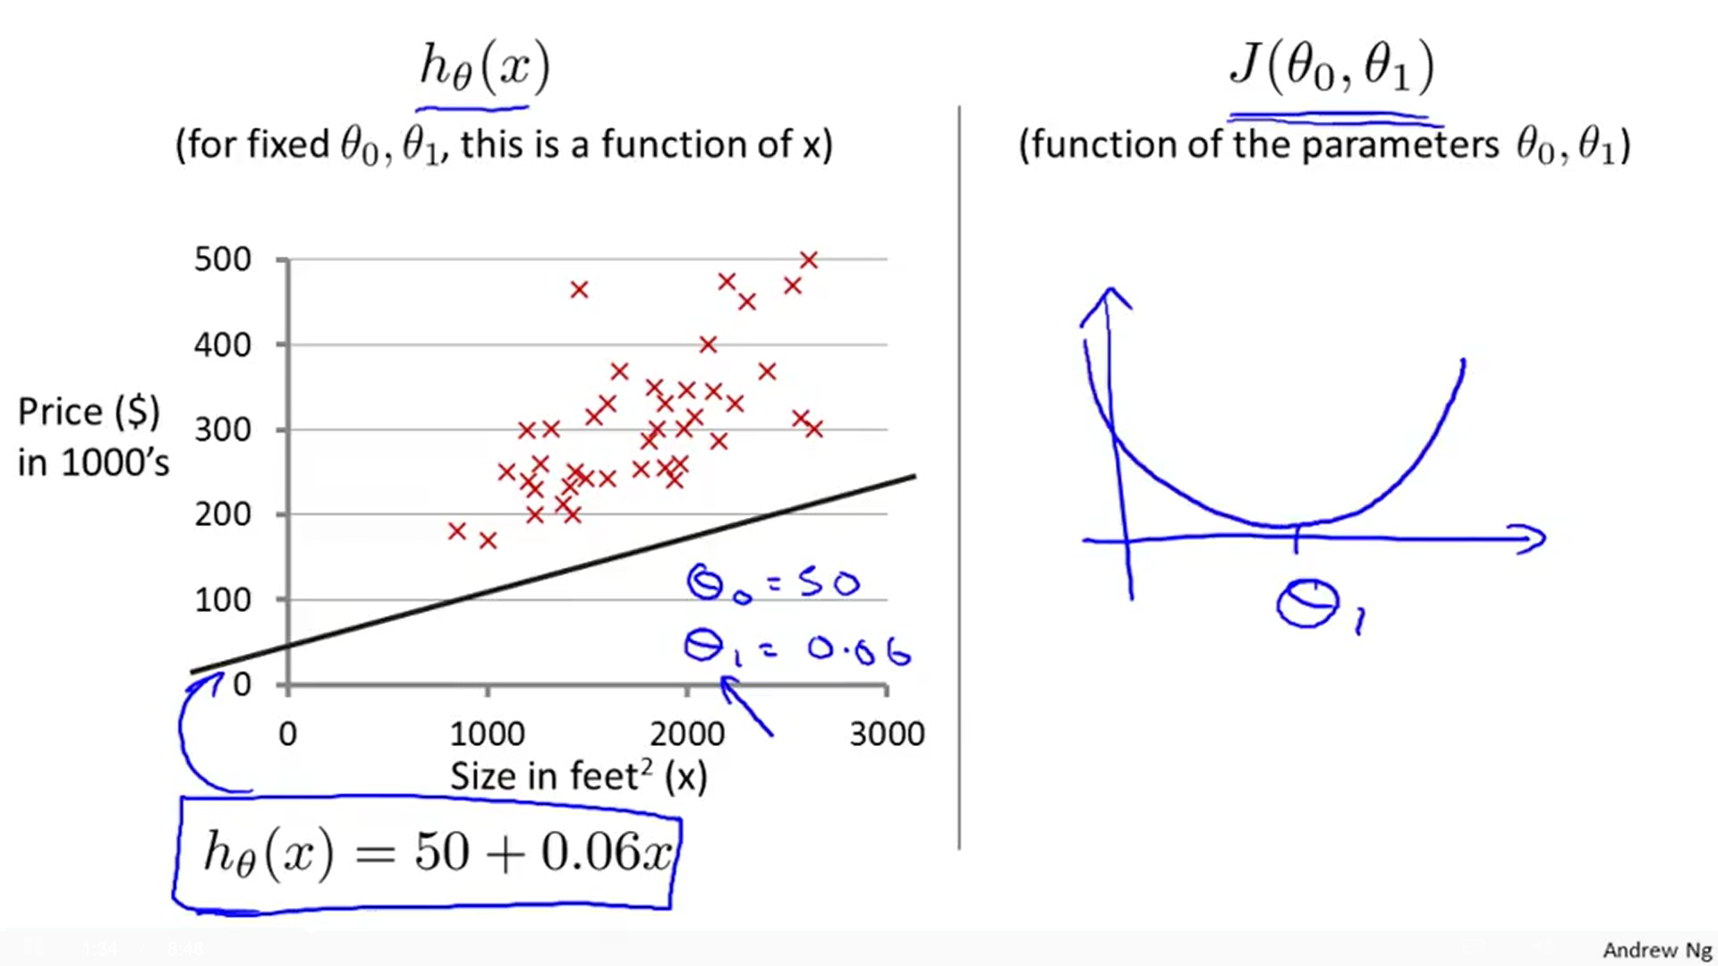

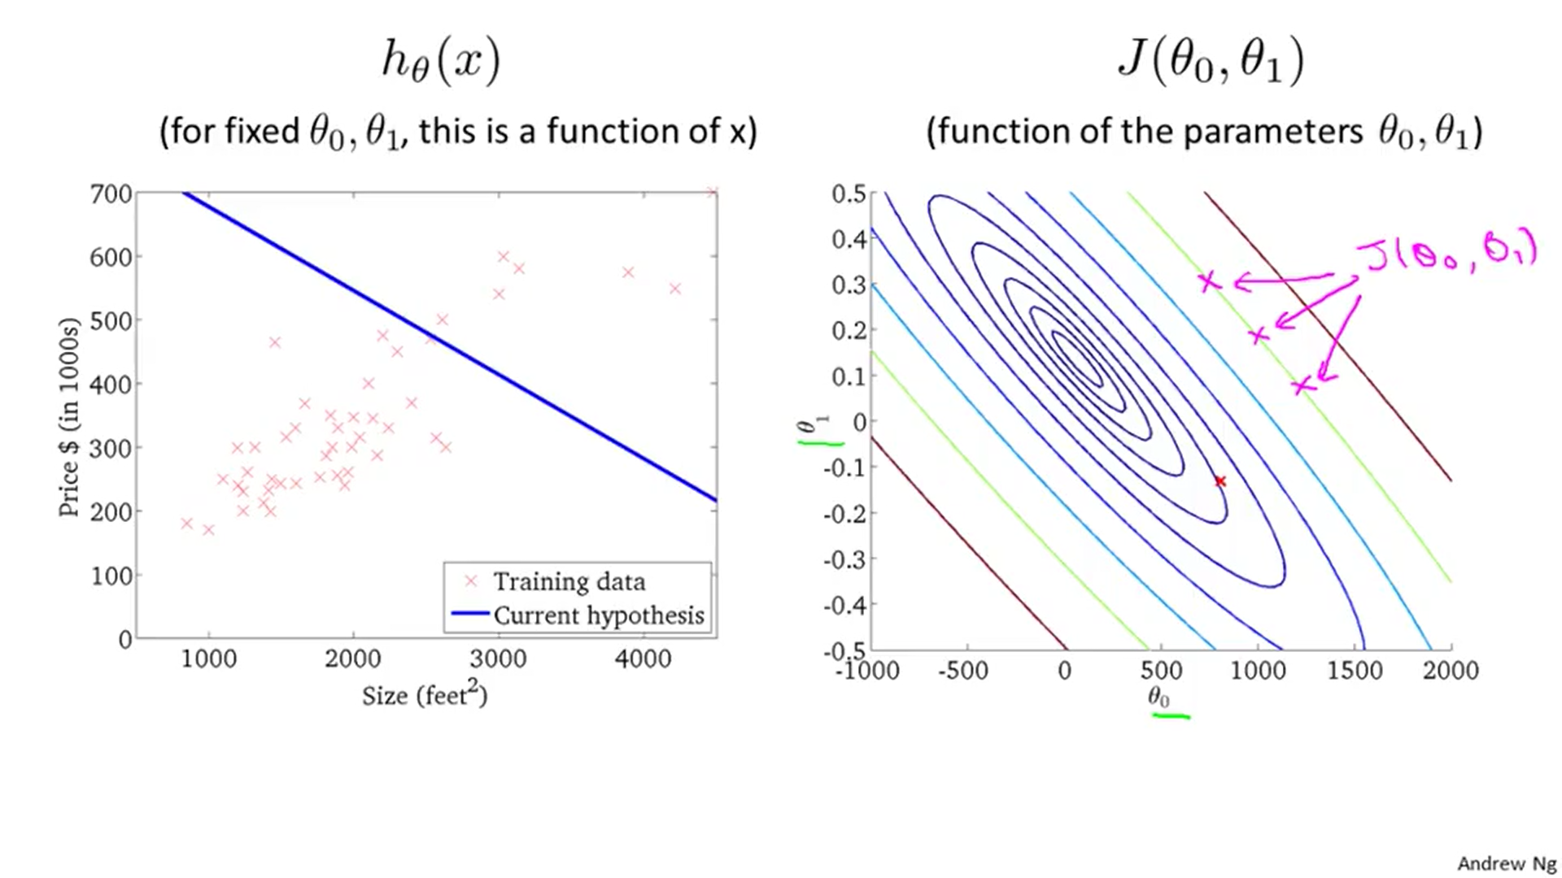

Instead of 3D charts, we will use Contour plots/figures. The lines in contour plots take a set of points (θ0, θ1) which have the same value for J(θ0, θ1). Each point represent a unique hθ(x) function.

## Gradient descent

**Gradient descent:** Algorithm for minimizing the cost function J. Used not only in linear regression, but all over the place in machine learning.

We start with some (θ0, θ1 ...) and keep changing their values to reduce J(θ0, θ1 ...) until we hopefully end up at a minimum.

Changes are toward points that go downwards in J.

for (until convergence) {

θj = θj - α $\frac{δJ\left(θ_{0},θ_{1}\right)}{δθ_{j}}$; // for j=0 and j=1

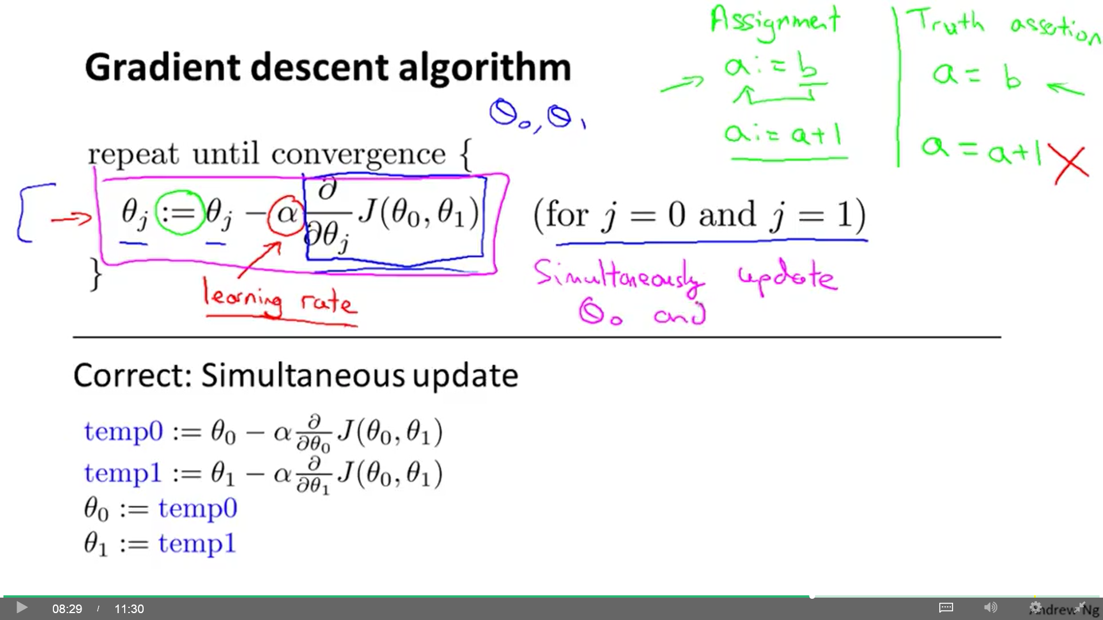}

α: Learning rate. It controls how big a step we take downhill.

$\frac{δJ\left(θ_{0},θ_{1}\right)}{δθ_{j}}$: Derivative term (δ: partial derivative symbol).

We compute the algorithm simultaneously for every θj (being θj every θ parameter), which will update every θ. Then, we compute again (iteration) with the new values for θ. And so on.

----------------------------------------------------------------------------------------------------------------

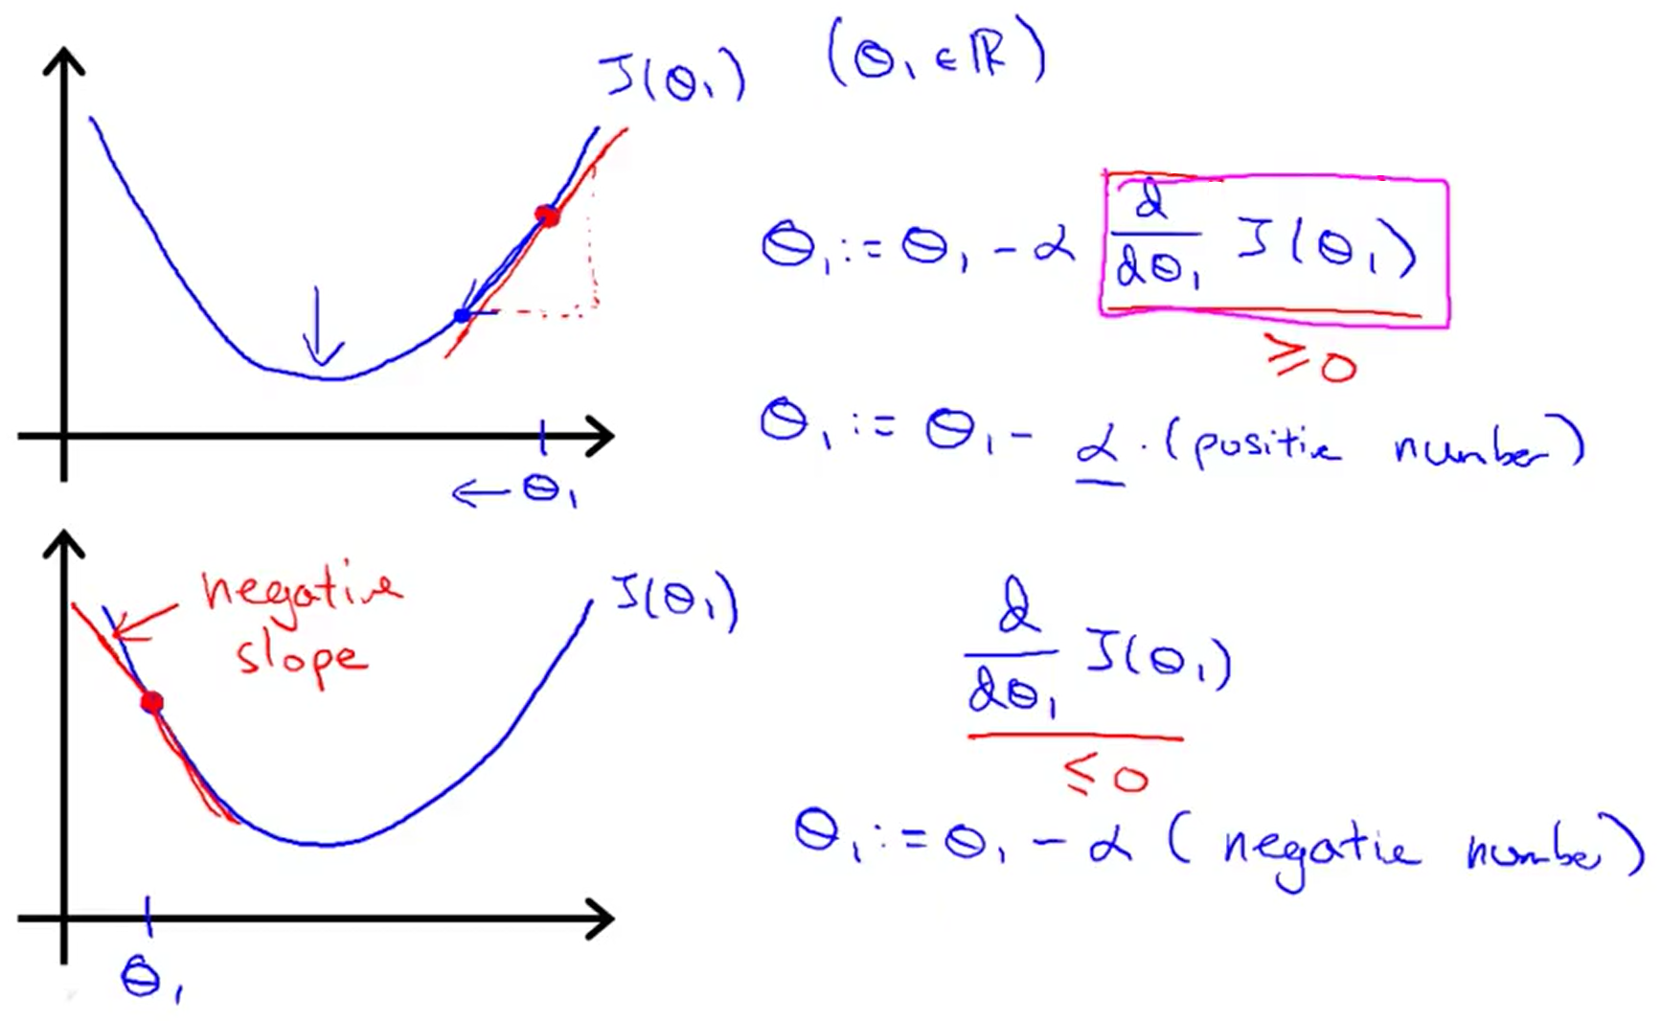Simple example: We want to minimize J(θ1) over θ1.

θj = θj - α

d: non-partial derivative symbol

Derivative part determines the slope at θj, then is multiplied by learning rate and subtracted from θj.

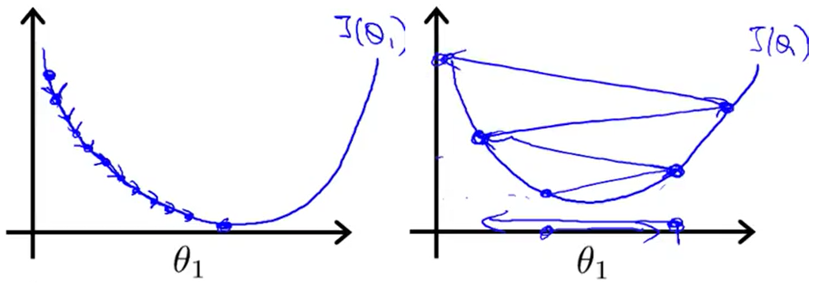This results in θj moving down the hill, closer to the minimum.

If α is too small, gradient descent can be slow. If α is too large, gradient descent can overshoot the minimum. It may fail to converge, or even diverge.

If you initialize θ1 at (or get it to) a local minimum, derivative would be zero and gradient descent update will leave θ1 unchanged.

Gradient descent can converge to a local minimum even if α is kept fixed. As we approach to a local minimum, gradient descent will automatically take smaller steps. So, no need to decrease α over time. But α cannot be too large, or else it may fail to converge.

----------------------------------------------------------------------------------------------------------------

## (Batch) Gradient descent for linear regression

Putting together Gradient descent and Cost function, we get the Learning algorithm.

; (x0=1)

Now, we can introduce both derivatives in our algorithm and use it to minimize J over θ0 and θ1.

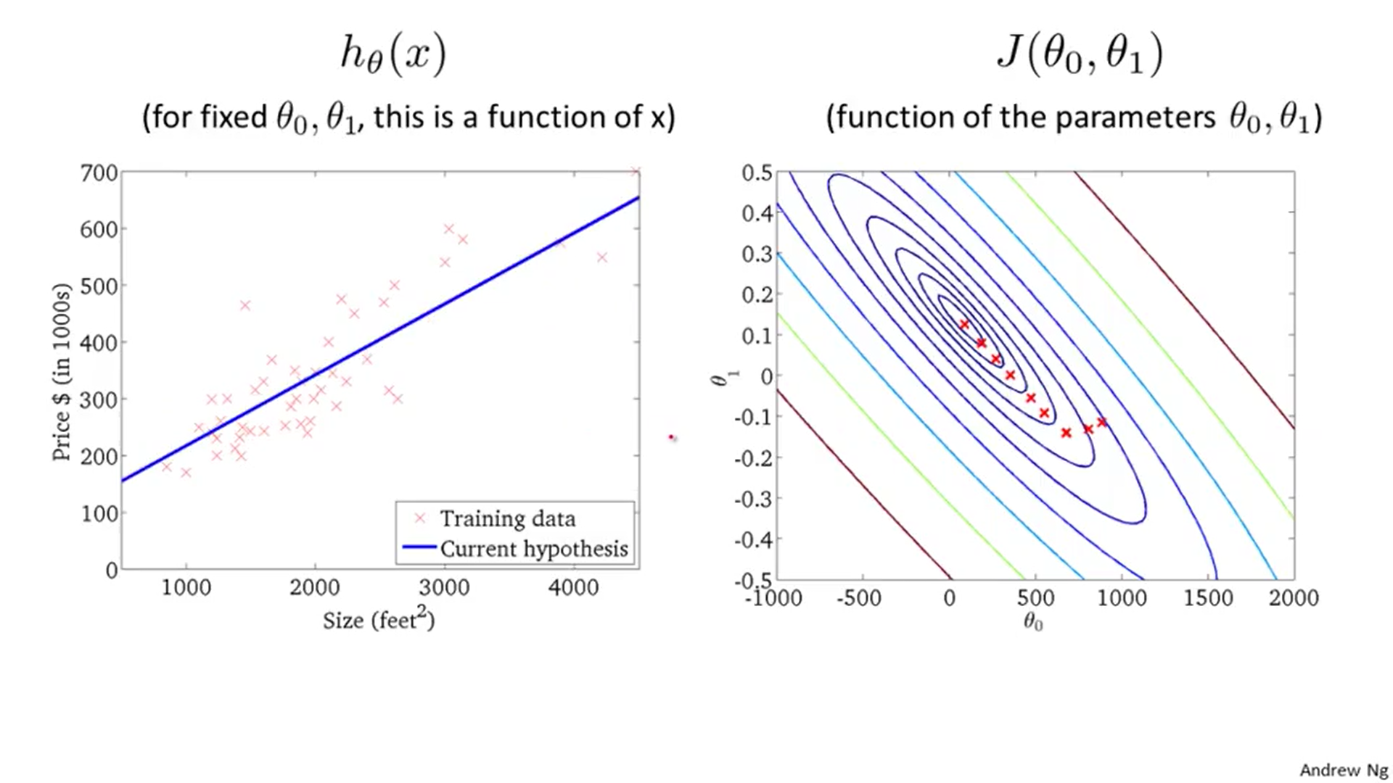Cost function of linear regression is a convex function. It doesn't have local optima except for the one global optimum.

The Gradient descent we used is also called Batch gradient descent (Batch: Each step of gradient descent used all the training examples). Another types may use a subset of the training examples.

Normal equation method is a solution for numerically solving for the minimum of the cost function J without using an iterative algorithm like Gradient descent. However, Gradient descent scales better to larger data sets.

# - Linear regression with multiple variables -

## Hypothesis, cost function, gradient descent

Or multivariant linear regression. In our previous training set we used only one variable/feature (x=size in feet) for every result (y=house price). Now, we take into account more than one feature.

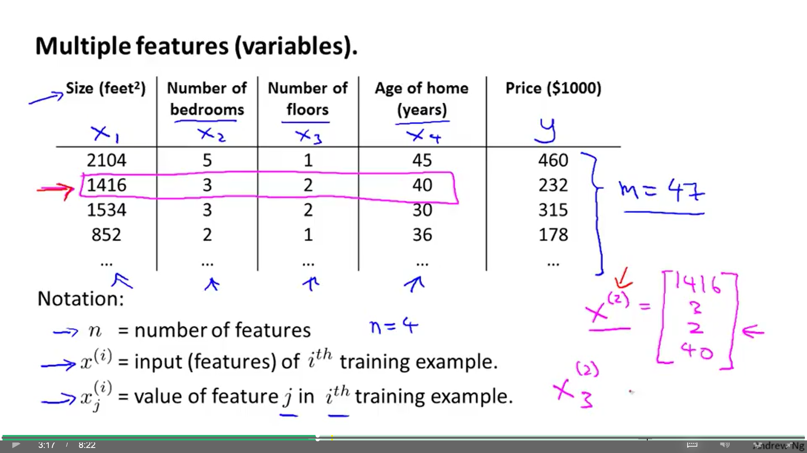**- n:** Number of features (previously, we used n to denote the number of examples in the training set).

**- x(i):** Vector that contains all the features in the ith example.

**- xj(i):** Value of feature j in x(i).

**Hypothesis:**

hθ(x) = θ0 + θ1x1 + θ2x2 + θ3x3 + θ4x4

We will introduce a new feature x0=1 to accompany θ0: **hθ(x) = θ0x0 + θ1x1 + θ2x2 + θ3x3 + θ4x4**

Now we have two vectors: $x^{\left(i\right)}=\left[\begin{aligned}x_{0} \\ x_{1} \\ x_{2} \\ ... \\ x_{n}\end{aligned}\right]$ $θ=\left[\begin{aligned}θ_{0} \\ θ_{1} \\ θ_{2} \\ ... \\ θ_{n}\end{aligned}\right]$ → **hθ(x(i)) = θT∙x(i)**

**Cost function: $J\left(θ_{0},θ_{1},...,θ_{n}\right)=J\left(θ\right)=\frac{1}{2m}\sum_{i=1}^{m}{{\left(h_{θ}\left(x^{\left(i\right)}\right)−y^{\left(i\right)}\right)}^{2}}$**

**Gradient descent:**

for (until convergence) {

θj = θj - α $\frac{δJ\left(θ\right)}{δθ_{j}}$; } // simultaneously update for every j = 0,... n

for (until convergence) {

θj = θj - α; }

1) Choose a type of h(x).

2) Obtain J(θ) using training examples and initial values for θ.

3) Minimize J(θ) using Gradient descent (obtain all θ in every iteration simultaneously).

4) Now you have the optimal h(x).

## Normalization

**Feature scaling**

In a problem with multiple features, if you make them have similar scale (take on similar ranges of values), then gradient descent can converge more quickly. If not, our contour plot may have sharper shapes that make Gradient descent to take more time to calculate the minimum.

Get every feature into approximately a range of:

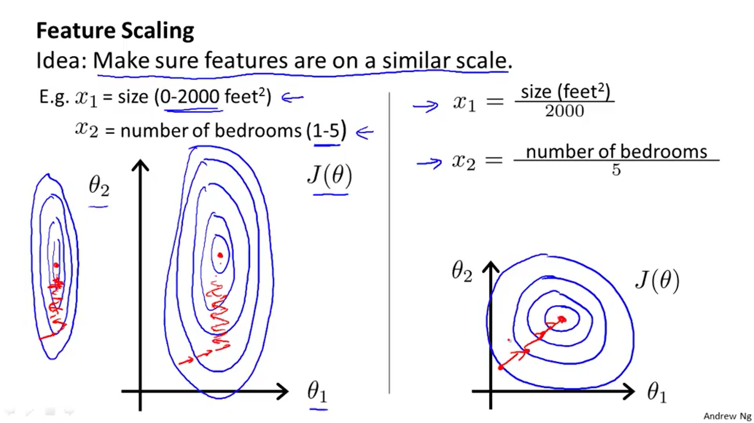-1 ≤ xi ≤ 1

x0 is already in range (x0=1).

Range values of [0, 3] or [-2, 0.5] are acceptable.

Ranges [-100, 100] or [-0.0001, 0.0001] are poor scaled.

Divide by the [max-min] value (or, alternatively, by the Standard Deviation).

**Mean normalization**

Used with feature scaling. Replace xi with xi-μi to make features have approximately zero mean (don't apply to x0 = 1). [μi: mean of xi in the training set] [s1: range of xi (max – min)]

(-0.5 ≤ x1 ≤ 0.5) (-0.5 ≤ x2 ≤ 0.5)

Feature scaling and mean normalization helps Gradient descent to run and converge faster.

When we want to make predictions, we must first normalize x using the mean and standard deviation previously applied to the training set.

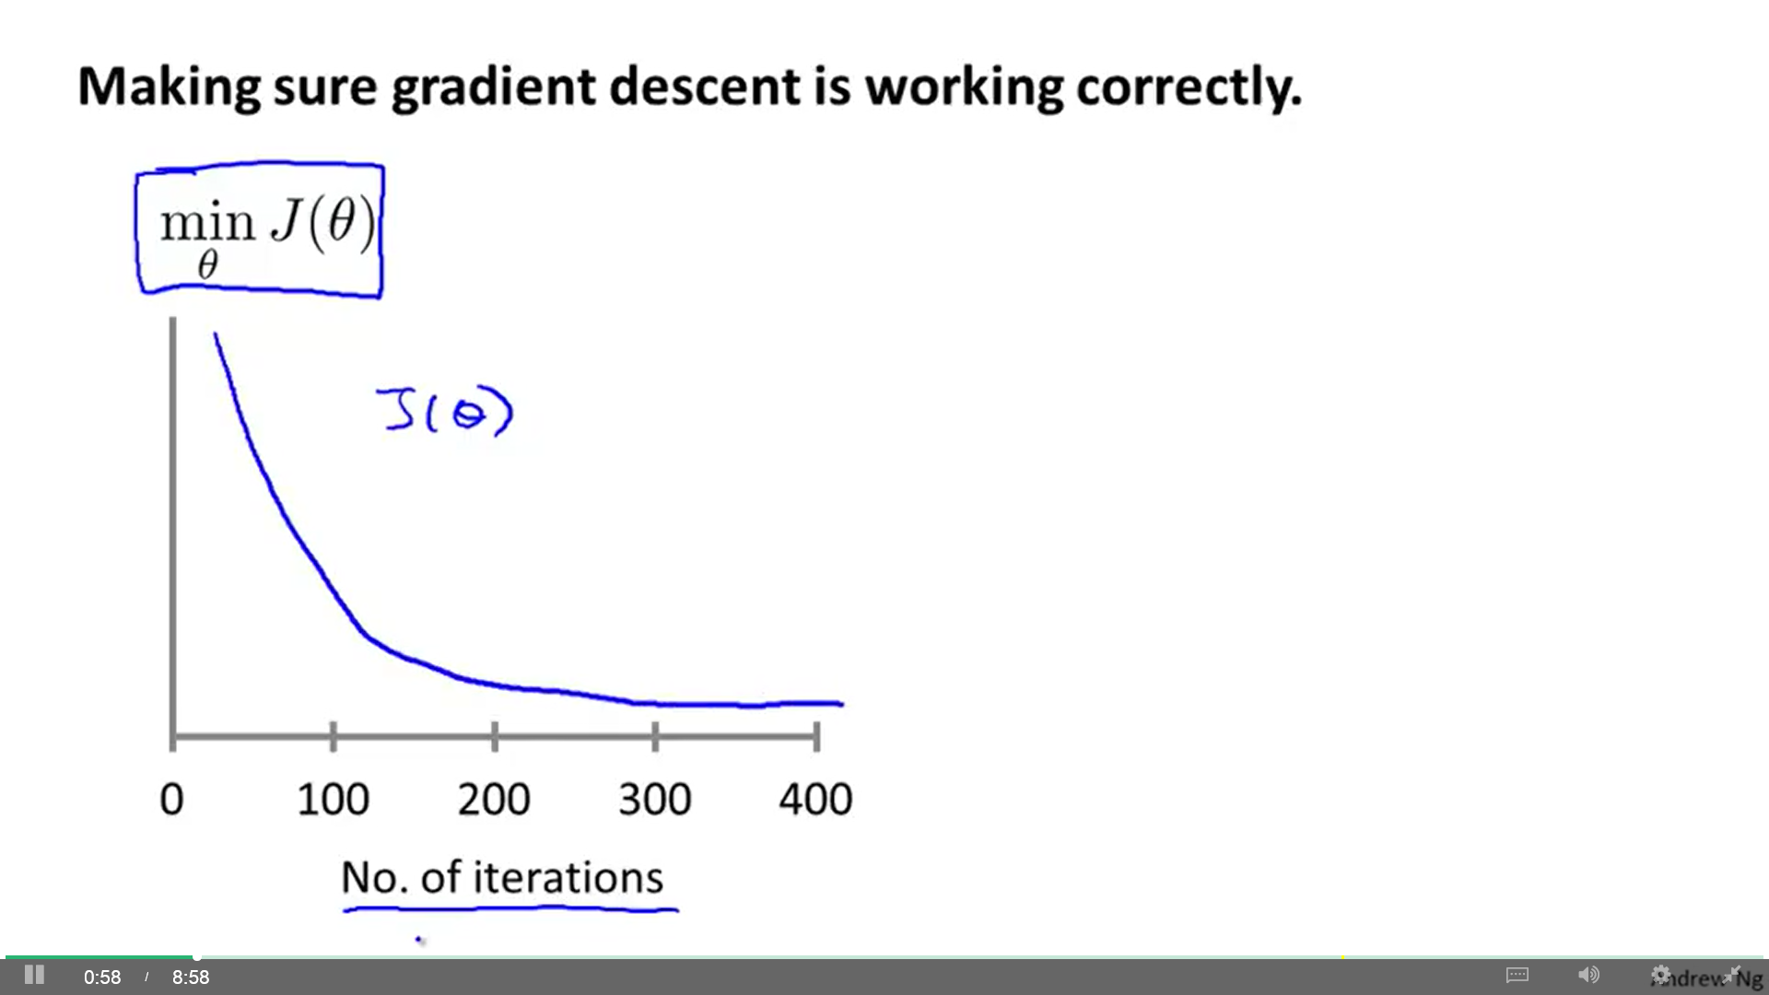**Learning rate (α)**

"Debugging": How to make sure gradient descent is working correctly.

- You can see it if you plot the graph in the right. J(θ) should decrease with each iteration. Number of iterations till convergence (flat line) vary much among applications. If J(θ) increases or goes up and down, you should use a smaller α. For sufficiently small α, J(θ) should decrease on every iteration; but if it is too small, gradient descent can be slow to converge.

Check different values of α to get good plot. Recommended: try values on a log-scale at about 3 time the previous value: 0.1, 0.03, 0.01, 0.003, 0.001).

- Another way is to use an algorithm that tells if gradient descent has converged. Example: "declare convergence if J(θ) decreases by less than ε (ex. 10-3) in one iteration". However, choosing ε is pretty difficult, so Andrew prefers to use plots.

**Features edition**

Sometimes, you can combine some features to create a new feature. Example: We may have two features that determines the price of a house (frontage and depth of terrain), but we may decide that a combination of both (Area) is what really determines the price of the house.

1) hθ(x) = θ0 + θ1x1 + θ2x2 (x1 = frontage) (x2 = depth)

2) hθ(x) = θ0 + θ1x1 (x1 = frontage · depth)

## Polynomial regression

We may decide that a quadratic /cubic/etc. polynomial model (rather than a linear one) fits better to the data.

[ θ0 + θ1x + θ2x2 ] [ θ0 + θ1x + θ2x2 + θ3x3 ] [ etc. ]

We can fit any of these models into our data introducing simple modifications to our multivariant linear regression algorithm. Example:

We have one feature (size) for the price of houses. Instead of a linear polynomial model we consider that a cubic polynomial model fits better. To fit that into our algorithm, we create 2 additional features.

[ θ0 + θ1x + θ2x2 + θ3x3 ] > hθ(x) = θ0 + θ1x1 + θ2x2 + θ3x3

where: (x1 = size) (x2 = size2) (x3 = size3)

Even though we have polynomial terms, we are still solving a linear regression optimization problem. The polynomial terms have turned into features we can use for linear regression

Feature scaling becomes increasingly important because the three features take very different ranges of values. It's important to apply feature scaling if you are using gradient descent to get them into comparable ranges of values.

There exists many other choices of features. Example: hθ(x) = θ0 + θ1(size) + θ2(√size)

## Normal equation

Normal equation is a method to solve θ analytically in linear regression problems.

Cost function J(θ0, θ1, ..., θm) is a function of vector θ. If we take the partial derivative of J with respect to every parameter of θ and set these to 0, we obtain the values of θ to minimize J.

Example of how to implement it:

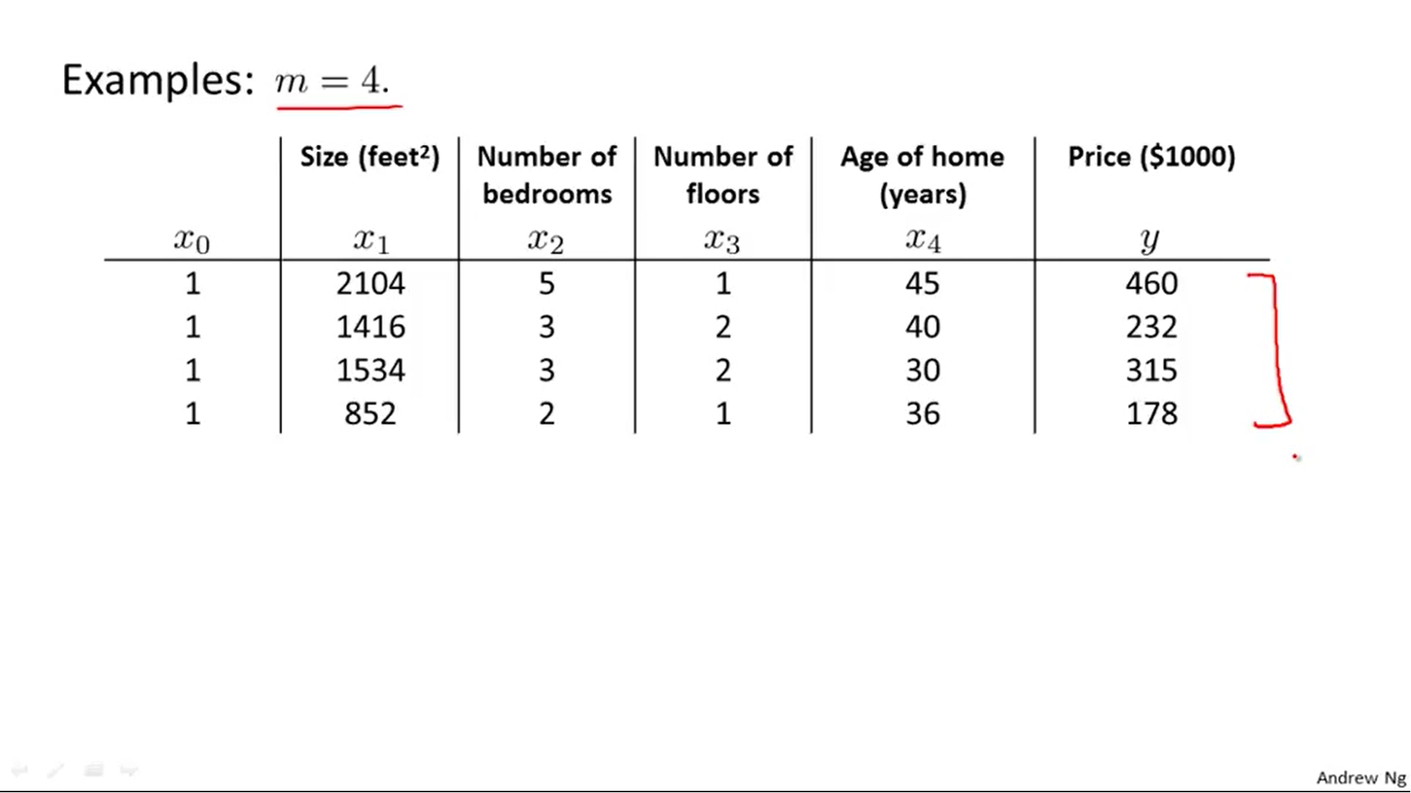

Here we have m=4 (nº of examples) and n=4 (nº of features). We create two matrices (Xmx(n+1), ymx1):

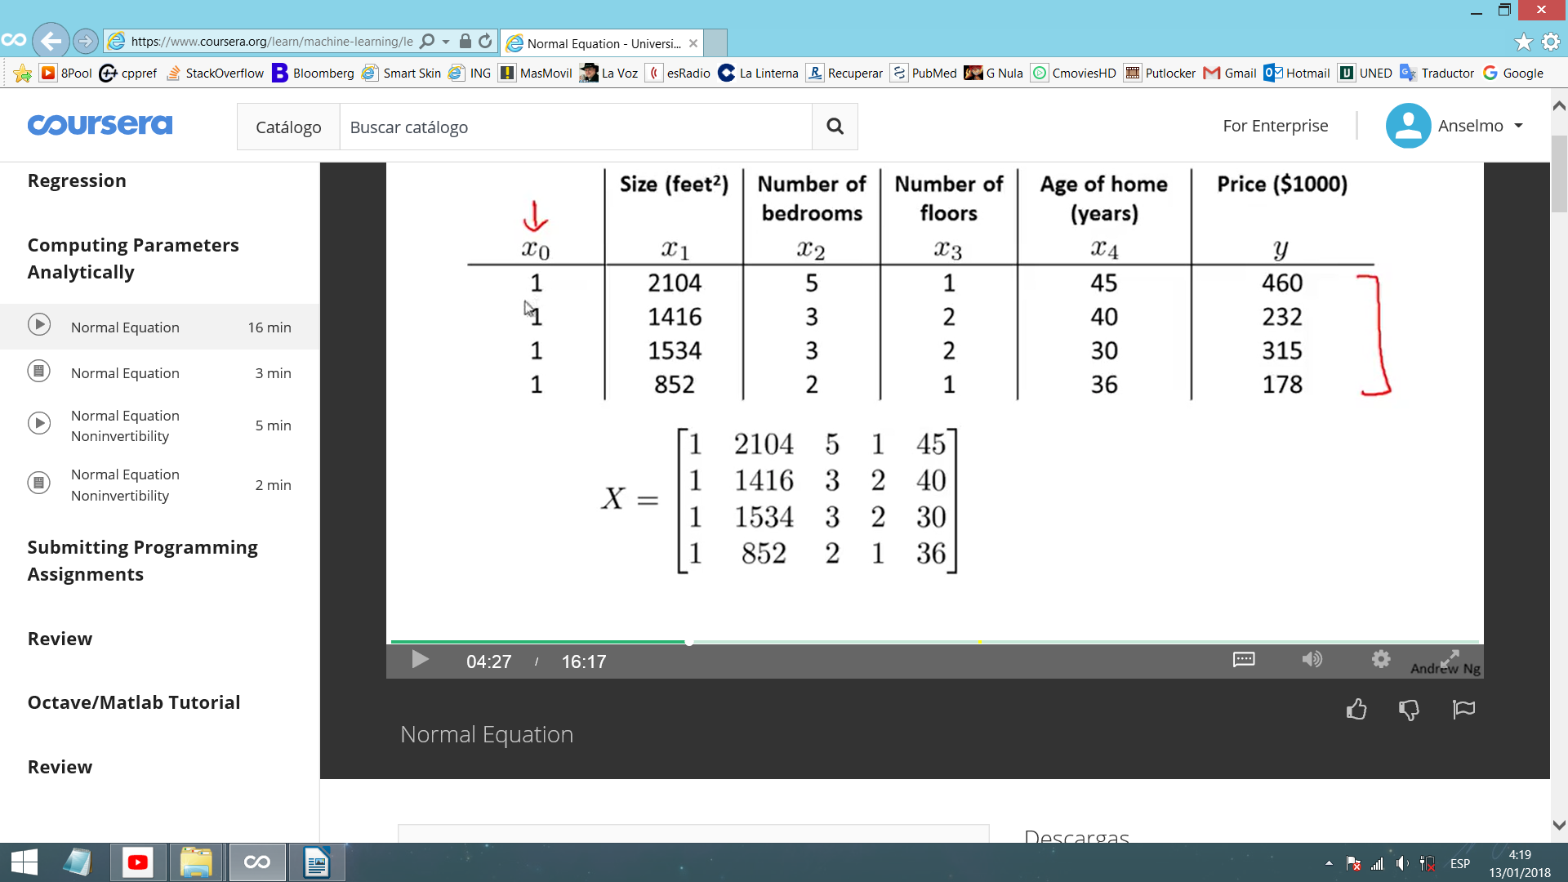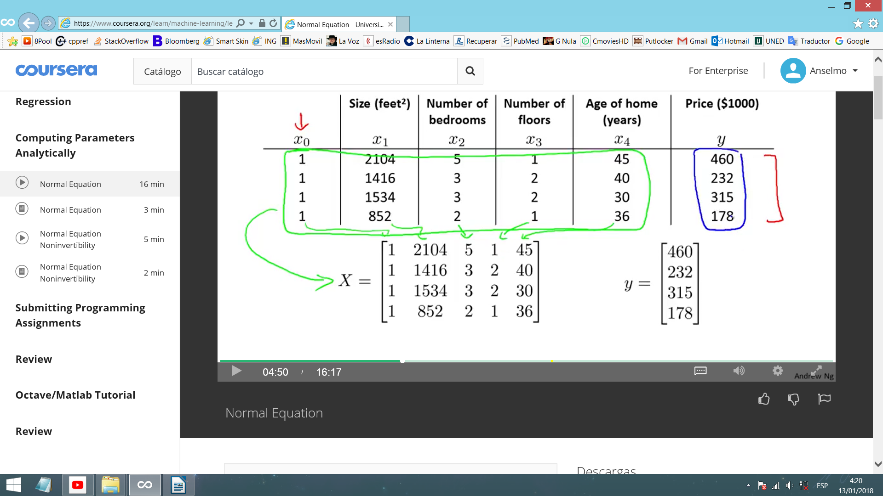To obtain the value of θ that minimizes J just compute:

- Vector mean square error (VMSE):

- Derivative of VMSE: →

- Octave code: pinv (X' * X) * X' * y

Using this function, feature scaling is no longer necessary.

> Normal equation: (+) No need to choose α, (+) No need to iterate, (-) Need to compute (XT·X)-1 (cost of inverting is about the cube of the dimension of the matrix), (-) Slow if n is very large.

> Gradient descent: (-) Need to choose α, (-). Many iterations, (+) Works well even when n is large.

Normal equation is acceptable for about n≤10.000 or less. Gradient descent is good for n≥100.000.

What if (XT∙X) is non-invertible (singular, degenerate)? In Octave there are two functions to calculate the inverse: inv (normal inverse), pinv (pseudo inverse). Using pinv we will always get an inverse. Using pinv works well but it's not clear that it would give you a very good hypothesis.

Why may (XT∙X) be non-invertible?

- Redundant features (linearly dependent). (Example: x1=size in feet2 / x2=size in m2 / x1 = 10,8x2)

- Fewer examples than features (m ≤ n). Delete some features or use Regularization.

# - Logistic regression -

Classification problem: Problem where variable y (the one you want to predict) is valued.

email [spam/not spam] online transactions [fraudulent/honest] tumour [malignant/benign]

y Î {0, 1} (first, we will study problems with two classes [positive and negative])

Linear regression is not recommended for classification problems (additional training examples may alter h(x) too much). Also, although y = 0 or 1, h(x) can be >1 or <0.

Logistic regression: Powerful and popular classification algorithm where h(x) satisfy 0 ≤ h(x) ≤ 1.

## Hypothesis representation

Linear regression case: $h_{θ}\left(x\right)=θ^{T}x$

Logistic regression case: $h_{θ}\left(x\right)=g\left(θ^{T}x\right)$ where $g\left(z\right)=\frac{1}{1+e^{−z}}$ (sigmoid/logistic function)

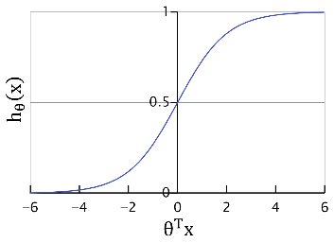 (z: real number)

equivalent to: $h_{θ}=\frac{1}{1+e^{−θ^{T}x}}$

Result of hθ(x) will be considered the probability of x of being hθ(x)=1.

Example: x may be the tumor size. hθ(x)=1 means 100% probability of having breast cancer. hθ(x)=0.7 means 70% probability.

$h_{θ}\left(x\right)=p\left({\left.y=1\right|}_{x};θ\right)$: hθ(x) outputs probability that y=1, given x, parameterized by θ.

$$p\left({\left.y=0\right|}_{x};θ\right)+p\left({\left.y=1\right|}_{x};θ\right)=1$$

## Decision boundary

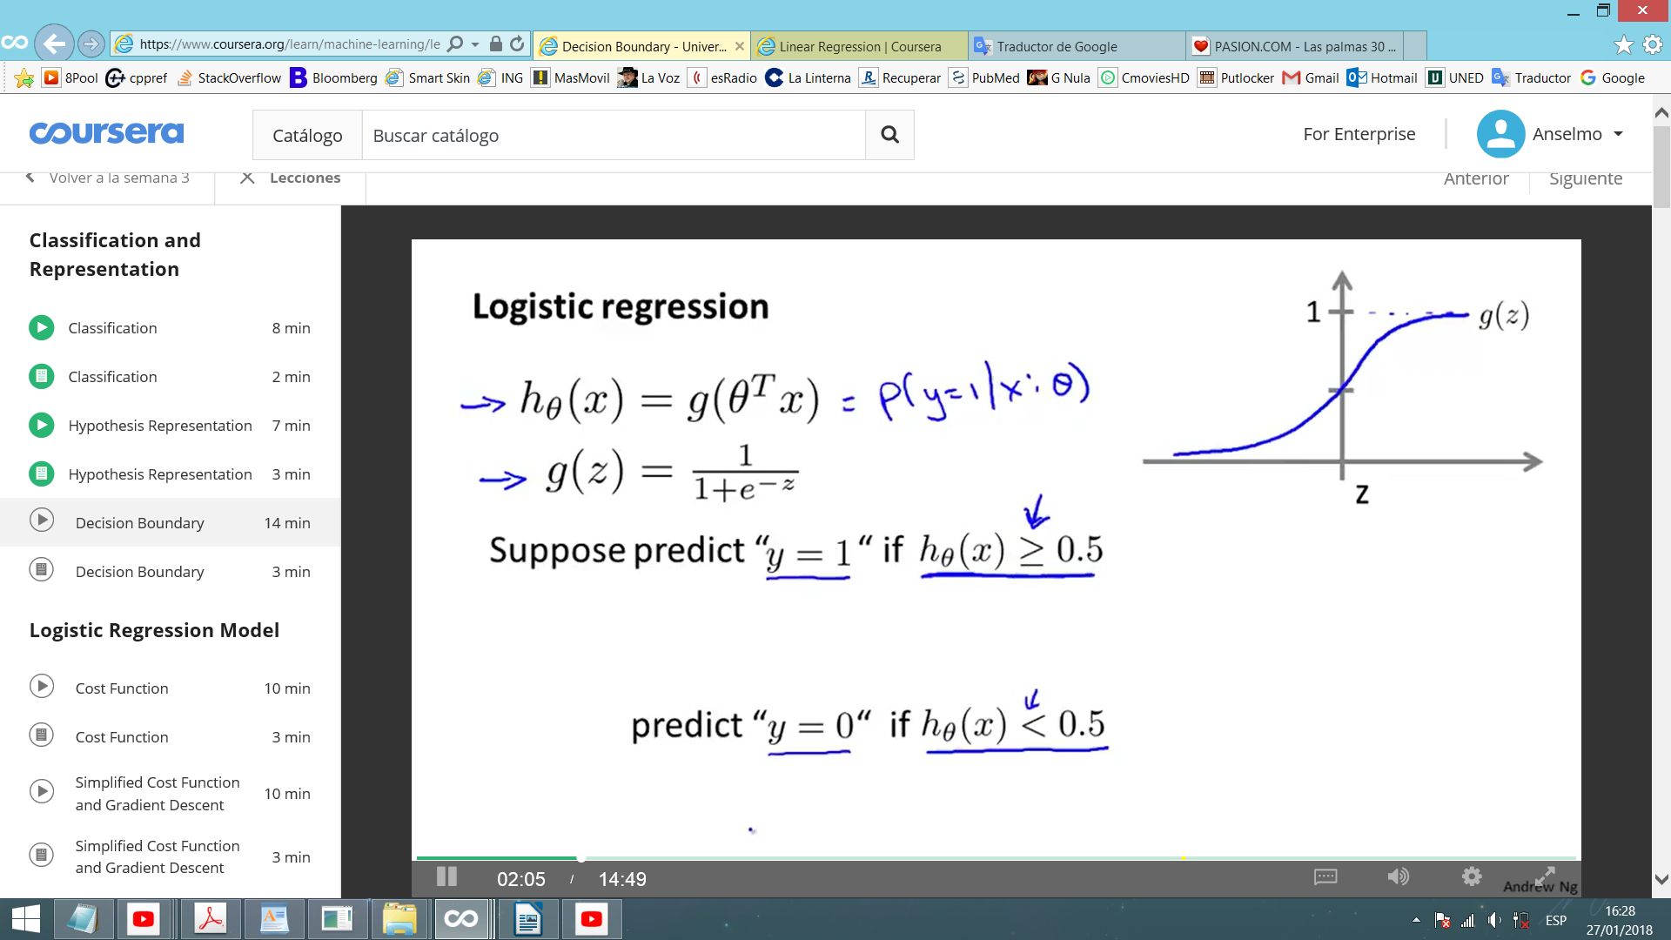Let's suppose we predict:

y = 1 if hθ(x) ≥ 0.5 this only happens when θTx ≥ 0

y = 0 if hθ(x) < 0.5 this only happens when θTx < 0

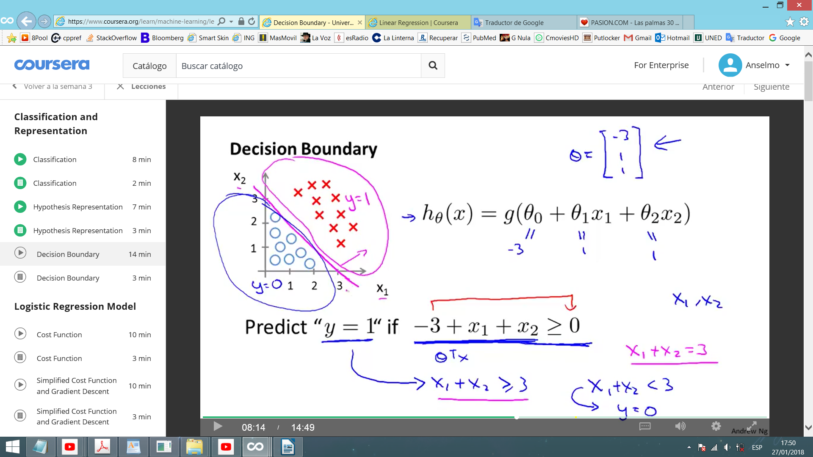Example 1 (linear boundaries):

$h_{θ}\left(x\right)=g\left(θ_{0}+θ_{1}x_{1}+θ_{2}x_{2}\right)$ vector θ = [-3; 1; 1]

So, we predict y=1 if -3 + x1 + x2 ≥ 0 (x1 + x2 ≥ 3)

If we plot all the features and z, then x1 + x2 = 3 will draw a line (decision boundary) dividing the combinations of features that correspond to y=0 and y=1. This line contains the combination of features that produce hθ(x)=0.5 (means, decision boundary is a property of hθ(x) under the parameters, not of the training set).

Example 2 (non-linear boundaries):

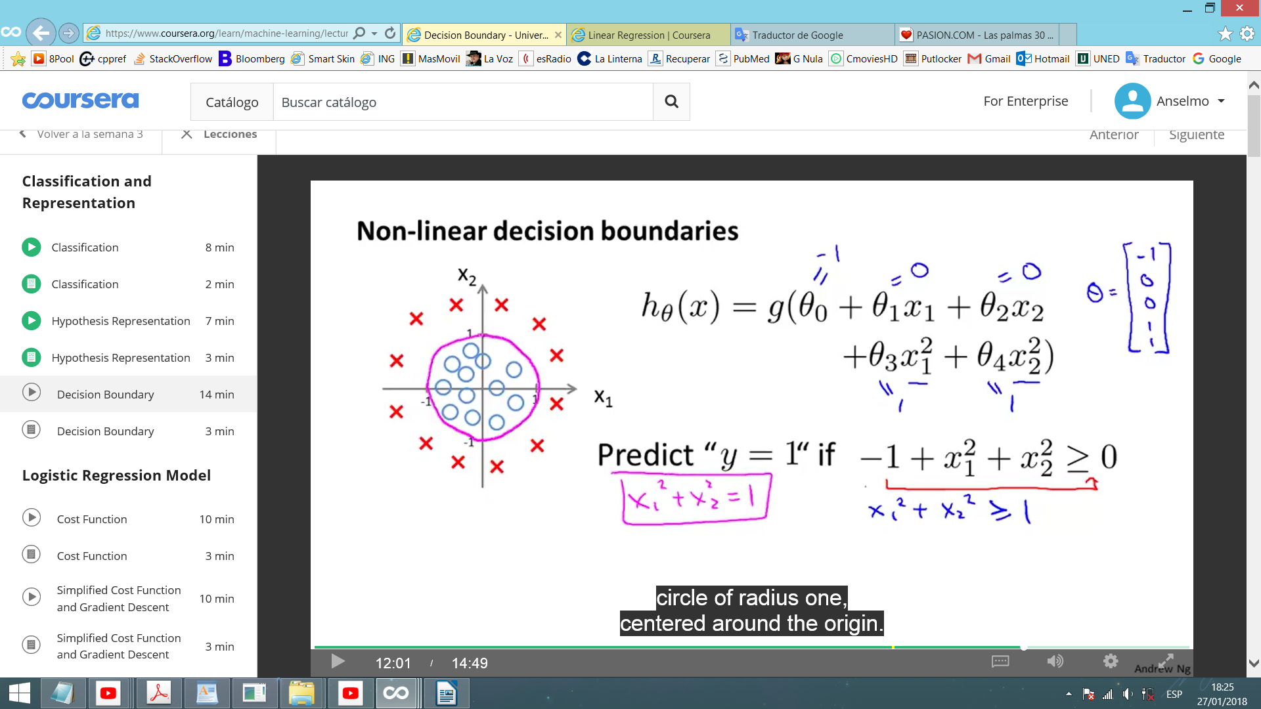Like in polynomial regression, we can add higher polynomial terms to the features.

$h_{θ}\left(x\right)=g\left(θ_{0}+θ_{1}x_{1}+θ_{2}x_{2}+θ_{3}x_{1}^{2}+θ_{4}x_{2}^{2}\right)$ vector θ = [-1; 0; 0;1;1]

So, we predict y=1 if $x_{1}^{2}+x_{2}^{2}≥1$ (ec. of circle of r=1 and O=(0,0))

Decision boundary is a property of hθ(x) under the parameters (not of the training set). Vector θ defines the decision boundary. Training set is used to fit the parameters θ.

We can create even more complex decision boundaries with funny shapes.

$$h_{θ}\left(x\right)=g\left(θ_{0}+θ_{1}x_{1}+θ_{2}x_{2}+θ_{3}x_{1}^{2}+θ_{4}x_{1}^{2}x_{2}+θ_{5}x_{1}^{2}x_{2}^{2}+θ_{6}x_{1}^{3}x_{2}+...\right)$$

## Cost function

We use cost function to choose parameters θ.

Training set: matrix x (including x0=1) and vector y (={0,1}). (y is always 0 or 1)

In linear regression we used: $J\left(θ\right)=\frac{1}{2m}\sum_{i=1}^{m}{{\left(h_{θ}\left(x^{\left(i\right)}\right)−y^{\left(i\right)}\right)}^{2}}$

In logaritmic regression we consider: $J\left(θ\right)=\frac{1}{m}\sum_{i=1}^{m}{\left(cost\left(h_{θ}\left(x^{\left(i\right)}\right),y^{\left(i\right)}\right)\right)}$

where $cost\left(h_{θ}\left(x\right),y\right)=\frac{1}{2}{\left(h_{θ}\left(x\right)−y\right)}^{2}$

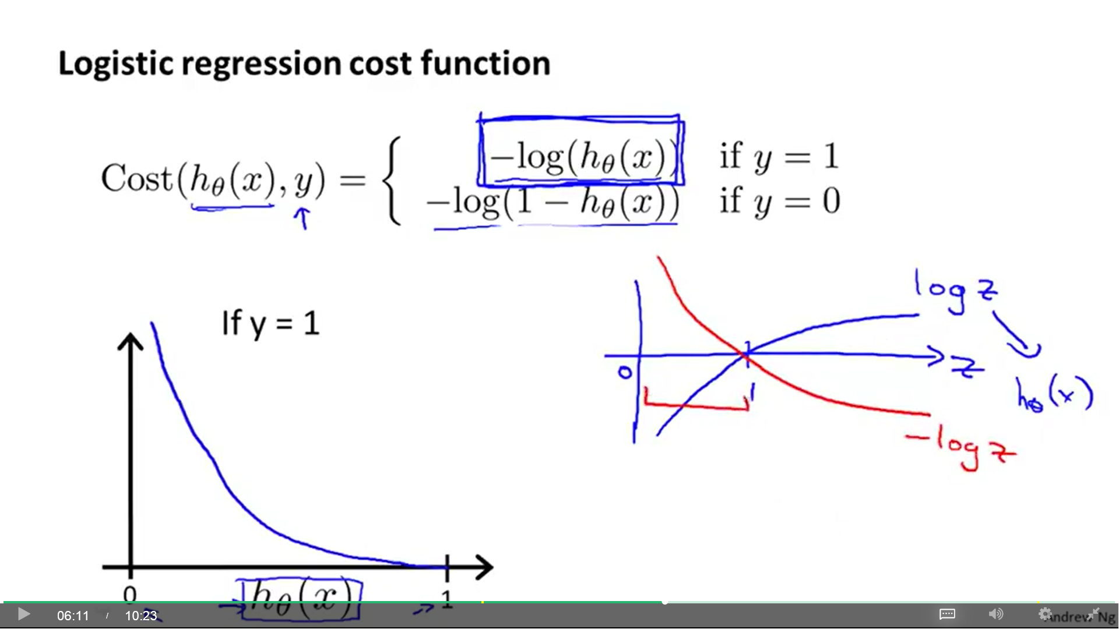However, our nonlinear sigmoid function hθ(x) makes J(θ) to be non-convex (it has many local minimums) if we define it as a square cost function. We need a convex J(θ), so we define:

$$cost\left(h_{θ}\left(x\right),y\right)=\left\{\begin{aligned}−log\left(h_{θ}\left(x\right)\right) \\ −log\left(1−h_{θ}\left(x\right)\right)\end{aligned}\right.\begin{matrix}ify=1 \\ ify=0\end{matrix}$$

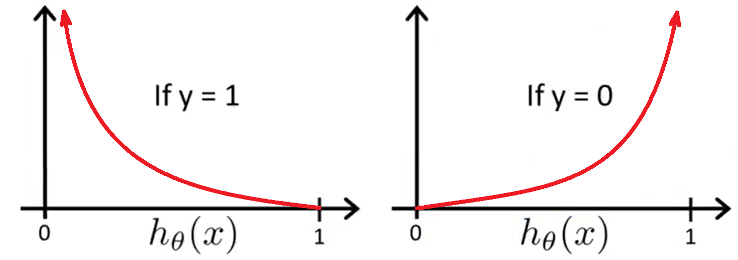"-log(z)" is represented in the previous picture, but we are only interested on the range [0, 1].

Properties when y=1:

- If hθ(x)=1, then J(θ)=0.

- As hθ(x)→0, J(θ)→ $∞$ (learning algorithm penalized by a large cost)

Properties when y=0:

- If hθ(x)=1, then J(θ)= $∞$ (learning algorithm penalized by a large cost)

- As hθ(x)→0, J(θ)→ 0

Convexity analysis is beyond the scope of this course, but with a particular choice of cost function we can obtain a convex optimization problem.

We can compress cost(h(x),y) into only one equation:

$$cost\left(h_{θ}\left(x^{\left(i\right)}\right),y^{\left(i\right)}\right)=−y^{\left(i\right)}⋅log\left(h_{θ}\left(x^{\left(i\right)}\right)\right)−\left(1−y^{\left(i\right)}\right)⋅log\left(1−h_{θ}\left(x^{\left(i\right)}\right)\right)$$

$$J\left(θ\right)=\frac{−1}{m}\sum_{i=1}^{m}{\left(y^{\left(i\right)}⋅log\left(h_{θ}\left(x^{\left(i\right)}\right)\right)+\left(1−y^{\left(i\right)}\right)⋅log\left(1−h_{θ}\left(x^{\left(i\right)}\right)\right)\right)}$$

We have chosen this particular cost function because it can be derived from statistics using the Principle of maximum likelihood estimation, which is an idea for how to efficiently find parameters data for different models, and it also is convex.

## Gradient descent

Used to minimize J(θ) to fit parameters θ.

Repeat {

$θ_{j}=θ_{j}−α\frac{δ}{δθ_{j}}J\left(θ\right)$// simultaneously update all θj

}

We get an algorithm identical to the one of linear regression. The only difference is that the definition of h(x) changes.

$$θ_{j}=θ_{j}−α\frac{1}{m}\sum_{i=1}^{m}{\left(h_{θ}\left(x^{\left(i\right)}\right)−y^{\left(i\right)}\right)}⋅x_{j}^{\left(i\right)}$$

Here, we will use the same method used previously to monitor a gradient descent to make sure that it is converging: Plot J(θ) as a function of the number of iterations and make sure J(θ) is decreasing on every iteration.

**Feature scaling** help gradient descent to converge faster.

## Optimization

Gradient descent isn`t the only **optimization algorithm** we can use. Given $J\left(θ\right)$ and $\frac{δ}{δθ_{j}}J\left(θ\right)$, there are others that use better strategies than gradient descent to minimize J(θ).

Examples: **Conjugate gradient**, **BFGS**, **L-BFGS**.

Advantages:

- No need to manually pick α: They have a clever inner-loop (called Line search algorithm) that automatically tries out different values for α and picks a good α (can even pick different α for every iteration).

- Faster than gradient descent (useful for larger machine learning problems).

Disadvantage:

- Very complex: It's recommended to take them from an existing software library. Octave and MATLAB have good libraries with these algorithms. If you are using other languages, try different libraries because there are good and bad implementations (performance differs).

In Octave, we can use the library function "**fminunc**" (**Function Minimization Unconstrain**), which is an optimized version of gradient descent (more information in the Octave's Excel and command "help fminunc"). Used in linear and logistic regression.

## Multi-class classification: One vs all

Multiclass classification problems: Problems with more than two classes. y Î {0,1,2,3,...}

- Email tagging as Work (y=1), Friends (y=2), Family (y=3), Hobby (y=4).

- Medical diagnosis: Not ill (y=1), Cold (y=2), Flu (y=3).

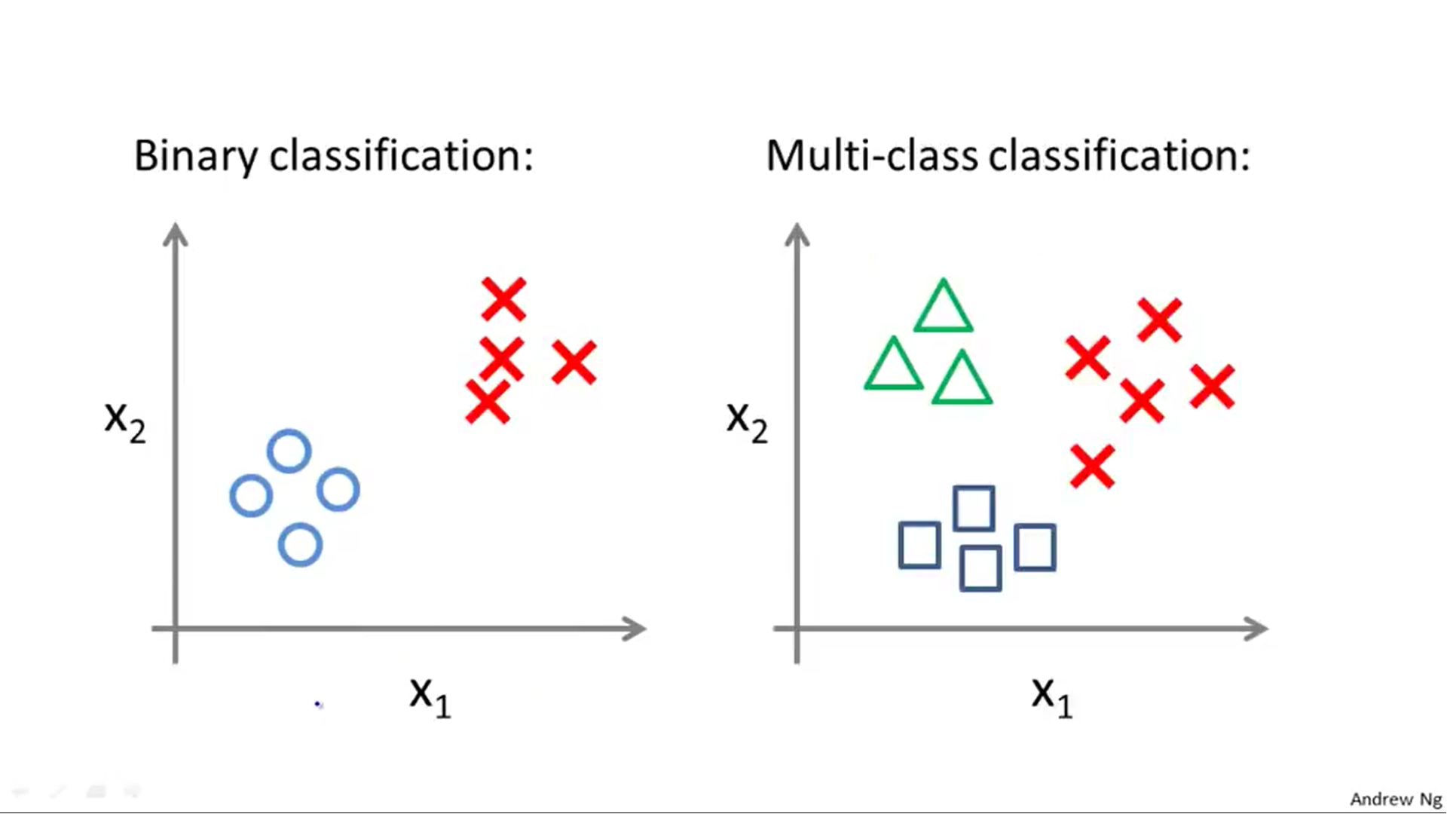- Weather: Sunny (y=1), Cloudy (y=2), Rain (y=3), Snow (y=4).

Our y indexes may start from 0 or 1. It's your choice.

Our data set will look like:

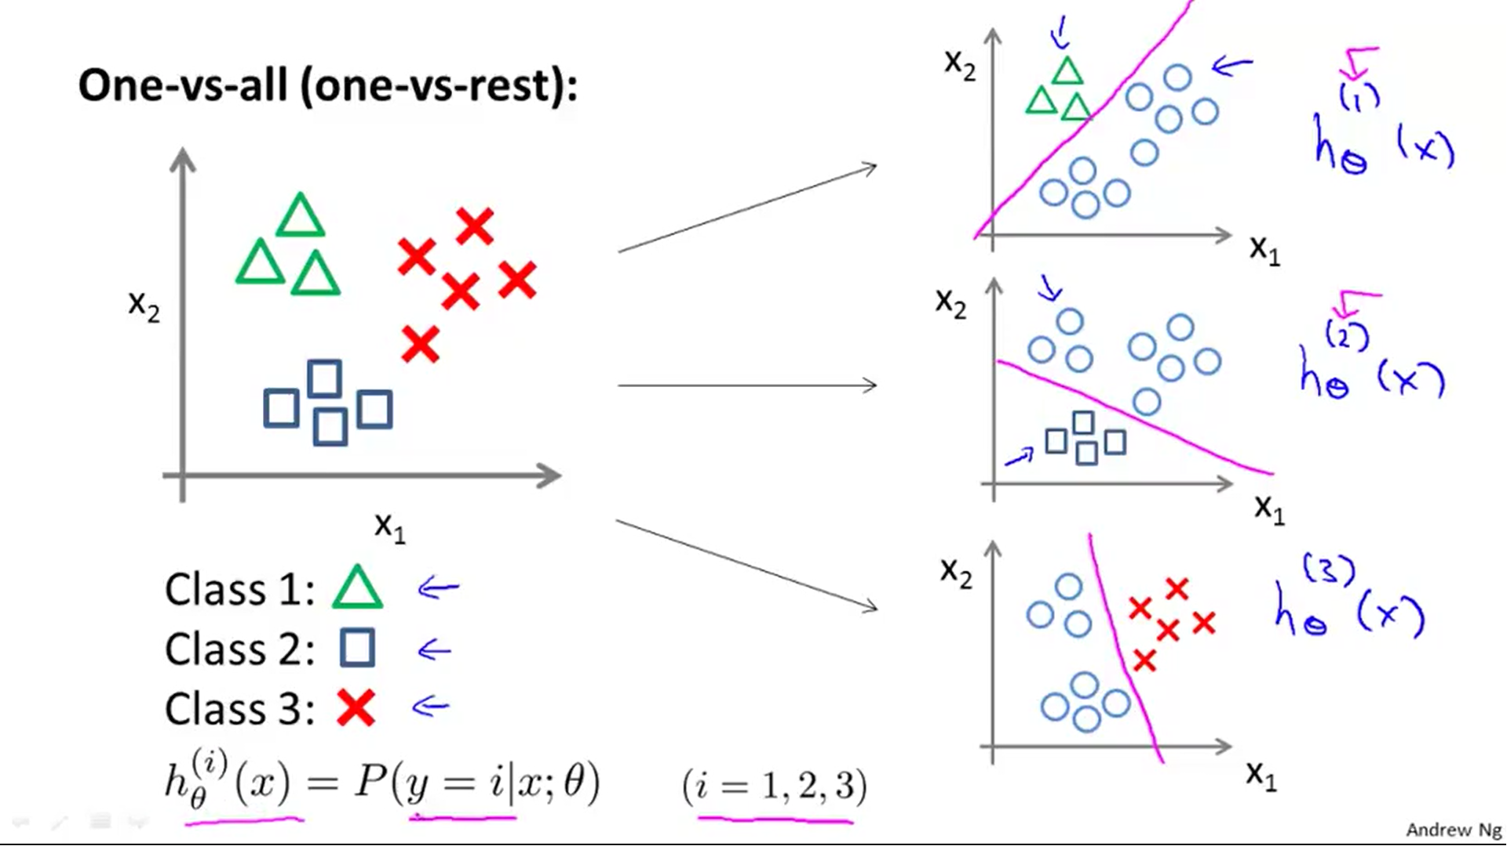We will use "One vs all classification algorithm" to solve multiclass classification problems. It takes the different classifiers and consider each one as a binary classification problem where that one classifier is opposed to the rest.

In the example with 3 classes we obtain 3 hypothesis:

Class 1 → $h_{θ}^{\left(1\right)}\left(x\right)$

Class 2 → $h_{θ}^{\left(2\right)}\left(x\right)$

Class 3 → $h_{θ}^{\left(3\right)}\left(x\right)$

$$h_{θ}^{\left(i\right)}\left(x\right)=P\left(y={i\text{|}}_{x};θ\right)$$

$$\left(i=1,2,3\right)$$

We train a logistic regression classifier $h_{θ}^{\left(i\right)}\left(x\right)$ for each class i to predict the probability that y = i.

On a new input x, to make a prediction, run all the classifiers on the input x and pick the class i that maximizes $\max_{i}h_{θ}^{\left(i\right)}\left(x\right)$ (the one that maximizes the three, that gives us the highest probability).

# - Regularization -

The learning algorithms we have seen (linear and logistic regression), when applied to certain machine learning applications, they can perform very poorly because of **overfitting**.

## Overfitting

If we have too many features, the learned hypothesis may fit the training set very well (J(θ)≈0), but fail to generalize to new examples (predict prices on new examples).

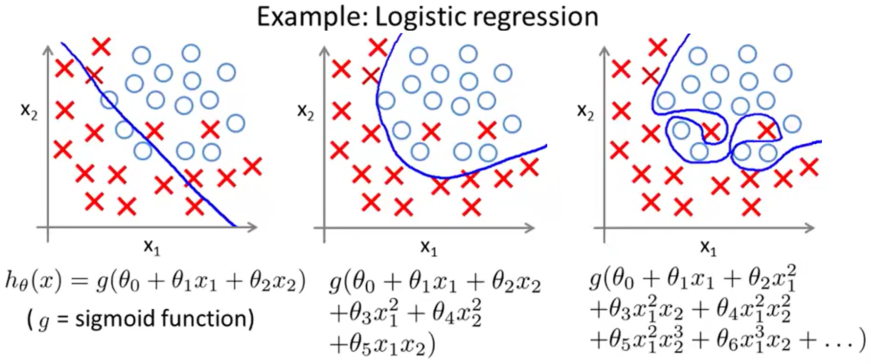1) Underfit (High bias): Our algorithm has strong preconception (bias) that housing prices varies linearly with the size. Despite of the data, its preconceptions still bias it to fit a straight line, resulting in poor fit to data.

2) Just right

3) Overfit (High variance): If we are fitting such a high order polynomial, then hypothesis can fit almost any function.

To address overfitting we have two options:

- Reduce number of features:

- Manually select which features to keep and which to throw out.

- Model selection algorithm (automatically decides which features to keep and throw out)

- Regularization: Keep all the features, but reduce magnitude/values of parameters θj. Works well when we have a lot of features, each of which contributes a bit to predict y.

When training a classification model with logistic regression, adding many new features to the model makes it more likely to overfit the training set.

## Cost function

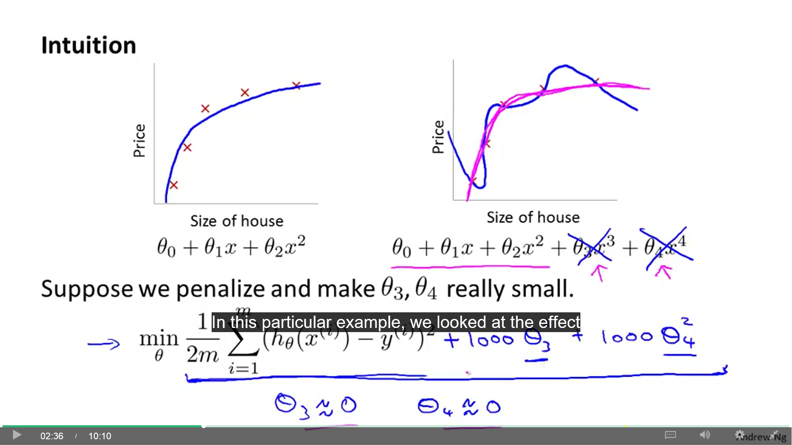Suppose we have an overfitting hypothesis like θ0 + θ1x + θ2x2 + θ3x3 + θ4x4. We can penalize θ3 and θ4 making them really small by minimizing:

$J\left(θ\right)=\frac{1}{2m}\sum_{i=1}^{m}{{\left(h_{θ}\left(x^{\left(i\right)}\right)−y^{\left(i\right)}\right)}^{2}}+1000∙θ_{3}^{2}+1000∙θ_{4}^{2}$.

The number 1000 represents a big number. This way, we get θ3 ≈ 0 and θ4 ≈ 0.

Small values for parameters θ0, θ1 ... θn correspond to simpler and smoother hypothesis, which makes it less prone to overfitting.

When we have n features and n+1 parameters θ, we can shrink every parameter by adding an extra term to the end of J(θ). The addition is not included inside the sumation (Σ). By convention, we don't regularize θ0 (doing so makes little difference). Cost function for Linear regression:

$$J\left(θ\right)=\frac{1}{2m}\sum_{i=1}^{m}{{\left(h_{θ}\left(x^{\left(i\right)}\right)−y^{\left(i\right)}\right)}^{2}}+λ\sum_{j=1}^{n}{θ_{j}^{2}}$$

Regularization parameter **(λ)**: Controls a trade-off between fitting the training set well (1st term) and keeping parameters small (2nd term). Introducing a too big λ can result in underfitting (hθ(x) ≈ θ0).

## Linear regression

Gradient descent with J(θ) regularized (j = 1, 2, 3, ..., n):

$θ_{j}=θ_{j}−α\left[\frac{δ}{δθ_{j}}J\left(θ\right)\right]$ → $θ_{j}=θ_{j}−α\left[\frac{1}{m}\sum_{i=1}^{m}{\left(h_{θ}\left(x^{\left(i\right)}\right)−y^{\left(i\right)}\right)}x_{j}^{\left(i\right)}+\frac{λ}{m}θ_{j}\right]$ →

→ $θ_{j}=θ_{j}\left(1−α\frac{λ}{m}\right)−α\frac{1}{m}\sum_{i=1}^{m}{\left(h_{θ}\left(x^{\left(i\right)}\right)−y^{\left(i\right)}\right)}x_{j}^{\left(i\right)}$

$\left(1−α\frac{λ}{m}\right)$: Number < 1 and > 0. It has the effect of shrinking θj.

The final gradient descent algorithm will be:

repeat {

// for θ0

// for θj (j={1,2,3..n})

## Normal equation

Without regularization: $θ={\left(X^{T}X\right)}^{−1}X^{T}y$ (value of θ that minimizes J(θ))

Regularized: $θ={\left(X^{T}X+λZ\right)}^{−1}X^{T}y$ $Z_{n+1,n+1}=\left[\begin{matrix}\begin{matrix}0 & 0 \\ 0 & 1\end{matrix} & \begin{matrix}0 & 0 \\ 0 & 0\end{matrix} \\ \begin{matrix}0 & 0 \\ 0 & 0\end{matrix} & \begin{matrix}1 & 0 \\ 0 & 1\end{matrix}\end{matrix}\right]$

Non-invertibility: (XT·X) may be invertible or not. But is proven that (XT·X+λZ) will always be invertible if λ > 0 (even when m ≤ n).

## Logistic regression

Cost function:

$$J\left(θ\right)=\left[\frac{−1}{m}\sum_{i=1}^{m}{\left(y^{\left(i\right)}⋅log\left(h_{θ}\left(x^{\left(i\right)}\right)\right)+\left(1−y^{\left(i\right)}\right)⋅log\left(1−h_{θ}\left(x^{\left(i\right)}\right)\right)\right)}\right]+\frac{λ}{2m}\sum_{j=1}^{n}{θ_{j}^{2}}$$

j = {1, 2, 3... n}

In regularized logistic regression, to monitor whether gradient descent is working correctly, you can plot the previous J(θ) as a function of the number of iterations and make sure it's decreasing.

Gradient descent (identical formulas to linear regression):

repeat {

// for θ0

// for θj (j={1,2,3..n})

}

# - Neural networks -

## Motivations

There are machine learning problems where we need to learn complex non-linear hypotheses.

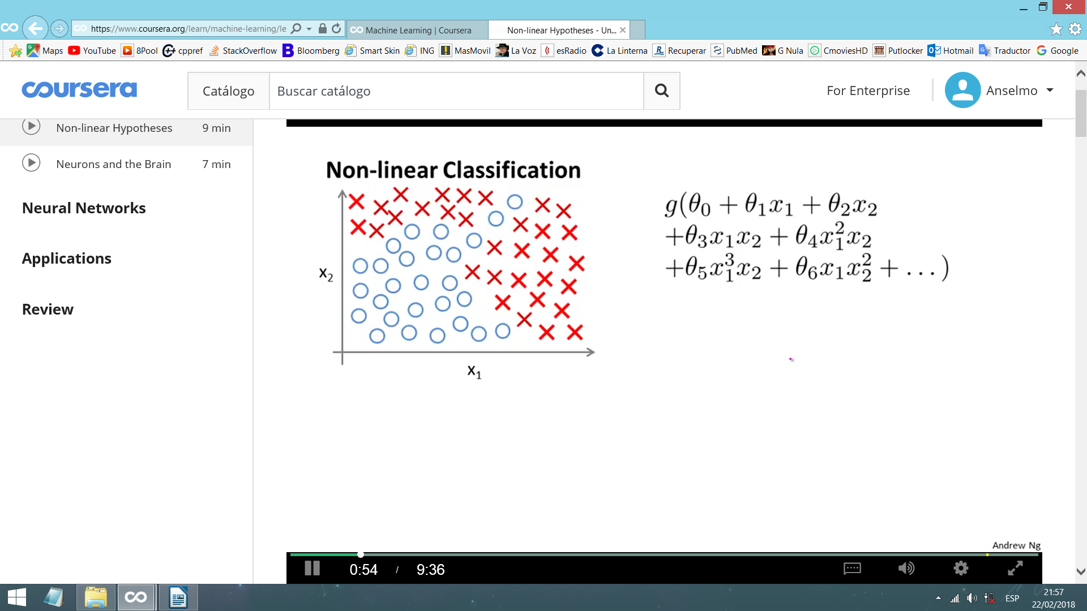Consider a supervised nonlinear classification problem. We can apply logistic regression including many polynomial features (nonlinear / quadratic / second order terms) in the hypothesis. This works well with a few features, but with a lot of them produces a huge amount of polynomial terms.

Example (2th order pol.): n=100 → $x_{1}^{2},x_{1}x_{2},x_{1}x_{3},…x_{1}x_{100},x_{2}^{2},x_{2}x_{3},…$ ≈ 5000 features ≈ $\frac{n^{2}}{2}$

Including all these quadratic features is computationally expensive and you may end up overfitting the training set. You can include only a subset like $x_{1}^{2},x_{2}^{2},x_{3}^{2},...x_{100}^{2}$ but this only allows you to create some simple shapes (ellipses, circles…) which cannot fit a more complex data set. If you include the 3th order polynomial (cubic) like $x_{1}x_{2}x_{3},x_{1}^{2}x_{3},x_{10}x_{11}x_{12}…$ you will get about $\frac{n^{3}}{2}$ features (too much).

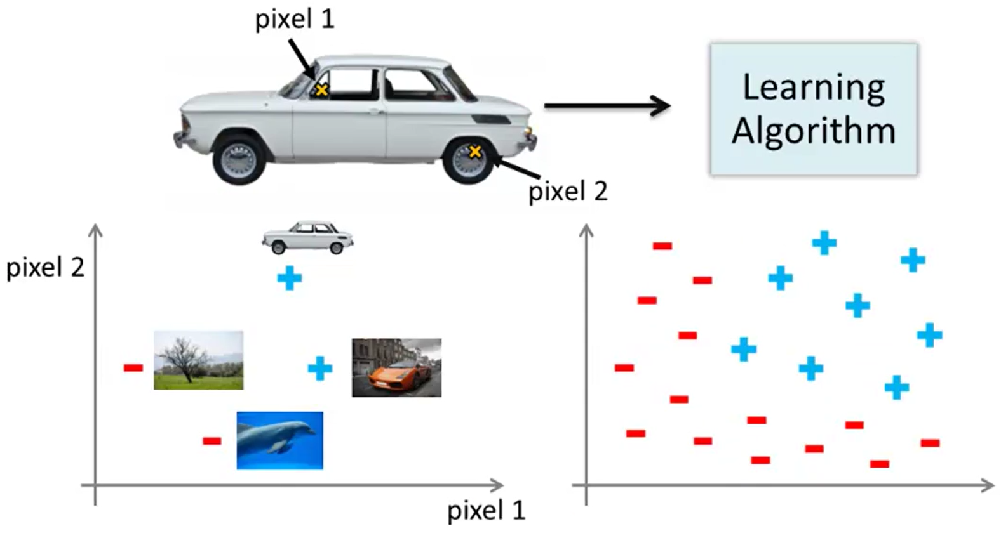For many machine learning problems, n will be pretty large (example: Computer vision). Where we see a car, computer sees lots of numbers (colour intensity of the pixels). When we use machine learning to build a car detector we take a label training set with examples of cars and non-cars and use it with our learning algorithm to train a classifier. Then, we test it. Here, we need non-linear hypothesis. Why?

Suppose we feed our algorithm with images of cars and non-cars and it evaluates the intensity of 2 pixels. We plot them and we come up with the rightmost plot. We need a nonlinear hypothesis to separate out the 2 classes.

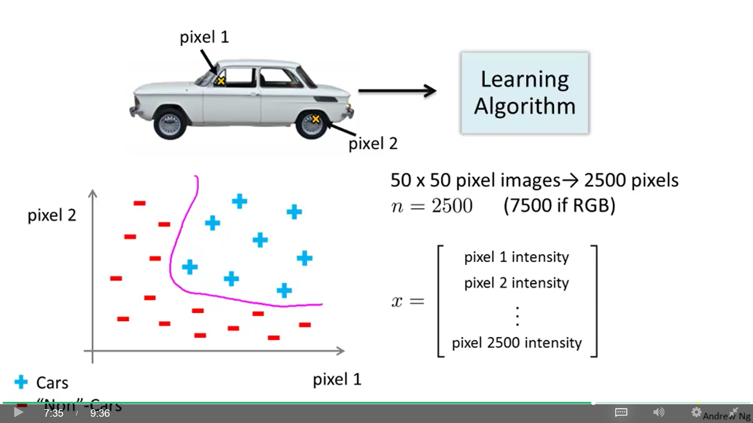The dimension of the feature space is the number of pixels (n) and vector x is the intensity of every pixel (0-255) of every training example.

If we try to learn a nonlinear hypothesis by including all the quadratic features (xi · xj) from 2500 pixels, we would end with 3 million features per training example. Too computationally expensive.

Neural networks are a much better way to learn complex nonlinear hypothesis, even when n (input feature space) is large.

Neural networks were originated when trying to mimic the brain. They were widely used in 80s and early 90s but their popularity diminished in late 90s. But recently they resurged (one reason: better machines to run these expensive algorithms).

**One learning algorithm hypothesis:** A brain is one big learning algorithm that does everything (vision, smell, hear, math, motion ...), and not a number of learning algorithms. Some evidence:

- Auditory cortex (AC): Ear takes a sound signal and routes it to your AC. If you cut the wire ear-AC and re-wire the signal from the eye to the AC, then your AC learns to see.

- Somatosensory cortex: Region that process your sense of touch. Do a similar re-wire and it will learn to see. These are called Neuro re-wiring experiments.

It's possible to plug in almost any sensor to almost any part of the brain and the brain learning algorithm will learn and deal with that data.

- See with your tongue: Connecting a camera to an array of electrodes placed on your tongue (higher voltages correspond to brighter pixels) you will learn to see with it in minutes.

- Human echolocation (sonar): By snapping your fingers or clicking your tongue you can learn to interpret the pattern of sounds bouncing off your environment.

- Haptic belt: If it has many buzzers around and the north-most is always buzzing, you can acquire a sense of where north is, like birds.

- Extra eye: A frog with a third eye implanted can learn to use it.

Maybe, to create truly intelligent machines, we just need to figure out the brain's learning algorithm (or some approximation), implement it and let it process by itself the different types of data.

## Model (hypothesis) representation

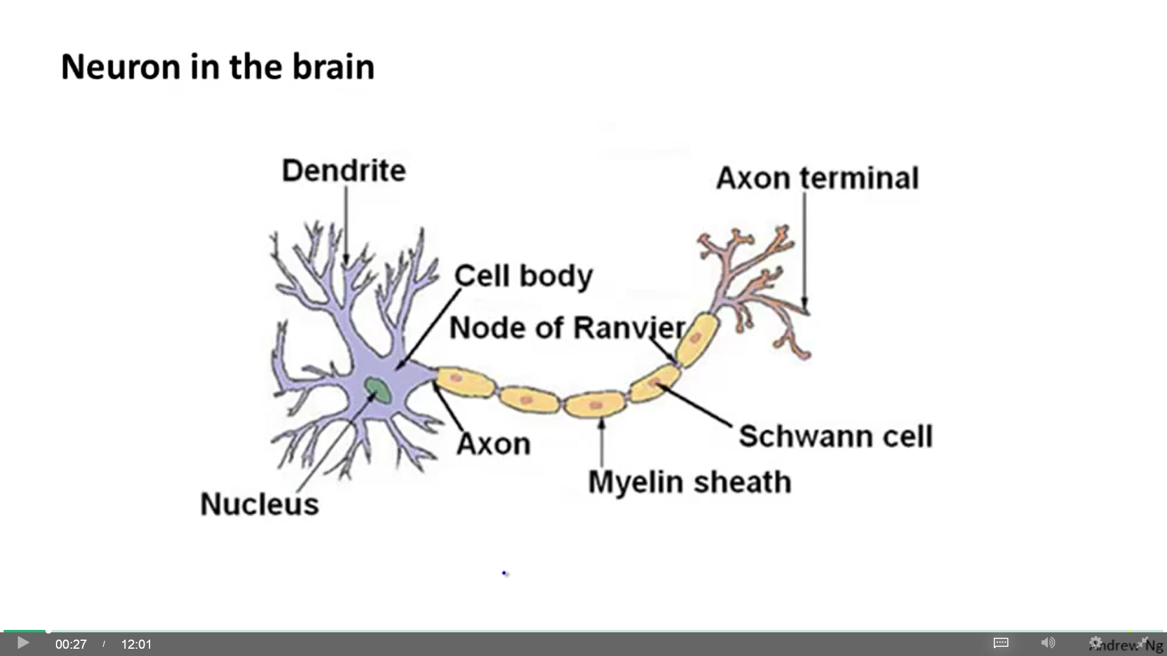A neuron is a kind of computational unit that gets some input through its input wires (dendrites), makes some computation (cell body) and send outputs (axon) to other nodes (neurons). Neurons communicate with each other with little pulses of electricity (spikes). The spikes goes through the axon and an open wire (axon terminal) that is connected to another neuron's dendrites.

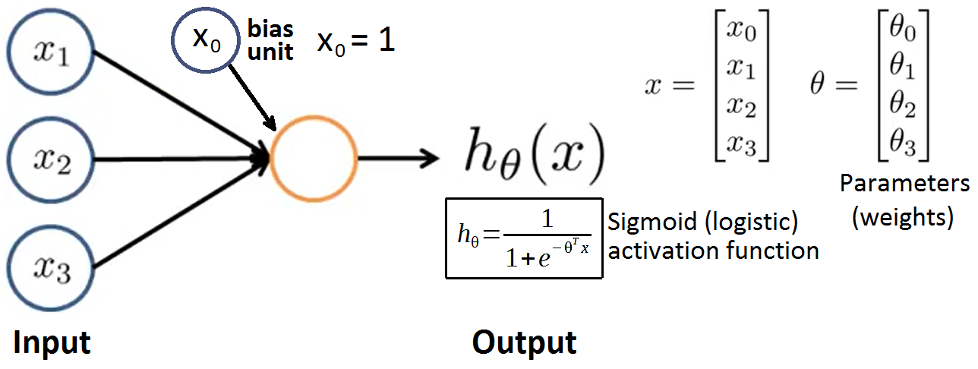Neurons send electricity to your muscles to contract them. The eyes send pulses of electricity to the brain to see.

**Single neuron**

(We model a single neuron as a logistic unit)

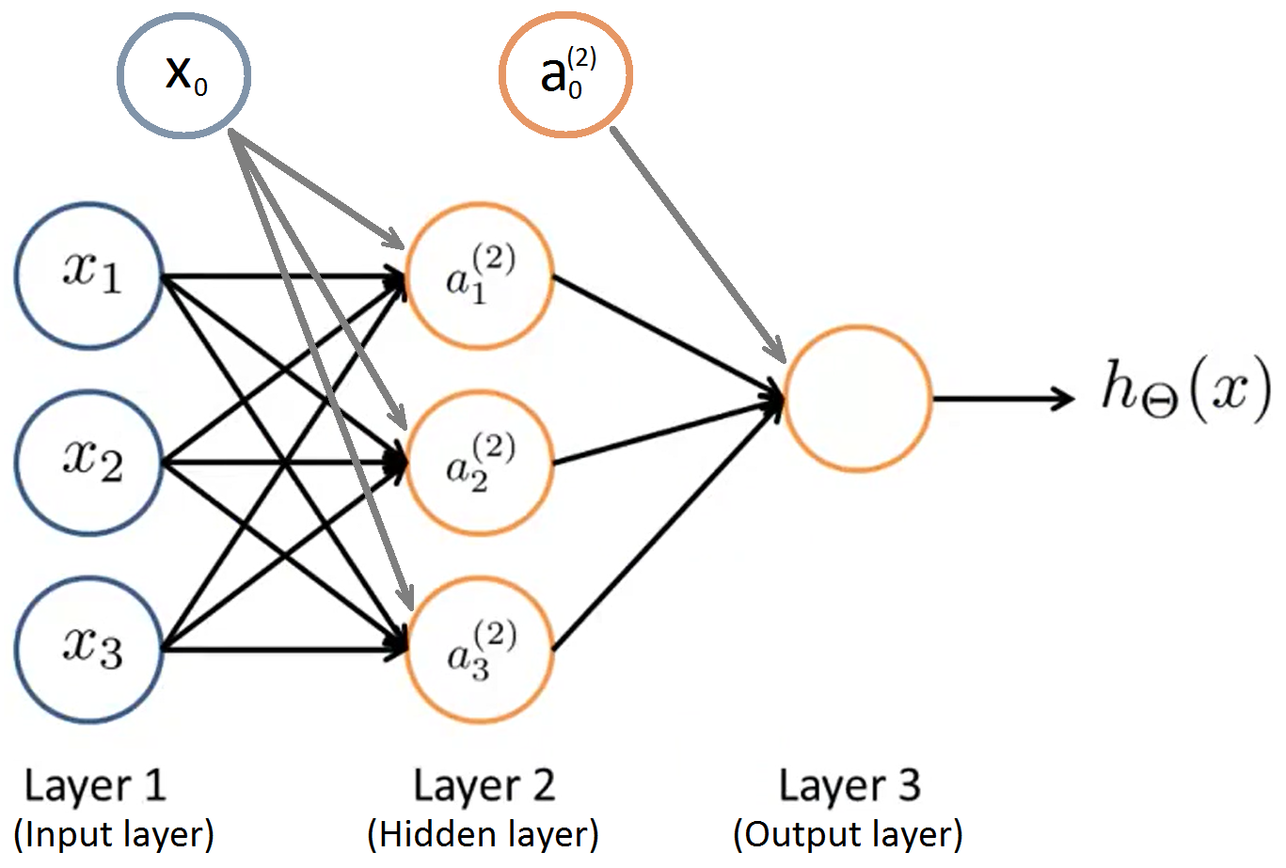**Neural network:**

$a_{i}^{\left(j\right)}$ = Activation of unit i in layer j (activation: value computed) (3 hidden units, 3 input units).

$Θ^{\left(j\right)}$ = Matrix of weights controlling function mapping from layer j to layer j+1. If network has sj units in layer j and sj+1 units in layer j+1, then θ(j) will be of dimension [sj+1 x (sj+1)].

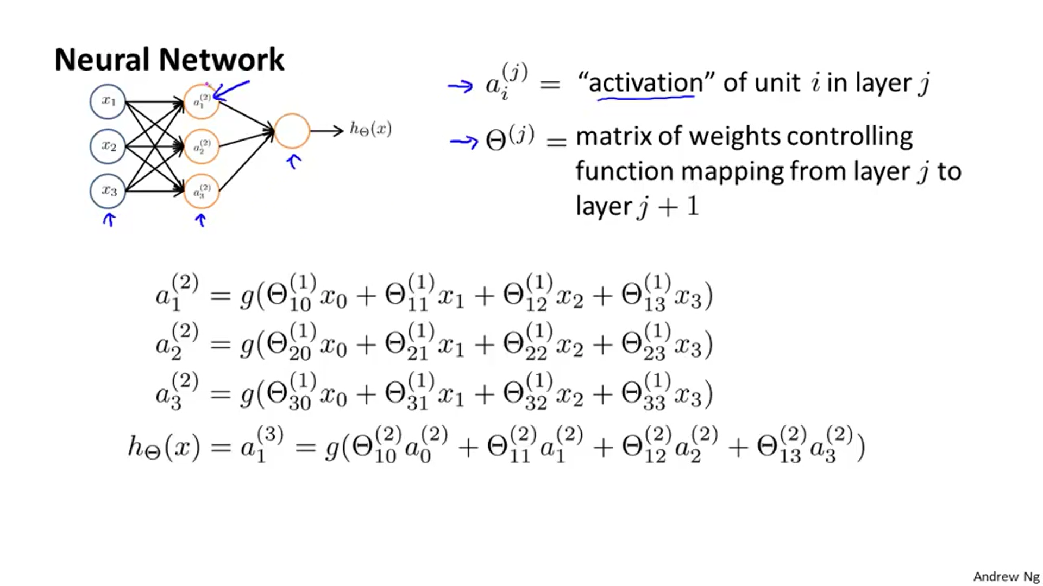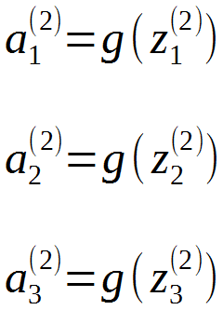

**Vectorized implementation:**

$x=a^{\left(1\right)}=\left[\begin{aligned}x_{0} \\ x_{1} \\ x_{2} \\ x_{3}\end{aligned}\right]$ $z^{\left(2\right)}=Θ^{\left(1\right)}x=\left[\begin{aligned}z_{1}^{\left(2\right)} \\ z_{2}^{\left(2\right)} \\ z_{3}^{\left(2\right)}\end{aligned}\right]$ $a^{\left(2\right)}=g\left(z^{\left(2\right)}\right)=\left[\begin{aligned}a_{0}^{\left(2\right)} \\ a_{1}^{\left(2\right)} \\ a_{2}^{\left(2\right)} \\ a_{3}^{\left(2\right)}\end{aligned}\right]\left(rememberadda_{0}^{\left(2\right)}=1\right)$

$z^{\left(3\right)}=Θ^{\left(2\right)}a^{\left(2\right)}$ $h_{Θ}\left(x\right)=a^{\left(3\right)}=g\left(z^{\left(3\right)}\right)$

This process of computing hΘ(x) is called **feed forward propagation** because we start with the activation of the input units, forward propagate that to the hidden layer, compute the activations of the hidden layer, forward propagate that and compute the activations of the output layer.

All this computation is very similar to a standard logistic regression problem. We compute hΘ(x) with logistic regression using $a_{0}^{\left(2\right)},a_{1}^{\left(2\right)},a_{2}^{\left(2\right)},a_{3}^{\left(2\right)}$ rather than the original features. We also use Θ instead of θ. Moreover, the $a^{\left(2\right)}$ features are learned as functions of the input $x_{0},x_{1},x_{2},x_{3}$ using other set of parameters Θ(1). The neural network, instead of being constrained to feed the original features to logistic regression, learns its own features. Depending of what Θ(1) you choose, you can learn complex features and end up with a better hypothesis than if you were constrained to the raw original features or to choose the polynomial terms.

**Network architecture:** It is the way the network is connected, how the different neurons are connected to each other. We can have networks with other types of diagrams. If we add more hidden layers, the network will learn even more complex features, creating a more interesting hΘ(x).

## Examples and intuition

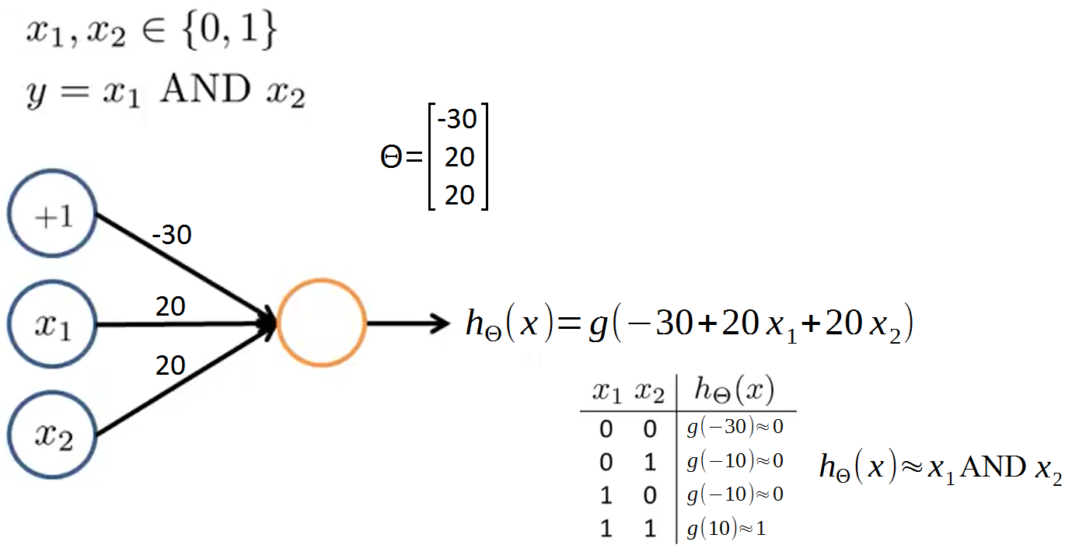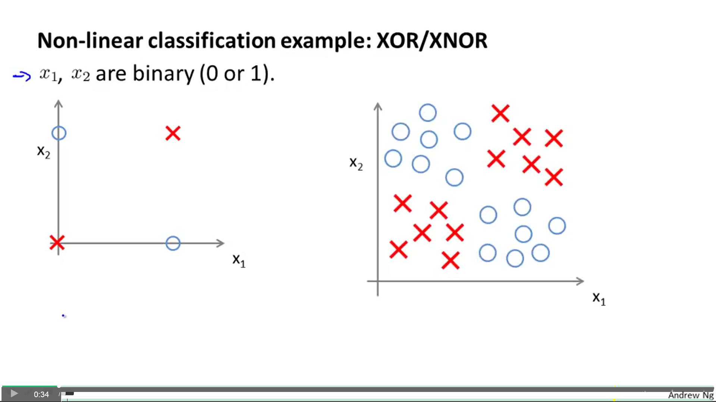We can compute different logic functions (logic gates) using a single neuron (one-unit network).

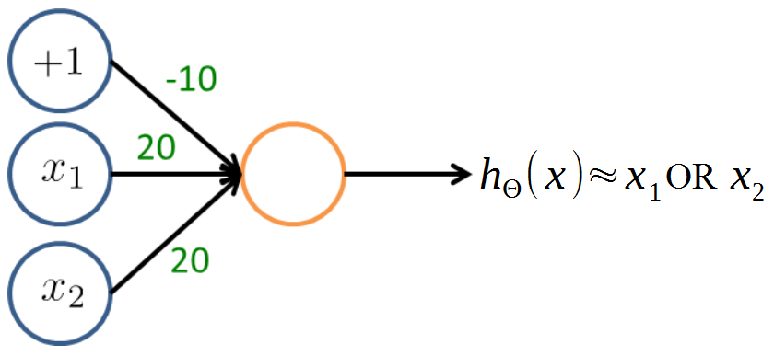

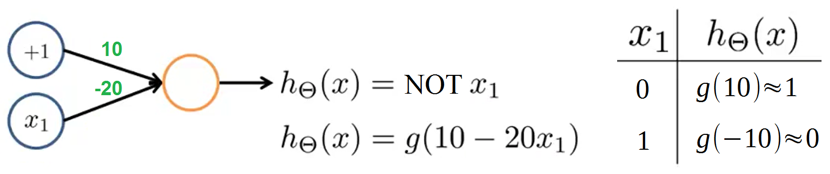

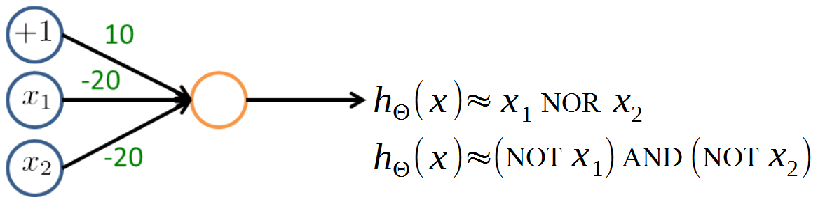

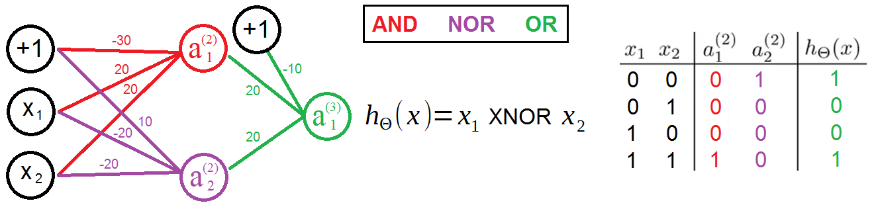We can make a XNOR putting together AND, NOR and OR:

The hidden layer computes slightly more complex functions of the inputs. And by adding another layer we end up with an even more complex nonlinear function. This intuition shows why neural networks can compute pretty complicated functions. Deeper layers compute more complex features.

Using neural networks it was possible the handwritten digit recognition, which was soon used to read zip codes and postal codes (multi-class classification problem with 10 categories). The first hidden layer computed certain features, the next layer computed more complex features and the next one even more complex features. These features can then be used by the final layer of logistic regression classifiers to make accurate predictions about the numbers the network sees.

## Multi-class classification

We do multi-class classification in a neural network with an extension of the "one vs all" method.

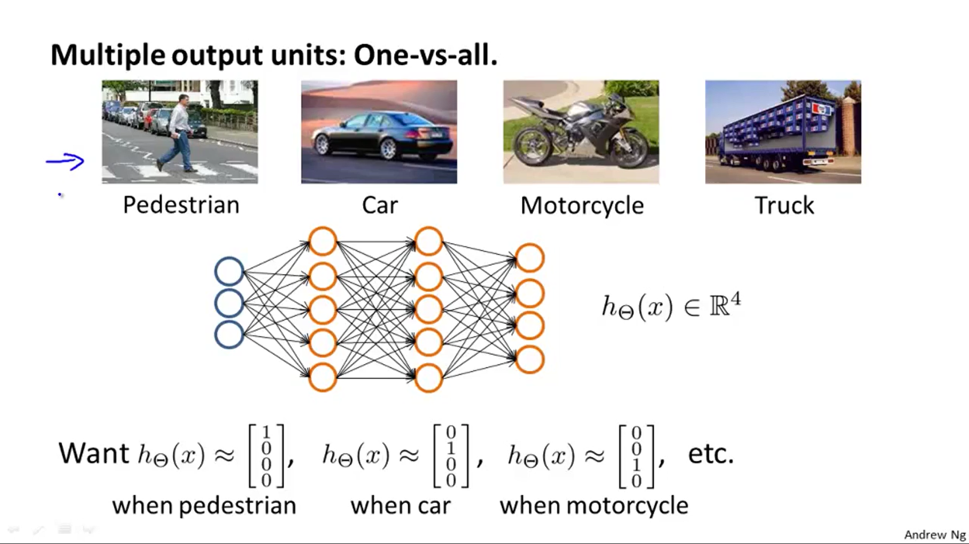Example: Computer vision able to see pedestrians, cars, motorcycles and trucks. We make a neural network with 4 output units (4 logistic regression **classifiers**), so it outputs a vector of 4 numbers. Each output unit classify one category:

1st: is pedestrian? yes/no.

2nd: is car? yes/no.

3Th: is motorcycle? yes/no.

4Th: is truck? yes/no.

Training set: $\left(\left(x^{\left(1\right)},y^{\left(1\right)}\right),\left(x^{\left(2\right)},y^{\left(2\right)}\right),...,\left(x^{\left(m\right)},y^{\left(m\right)}\right)\right)$

Previously, in logistic regression we used $y∈\left\{1,2,3,4\right\}$, but this is not used here. Instead, use:

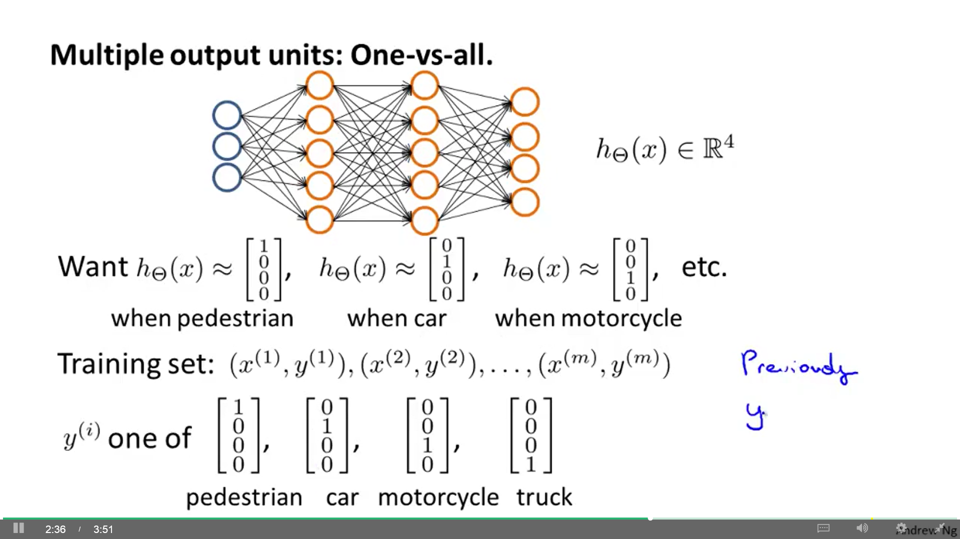

x(i) : One image. y(i) : One of these vectors.

$h_{Θ}\left(x^{\left(i\right)}\right)=y^{\left(i\right)}$ (both are vectors of dimension 4)

Function **fmincg** works similarly to fminunc, but is more efficient when we are dealing with large number of parameters.

## Cost function

Training set: $\left(\left(x^{\left(1\right)},y^{\left(1\right)}\right),\left(x^{\left(2\right)},y^{\left(2\right)}\right),...,\left(x^{\left(m\right)},y^{\left(m\right)}\right)\right)$

L = Total number of layers in a network (L = 4).

sl = Number of units (not counting bias unit) in layer l (s2 = 5).

K: Another name for the number of output units (also sL).

We will consider 2 types of classification problems:

- Binary classification: One output unit. (y = 0 or 1) (K = sL = 1) $h_{Θ}\left(x\right)∈R$

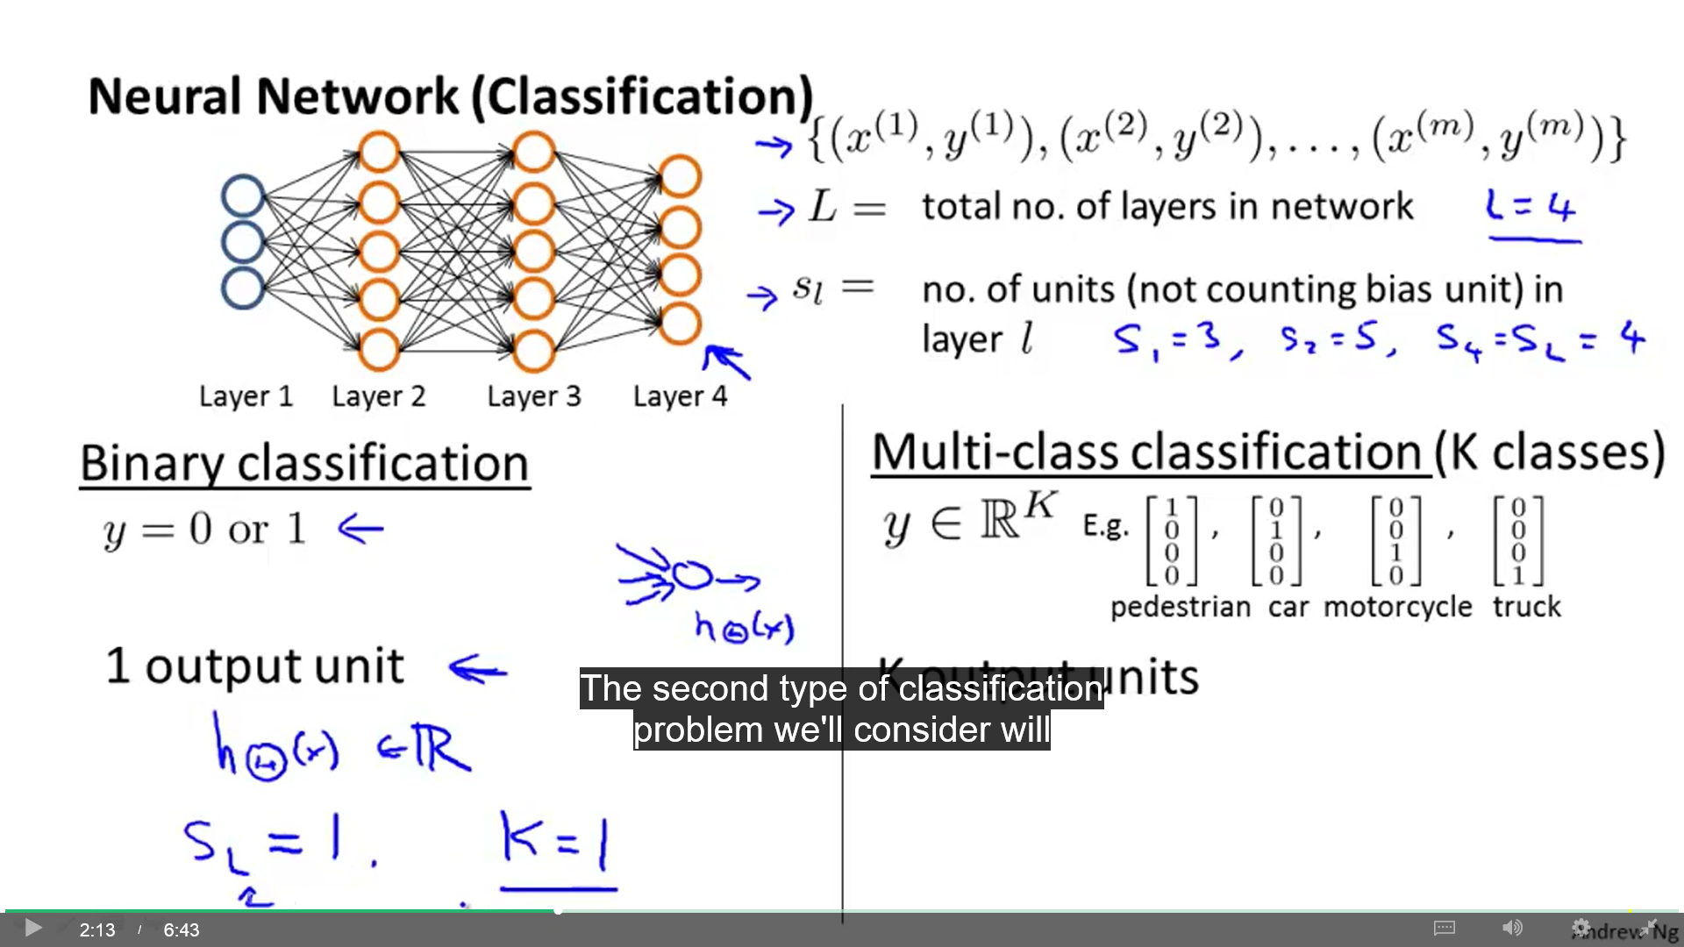- Multi-class classification: K output units. K classes. $h_{Θ}\left(x\right)∈R^{K}$

We use the "one vs all" method when K ≥ 3. Otherwise, it isn't necessary (with 2 classes, we can use one output unit).

The cost function used for neural networks is a generalization of the one used for logistic regression. In this case, instead of one output unit, we will have K outputs.

Logistic regression:

$$J\left(θ\right)=\frac{−1}{m}\left[\sum_{i=1}^{m}{y^{\left(i\right)}}⋅log\left(h_{θ}\left(x^{\left(i\right)}\right)\right)+\left(1−y^{\left(i\right)}\right)⋅log\left(1−h_{θ}\left(x^{\left(i\right)}\right)\right)\right]+\frac{λ}{2m}\sum_{j=1}^{n}{θ_{j}^{2}}$$

Neural networks:

$$J\left(θ\right)=\frac{−1}{m}\left[\sum_{i=1}^{m}{\sum_{k=1}^{K}{y_{k}^{\left(i\right)}}}⋅log{\left(h_{Θ}\left(x^{\left(i\right)}\right)\right)}_{k}+\left(1−y_{k}^{\left(i\right)}\right)⋅log{\left(1−h_{Θ}\left(x^{\left(i\right)}\right)\right)}_{k}\right]+\frac{λ}{2m}\sum_{l=1}^{L−1}{\sum_{i=1}^{s_{l}}{\sum_{j=1}^{s_{l+1}}{{\left(Θ_{ji}^{\left(l\right)}\right)}^{2}}}}$$

$h_{Θ}\left(x\right)∈R^{K}$ $h_{Θ}{\left(x\right)}_{i}$ = ith output

First term: Addition of every cost function of every output unit (k) for all examples (i).

Second term: Addition of every parameter Θ in the network (not including those that correspond to the bias: Θ0). Every layer (l), unit (j), parameter (i).

## Backpropagation

If we want to minimize J(Θ) using gradient descent or one advanced optimization method (fminunc, conjugate gradient, BFGS, L-BFGS, ...), we need to supply J(Θ) and the partial derivative terms $\frac{δ}{δΘ_{ij}^{\left(l\right)}}j\left(Θ\right)$ for every i, j, l (every θ in the NN).

**Gradient computation:**

Suppose our training set only has 1 training example (x, y). This is the sequence of calculations:

1 – **Forward propagation:** Computes the activation values for all of the neurons. Applied in order to compute whether hypothesis actually outputs given the input.

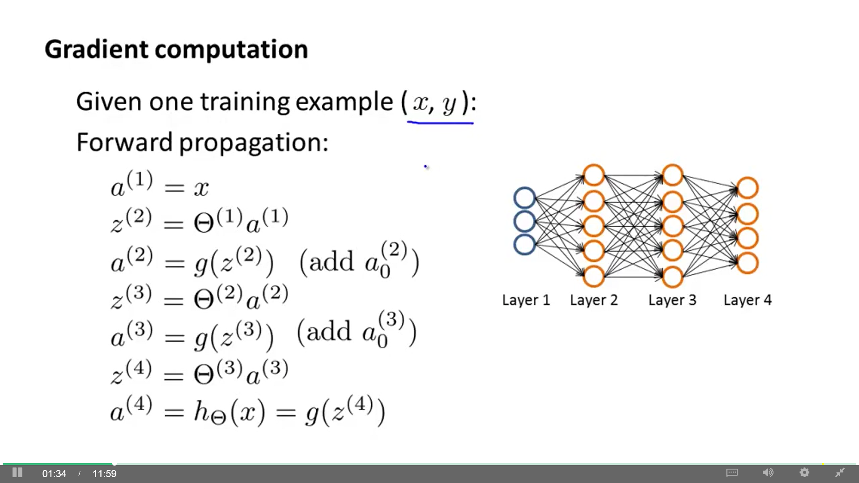

2 – **Backpropagation:** Algorithm for computing the derivatives, for minimizing J(Θ). It fits the parameters of the network given a training set. Errors are back propagated through layers.

We compute $δ_{j}^{\left(l\right)}$, which represents the "error" of node $a_{j}^{\left(l\right)}$ (activation of that neuron). For each output unit we compute:

$δ_{k}^{\left(L\right)}=a_{k}^{\left(L\right)}−y_{k}$ (our example is L=4) (yk : kth element of vector y) ($a_{k}^{\left(4\right)}={\left(h_{Θ}\left(x\right)\right)}_{k}$)

Instead of computing δ for each unit, we can use vectorized implementation. Next, we compute this for the earlier layers (the errors are back propagated through the layers):

g'( z(3)) : Derivative of a3.

Don't include θ0 in the previous computation of δ.

There is no δ(1) because the input layer correspond to the features and they have no errors. We don't want to modify them.

Finally: $\frac{δ}{δΘ_{ij}^{\left(l\right)}}J\left(Θ\right)=δ_{i}^{\left(l+1\right)}a_{j}^{\left(l\right)}$ supposing no regularization (λ=0)

**Backpropagation algorithm (for many examples):**

Training set { (x(1), y(1)), ..., (x(m), y(m)) }

Set $Δ_{ij}^{\left(l\right)}=0$ (for all l, i, j) (Δ is capital δ)

(used as accumulators that slowly add things in order to compute $\frac{δ}{δΘ_{ij}^{\left(l\right)}}J\left(Θ\right)$)

For i = 1 to m: (x(i), y(i))

Set a(1) = x(i)

Perform forward propagation to compute a(l) for l = 2, 3, ..., L

Using y(i), compute δ(L) = a(L) – y(i)

Perform Backpropagation to compute δ(L-1), δ(L-2), ..., δ(2)

Accumulate the previous partial derivative terms in $Δ_{ij}^{\left(l\right)}:=Δ_{ij}^{\left(l\right)}+a_{j}^{\left(l\right)}δ_{i}^{\left(l+1\right)}$

(Vectorized implementation: $Δ^{\left(l\right)}:=Δ^{\left(l\right)}+δ^{\left(l+1\right)}{\left(a^{\left(l\right)}\right)}^{T}$)

$D_{ij}^{\left(l\right)}:=\frac{1}{m}Δ_{ij}^{\left(l\right)}$ if j = 0 $D_{ij}^{\left(l\right)}:=\frac{1}{m}\left(Δ_{ij}^{\left(l\right)}+λΘ_{ij}^{\left(l\right)}\right)$ if j ≠ 0 (regularization)

D is the partial derivative of the cost function with respect to every parameter: $D_{ij}^{\left(l\right)}=\frac{δ}{δΘ_{ij}^{\left(l\right)}}J\left(Θ\right)$. You can use these D in gradient descent or any other advanced optimization algorithm.

Suppose we have 2 training examples (x(1), y(1)), (x(2), y(2)). For computing the gradient, first we compute FP using x(1) followed by BP using y(1), then FP using x(2) followed by BP using y(2).

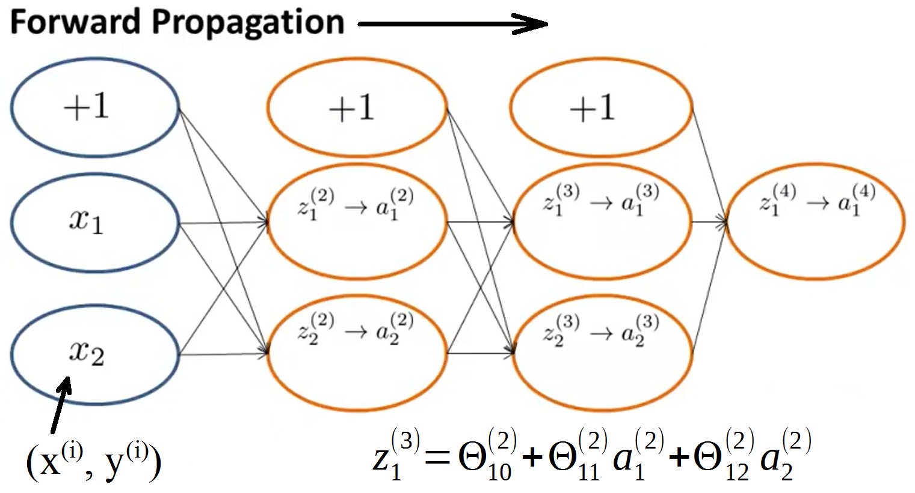**Backpropagation intuition:**

Forward propagation goes from left to right and gets the values of $a_{i}^{\left(l\right)}$ following the process showed under the image in the right.

Backpropagation does a very similar process/computation, except that it goes backwards.

Let's consider one example (x(i), y(i)), one output unit and ignore regularization (λ=0). Then, we have:

$cost\left(i\right)=y^{\left(i\right)}logh_{Θ}\left(x^{\left(i\right)}\right)+\left(1−y^{\left(i\right)}\right)logh_{Θ}\left(x^{\left(i\right)}\right)$ think of $cost\left(i\right)≈{\left(h_{Θ}\left(x^{\left(i\right)}\right)−y^{\left(i\right)}\right)}^{2}$

Cost measures how close is the output to the actual observed label y(i).

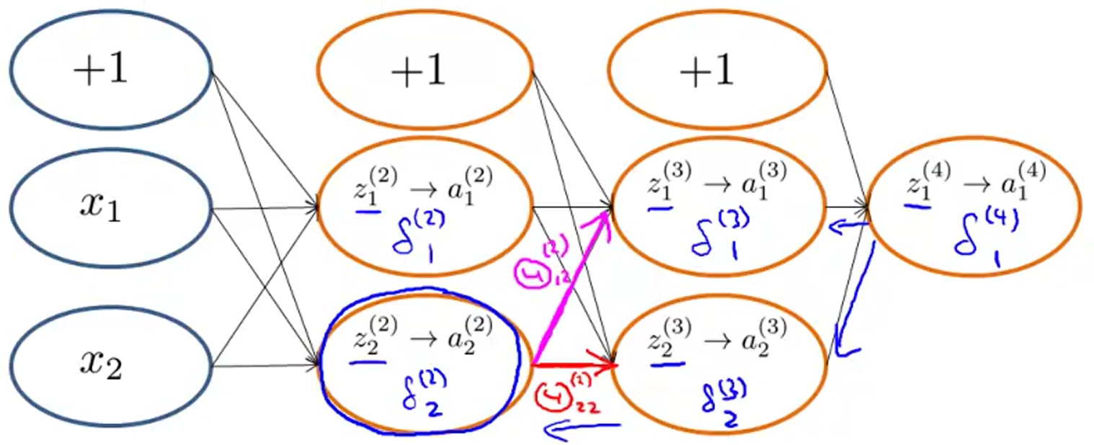Backpropagation computes the $δ_{j}^{\left(l\right)}$ terms, which we can consider the "errors" of each activation value $a_{j}^{\left(l\right)}$ (measures how much that node is "responsible" for any errors in the output). Actually, it is (for j ≥ 0): $δ_{j}^{\left(l\right)}=\frac{δ}{δz_{j}^{\left(l\right)}}cost\left(i\right)$. They are a measure of how much would we like to change the parameters in order to affect the values $z_{j}^{\left(l\right)}$ so as to affect hΘ(x) and the overall cost.

Examples (without g'(z)):

$δ_{2}^{\left(3\right)}:=Θ_{12}^{\left(3\right)}δ_{1}^{\left(4\right)}$

$δ_{2}^{\left(2\right)}:=Θ_{12}^{\left(2\right)}δ_{1}^{\left(3\right)}+Θ_{22}^{\left(2\right)}δ_{2}^{\left(3\right)}$

Note that $δ_{2}^{\left(2\right)}$ is the sum of the products of every Θ from $δ_{2}^{\left(2\right)}$ and their corresponding δ (δ is a weighted sum of delta values).

For output unit: Difference between network's activation and true value.

For hidden units: Computed based on weighted average of error terms of the nodes in the next layer.

Depending on how you implement BP, you may end up implementing something that computes $δ_{0}^{l}$ too (bias unit), but we don't usually do so because they don't end up being part of the calculation needed to get a derivative.

**Synthesis:**

Cost function of a network: Result is one number. It's made of:

- Every hΘ(x) for every example.

- Every y for every example and every hΘ(x).

- Every parameter of the network.

Minimize J(θ) using an optimization method. You must provide:

- J(θ).

- Partial derivatives of every Θ with respect to J(θ)

Forward propagation: Activation values.

Backpropagation: Derivatives.

- Compute δ for every a (except L=1 and a0).

- Compute derivatives for every θ.

Proccess with many examples (do this with each example):

- Forward propagation > Backpropagation.

- Accumulate partial derivatives in Δ.

- Compute average of every derivative.

## Unrolling parameters from matrices into vectors

Process needed in order to use advanced optimization routines. In logistic regression we enter a vector θ into "costFunction" (and it outputs a vector of derivatives). Also "fminunc" and any other optimization algorithm.

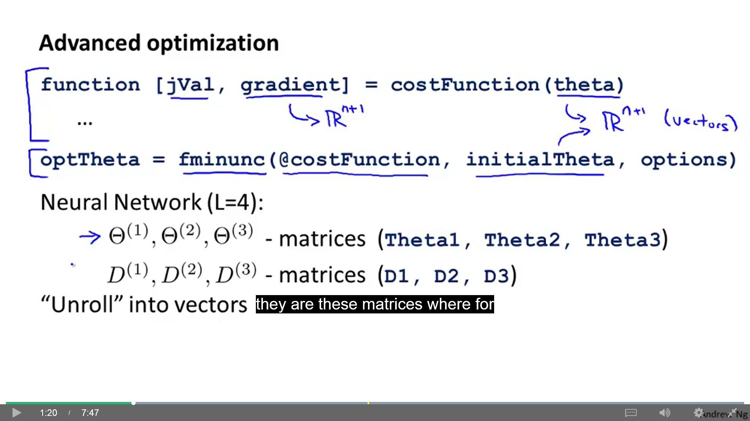

In a neural network, our parameters are matrices (not vectors). If L=4, we have:

- Parameters matrices: $Θ^{\left(1\right)},Θ^{\left(2\right)},Θ^{\left(3\right)}$ (theta1, theta2, theta3)

- Derivatives matrices (gradient): $D^{\left(1\right)},D^{\left(2\right)},D^{\left(3\right)}$ (D1, D2, D3)

We have to unroll these matrices to be able to pass them to the Octave functions.

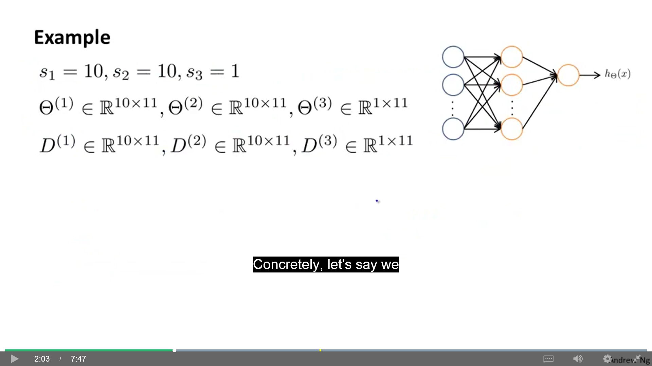

error

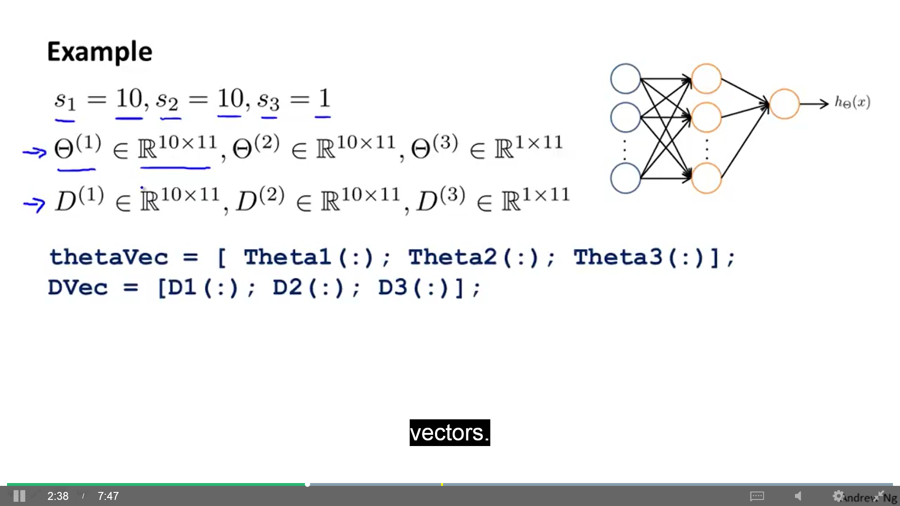To unroll these matrices we write:

Use these functions to reshape them to matrices again:

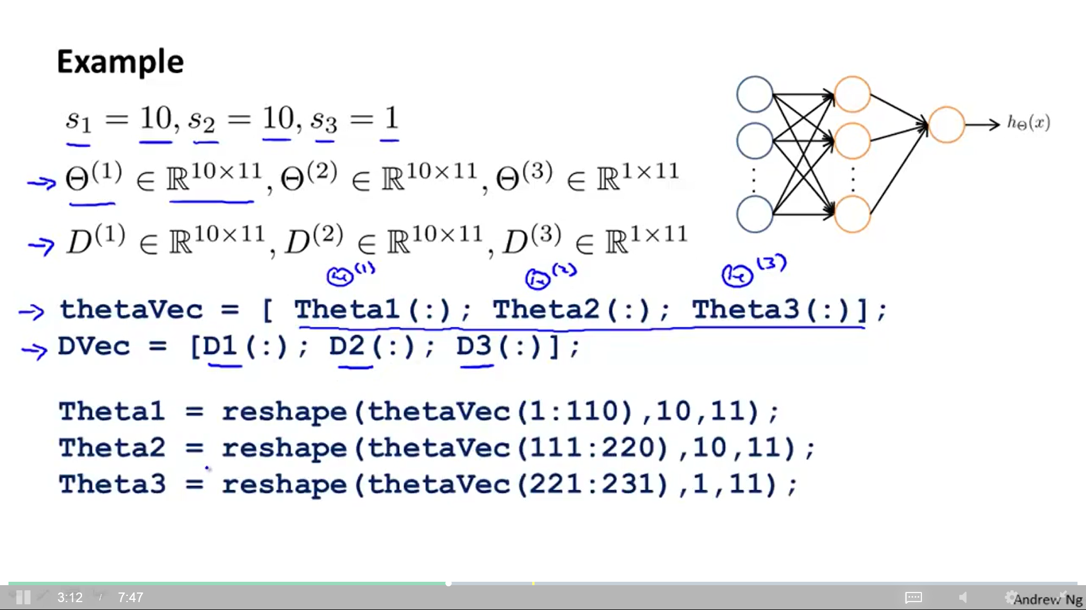

Learning algorithm steps:

1) Have initial parameters .

2) Unroll to get "initialTheta" to pass it to function "fminunc".

3) Pass that "initialTheta" to "costFunction" and

- Reshape "thetaVec" to .

- Use FP and BP to compute $D^{\left(1\right)},D^{\left(2\right)},D^{\left(3\right)}$ and .

- Unroll $D^{\left(1\right)},D^{\left(2\right)},D^{\left(3\right)}$ to get "gradientVec".

## Gradient checking

Subtle bugs may be implemented in BP but look like it's working correctly (costfunction decreases), but it's causing a worse performance. Gradient checking eliminates almost all of these problems in 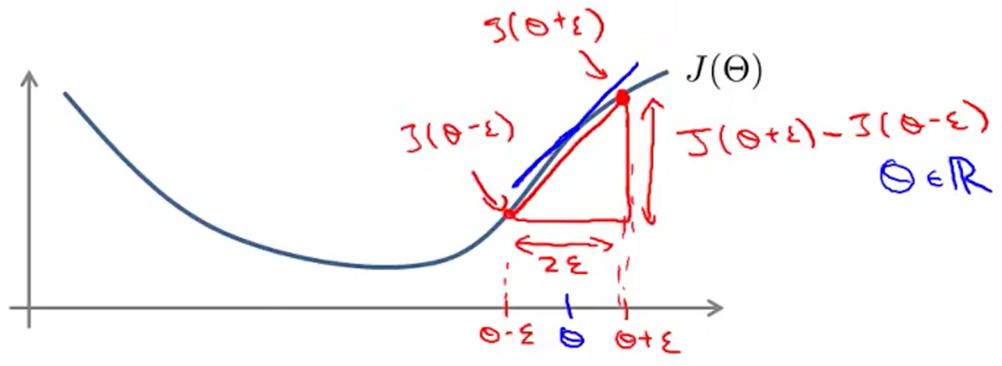BP or any similar gradient descent algorithm (on neural network or any other complex model).

Using a small value ε we can calculate an approximation of the actual derivative of a point of J(θ).

$$\frac{d}{dθ}J\left(θ\right)≈\frac{J\left(θ+ε\right)−j\left(θ−ε\right)}{2ε}$$

ε: It's a really small number. There is a large range of possible numbers (I like 10-4). But if it is too too small, we might run into numerical problems.

Implementation: **gradApprox = (J(theta + EPSILON) – J(theta – EPSILON)) / (2 * EPSILON)**

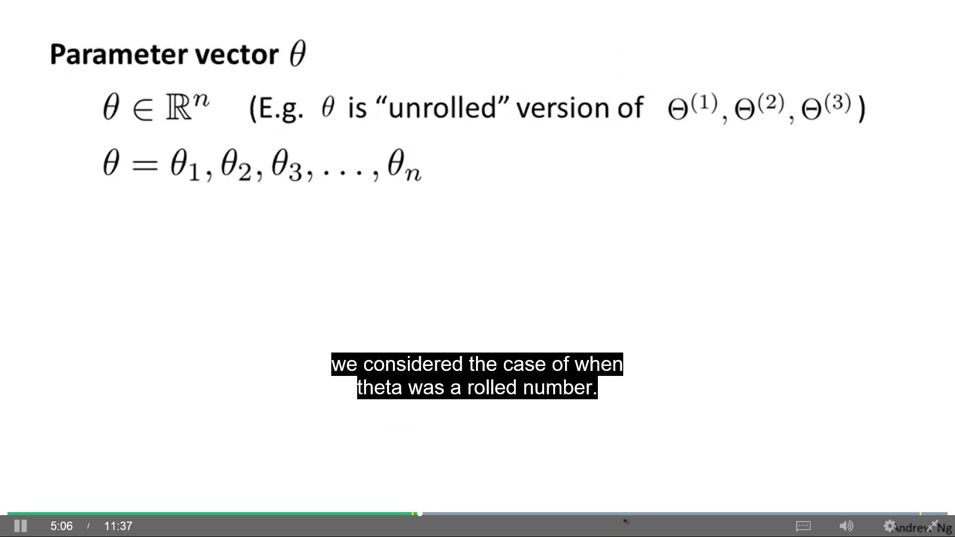In the case of a parameter vector θ:

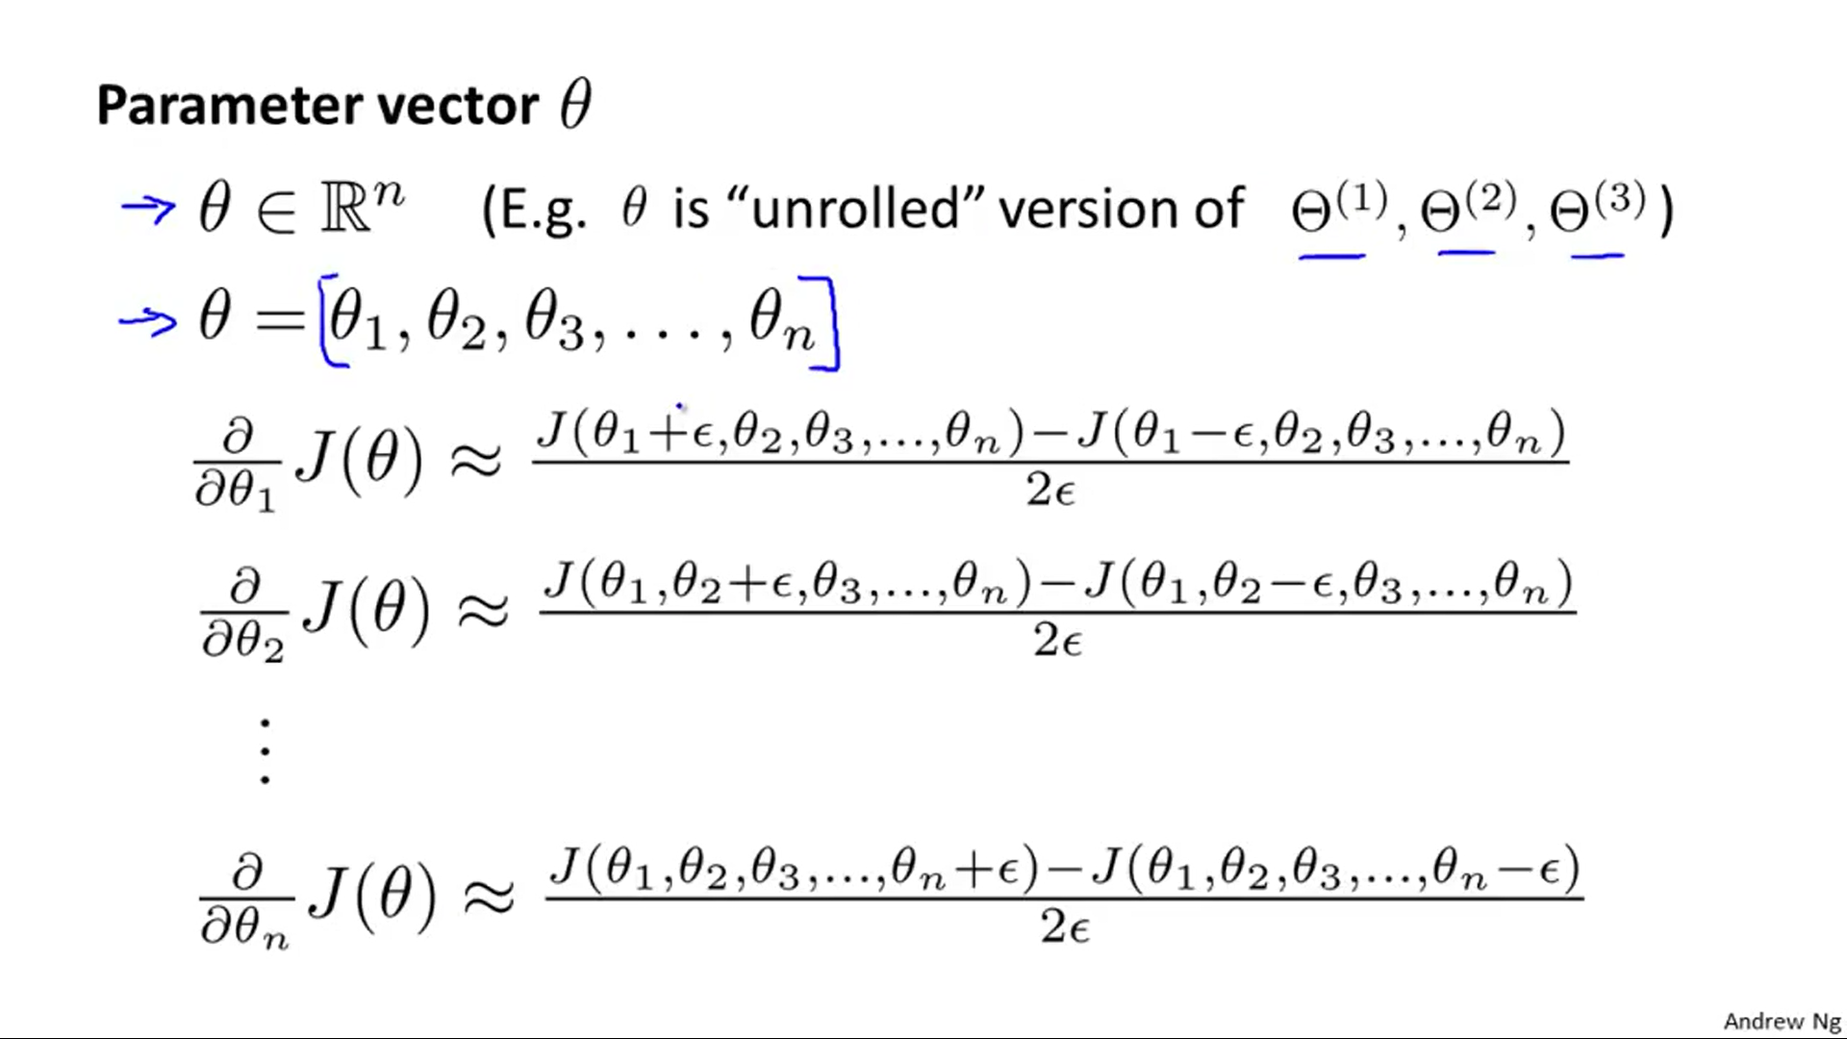

Implementation:

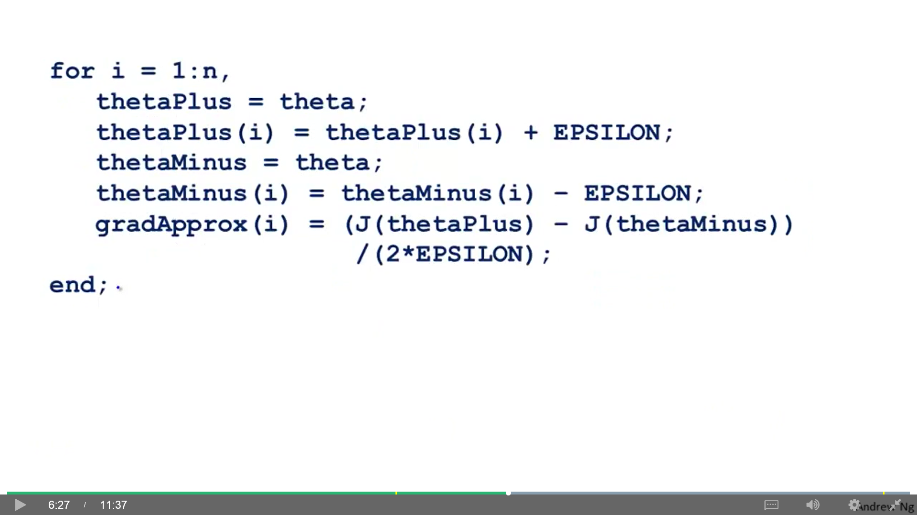

- Implement BP to compute "Dvec" (unrolled ).

- Implement numerical gradient check to compute "gradApprox".

- Make sure they give similar values. **gradApprox ≈ Dvec** (it should give a similar answer up to a few decimal places) (gives you confidence about DVec)

- Turn off gradient checking before using BP code for learning (serious training). Gradient checking is much more computationally expensive than BP.

## Random initialization

For gradient descent and advanced optimization methods we need to provide an initial value for Θ. In logistic regression it's ok to set "initialTheta" to a vector of zeros, but this doesn't work for neural networks. When we zero initialize Θ, we get:

$a_{1}^{\left(2\right)}=a_{2}^{\left(2\right)}$ $δ_{1}^{\left(2\right)}=δ_{2}^{\left(2\right)}$ $\frac{δ}{δΘ_{01}^{\left(1\right)}}J\left(Θ\right)=\frac{δ}{δΘ_{02}^{\left(1\right)}}J\left(Θ\right)$ $Θ_{01}^{\left(1\right)}=Θ_{02}^{\left(1\right)}$

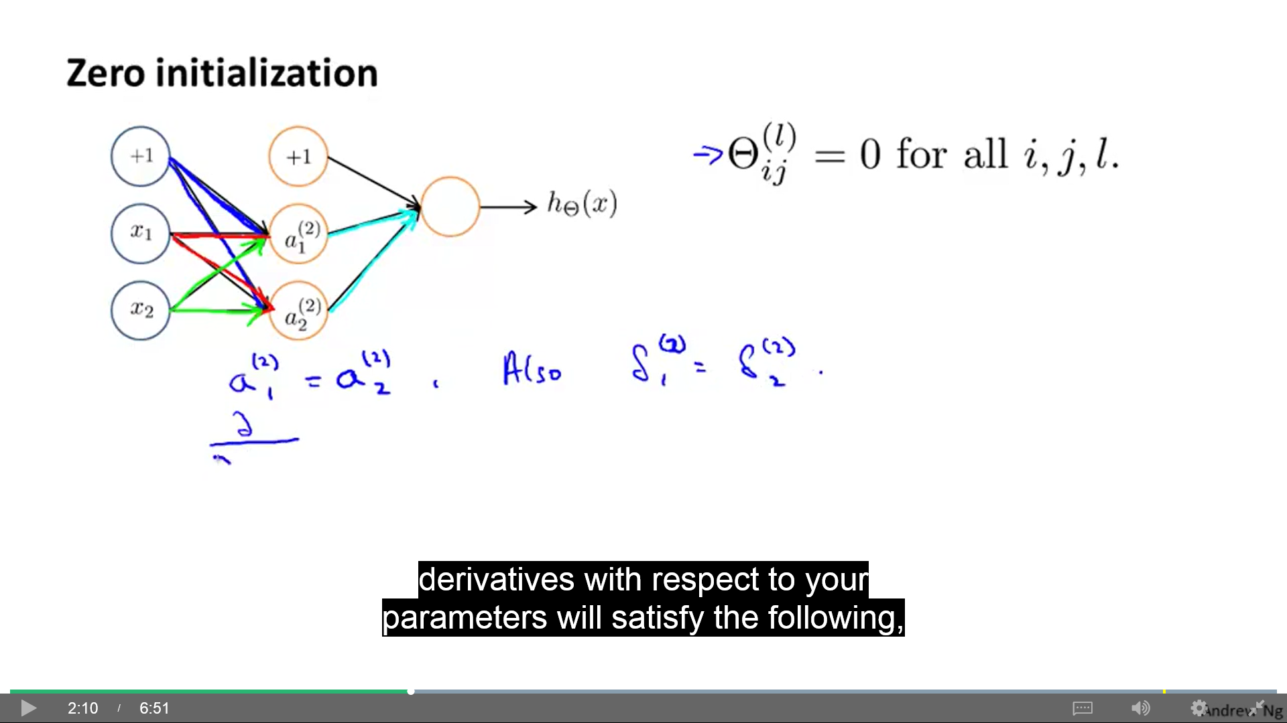The two blue (red) (green) ways (Θ) are equal to each other (the problem of symmetric ways).

After each update (iteration), parameters corresponding to inputs going into each of the two hidden units are still identical. You are back in the previous situation.

Therefore, we use Random initialization to break the symmetry. Initialize each $Θ_{IJ}^{\left(l\right)}$ to a random value in [-ε, ε].

Theta1 = rand(10,11)*(2*INIT_EPSILON) – INIT_EPSILON;

Theta2 = rand(1,11)*(2*INIT_EPSILON) – INIT_EPSILON;

One effective strategy: $ε=\frac{\sqrt{6}}{\sqrt{s_{l}+s_{l+1}}}$ sl , sl+1 : number of units in the layers adjacent to Θ(l)

## Putting all together

1) Pick a network architecture (connectivity pattern between neurons)

- Number of input units (dimension of features x(i))

- Number of output units (number of classes)

- Reasonable default:

One hidden layer (if >1 hidden layer, have same number of hidden units in every layer, usually the more the better).

Number of hidden units usually is comparable to the dimension of x (1, 2, 3 or 4 times x.)

2) Training a neural network:

- Randomly initialize weights

- Implement FP to get hΘ(x(i)) for any x(i)

- Implement code to compute cost function J(Θ)

- Implement BP to compute partial derivatives $\frac{δ}{δΘ_{jk}^{\left(l\right)}}j\left(Θ\right)$. You implement FP and BP using a for-loop over each training example (some advanced factorization methods don't use for-loop).

- Use gradient checking to compare $\frac{δ}{δΘ_{jk}^{\left(l\right)}}j\left(Θ\right)$ computed using BP vs Numerical estimate of gradient of J(Θ). Then disable gradient checking code.

- Use gradient descent or advanced optimization method with BP to try to minimize J(Θ) as a function of parameters Θ.

For neural networks, J(Θ) is non-convex and gradient descent and advanced optimization methods can be stuck in local minima. But in practice this is not a huge problem: we can't guarantee these algorithms will find global optimum but they do a good job minimizing J(Θ).

**Programming a 3 layer NN (Cost and gradient) with complete vectorization of all examples:**

Get a function with these inputs:

“parameters Θ” “input layer size” “hidden layer size” “output layer size (labels)” “X” “y” “λ”

And these outputs: “J(Θ)” “Gradients” (partial derivatives of all θ)

Calculate:

- Forward propagation:

z(2) = Θ(1)∙X' (add bias to a(1)) (a(1) = X)

a(2) = g(z(2)) (add bias to a(2))

a(3) = g(z(3))

- Cost function:

- Backpropagation:

δ(3) = a3 – y

δ(2) = (Θ(2) ' * δ(3)) .* g'(z(2)) (put out bias from Θ(2))

Δ(2) = δ(3) * a(2) '

Δ(1) = δ(2) * X

Gradient Θ(2) if j = 0 if j ≠ 0

Gradient Θ(1)

**Autonomous driving using BP:** Car sees 30x30 pixel images of what is in front of the car. A driver steers the car and the neural network takes an image and the direction of the driver every 2 seconds. After 2 minutes, it has learned to drive by the road. Car is let alone to drive, taking 12 images per second. When an intersection comes, the network confidence decreases. When a 2 lane road comes, the 2 lane network takes control.

# - Advice for machine learning -

**Machine learning diagnostic:** Test you can run to gain insight what is or isn't working with a learning algorithm, and gain guidance as to how best to improve its performance. Diagnostics can be time-consuming to implement, but doing so can be a very good use of your time. They can save you from spending a lot of time in unfruitful options.

## Evaluating an hypothesis

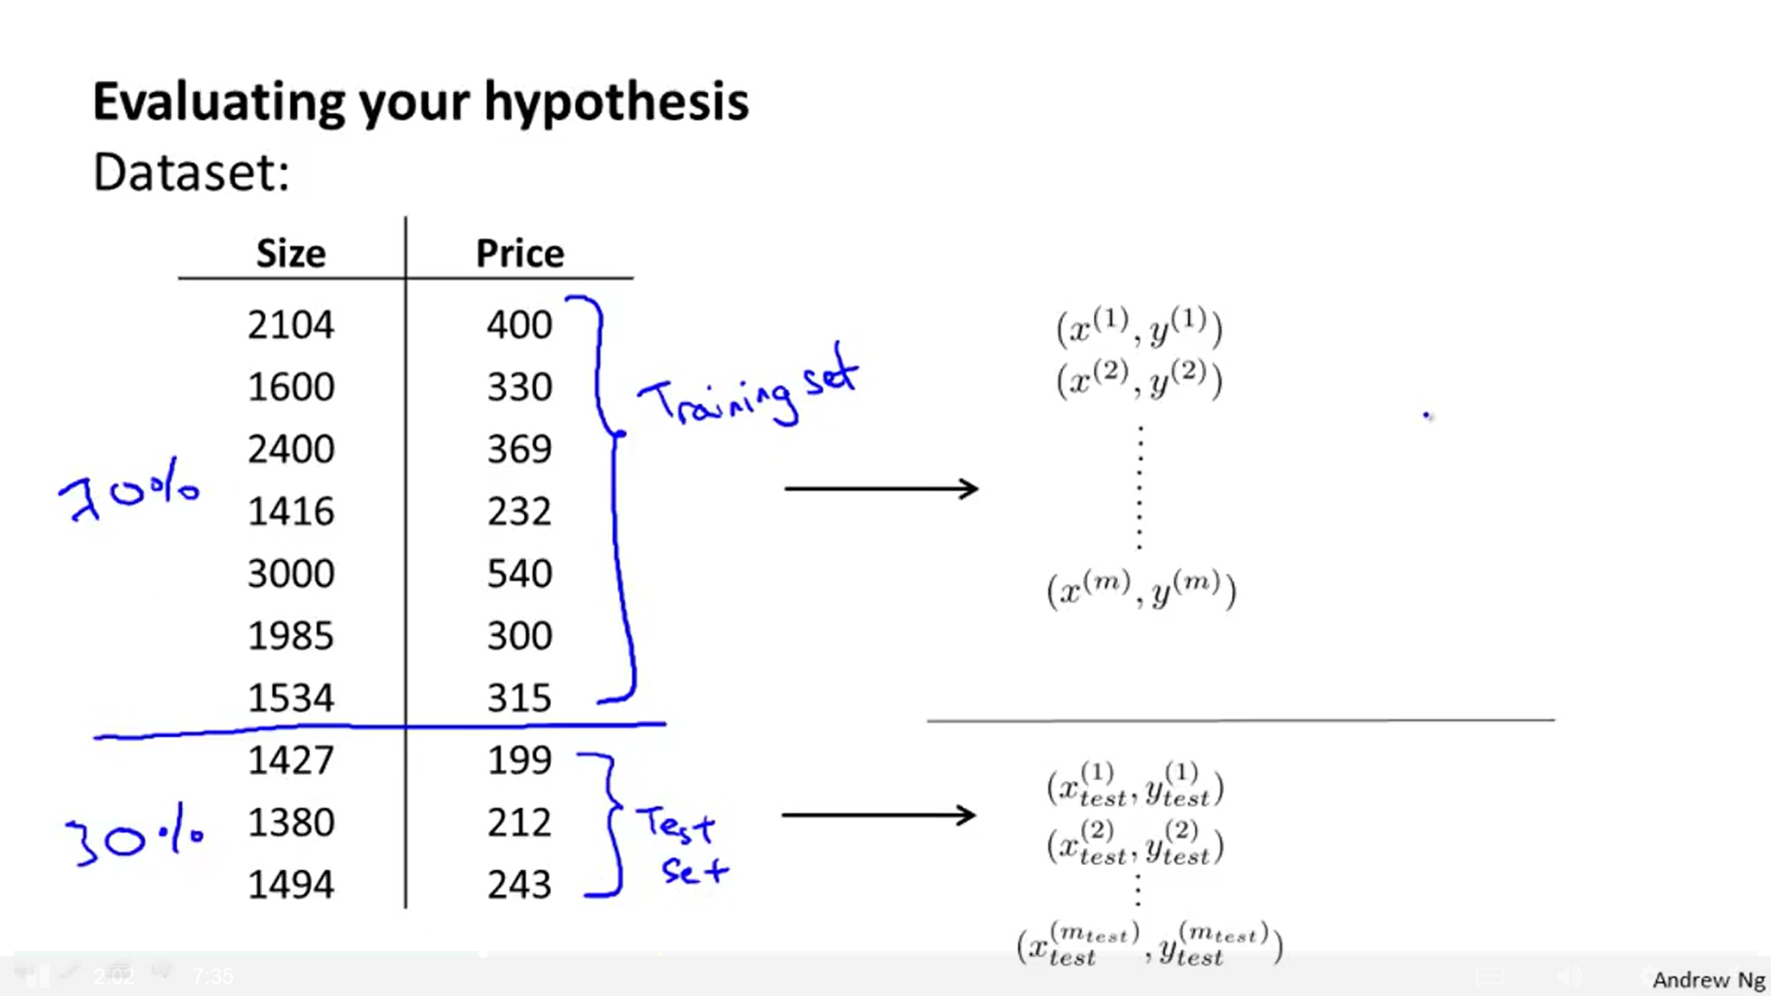When we fit the parameters, an hypothesis with a really low error doesn't mean it is a good hypothesis (overfitting). Hypothesis may fail to generalize to new examples not in the training set. How may we tell an hypothesis is overfitting?

We can split our training set in two parts: **70% training set** and **30% test set**.

mtest = Number of test examples

$\left(x_{test}^{\left(1\right)},y_{test}^{\left(1\right)}\right)$: First test example.

The order of the data should be random before the split.

If an implementation of **linear regression** (without regularization) is badly overfitting the training set, we can expect a low training error J(θ) and a high test error Jtest(θ). Steps for linear regression:

1) **Learn parameter θ** from training data (70%) by minimizing training error J(θ).

2) Compute **test set error** (30%): $J_{test}\left(θ\right)=\frac{1}{2⋅m_{test}}⋅\sum_{i=1}^{m_{test}}{{\left(h_{θ}\left(x_{test}^{\left(i\right)}\right)−y_{test}^{\left(i\right)}\right)}^{2}}$

If we are doing a classification problem (like **logistic regression**) we do this:

1) Learn parameter θ from training data.

2) Compute test error:

2) 0/1 misclassification error (alternative way): You get an example right or wrong.

$err\left(h_{θ}\left(x\right),y\right)=\left\{\begin{matrix}1 & \begin{aligned}ifh_{θ}\left(x\right)≥0.5,y=0 \\ \text{or} h_{θ}\left(x\right)<0.5,y=1\end{aligned} \\ 0 & otherwise\end{matrix}\right\}\begin{aligned}1=error \\ 0=\text{right}\end{aligned}$

$$J_{test}\left(θ\right)=\frac{1}{m_{test}}\sum_{i=1}^{m_{test}}{err}\left(h_{Θ}\left(h_{test}^{\left(i\right)}\right),y_{test}^{\left(i\right)}\right)$$

## Model selection problem

Once all parameters Θ were fit to some set of data (training set), their error as measured on that data (J(Θ)) is likely to be lower than the actual generalization error (Jtest(Θ)).

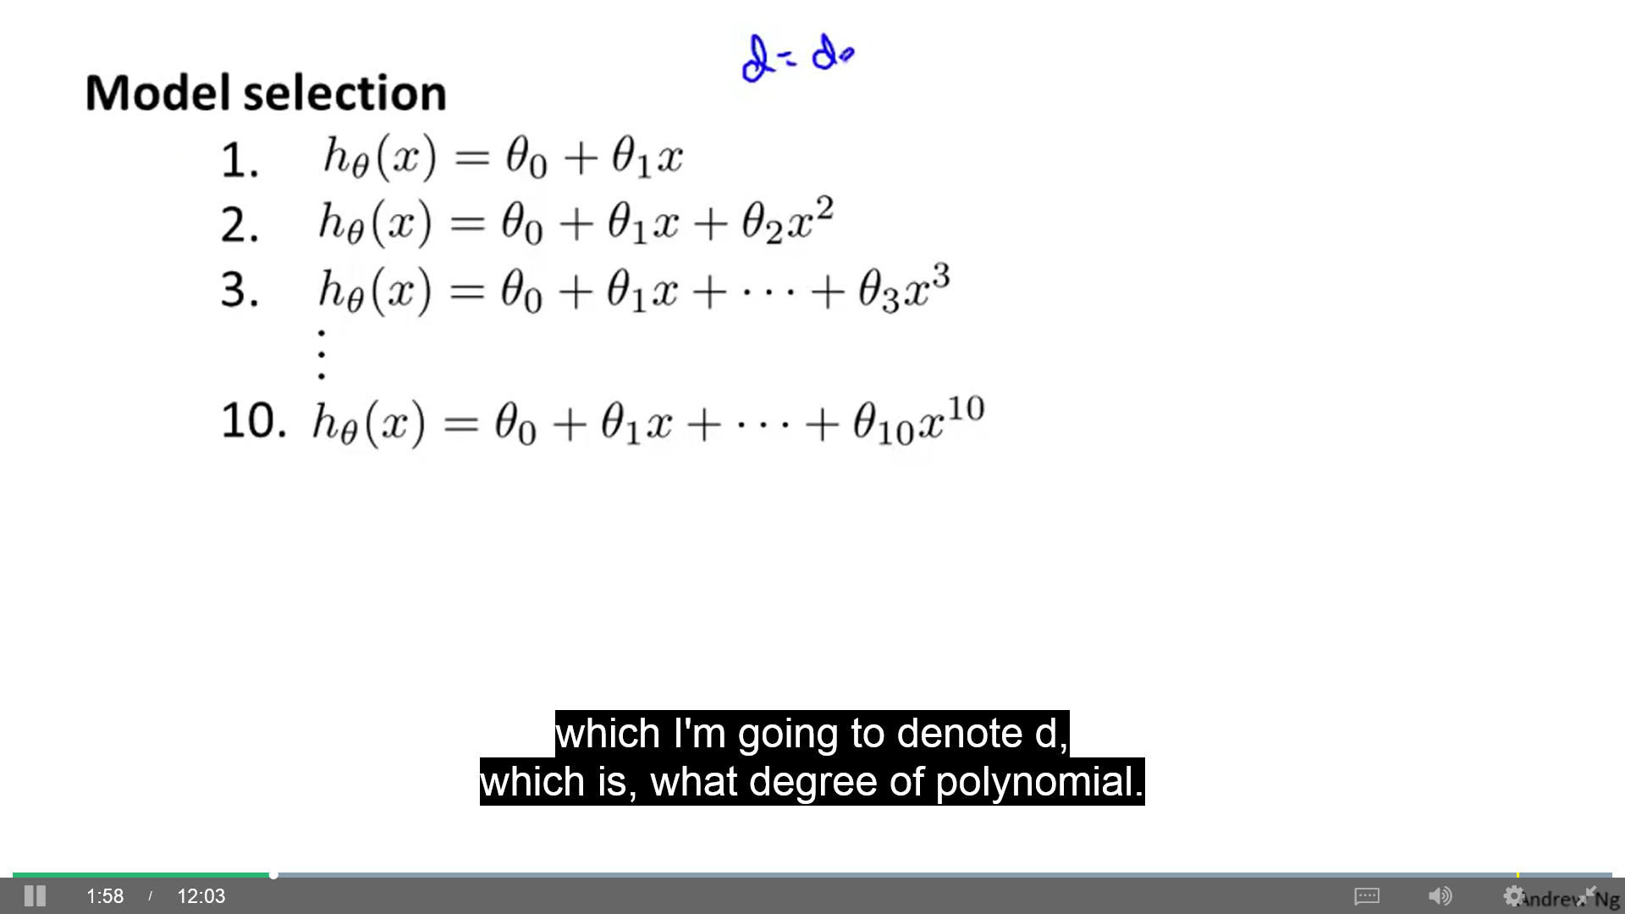**Model selection problem:** What degree polynomial should we choose to fit to data? (linear, cuadratic, cubic, ...).

d = degree of polynomial (right image has from 1 to 10).

1) Minimize training error and get Θ for every model.

2) Compute test error (cv error) for every model.

3) Choose the model with less test error (cv error).

Now, we can't use that Jtest(Θ) of our chosen model to determine how well it generalize because when we choose model **d** we are adding an extra parameter d that fits our model to our test set. The Jtest(Θ) will be over optimistic. We must use a new test set to evaluate hΘ(x). To address this problem in a model selection setting we can divide the training set into **60% training set**, **20% cross validation set**, **20% test set**. Then, we use Jtest(Θ) to select a model and Jcv(Θ) to evaluate the chosen model.

mcv = Number of cross validation examples. $\left(x_{cv}^{\left(1\right)},y_{cv}^{\left(1\right)}\right)$: First cross validation example.

## Diagnosing bias vs variance

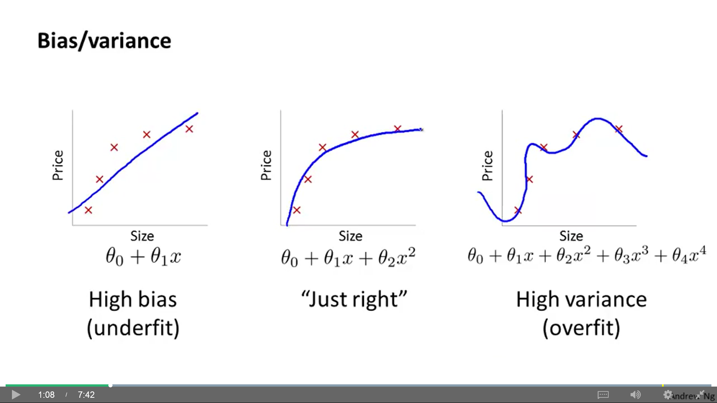If you run a learning algorithm and it doesn't do as well as you expected, almost all the time it will be because you have either high bias problem (underfit) or high variance problem (overfit). How do we figure out which one is?

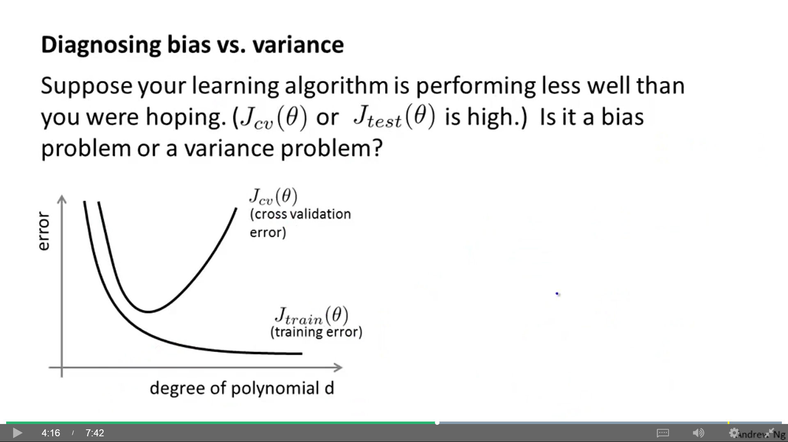As we increase **d**, our training error decreases.

As we increase **d**, our cross validation error starts high, then decreases and then goes high again.

If there is a **bias** problem, J(Θ) and Jcv(Θ) are high.

If it's a **variance** problem, J(Θ) is low and Jcv(Θ) is high (0.1, 0.3).

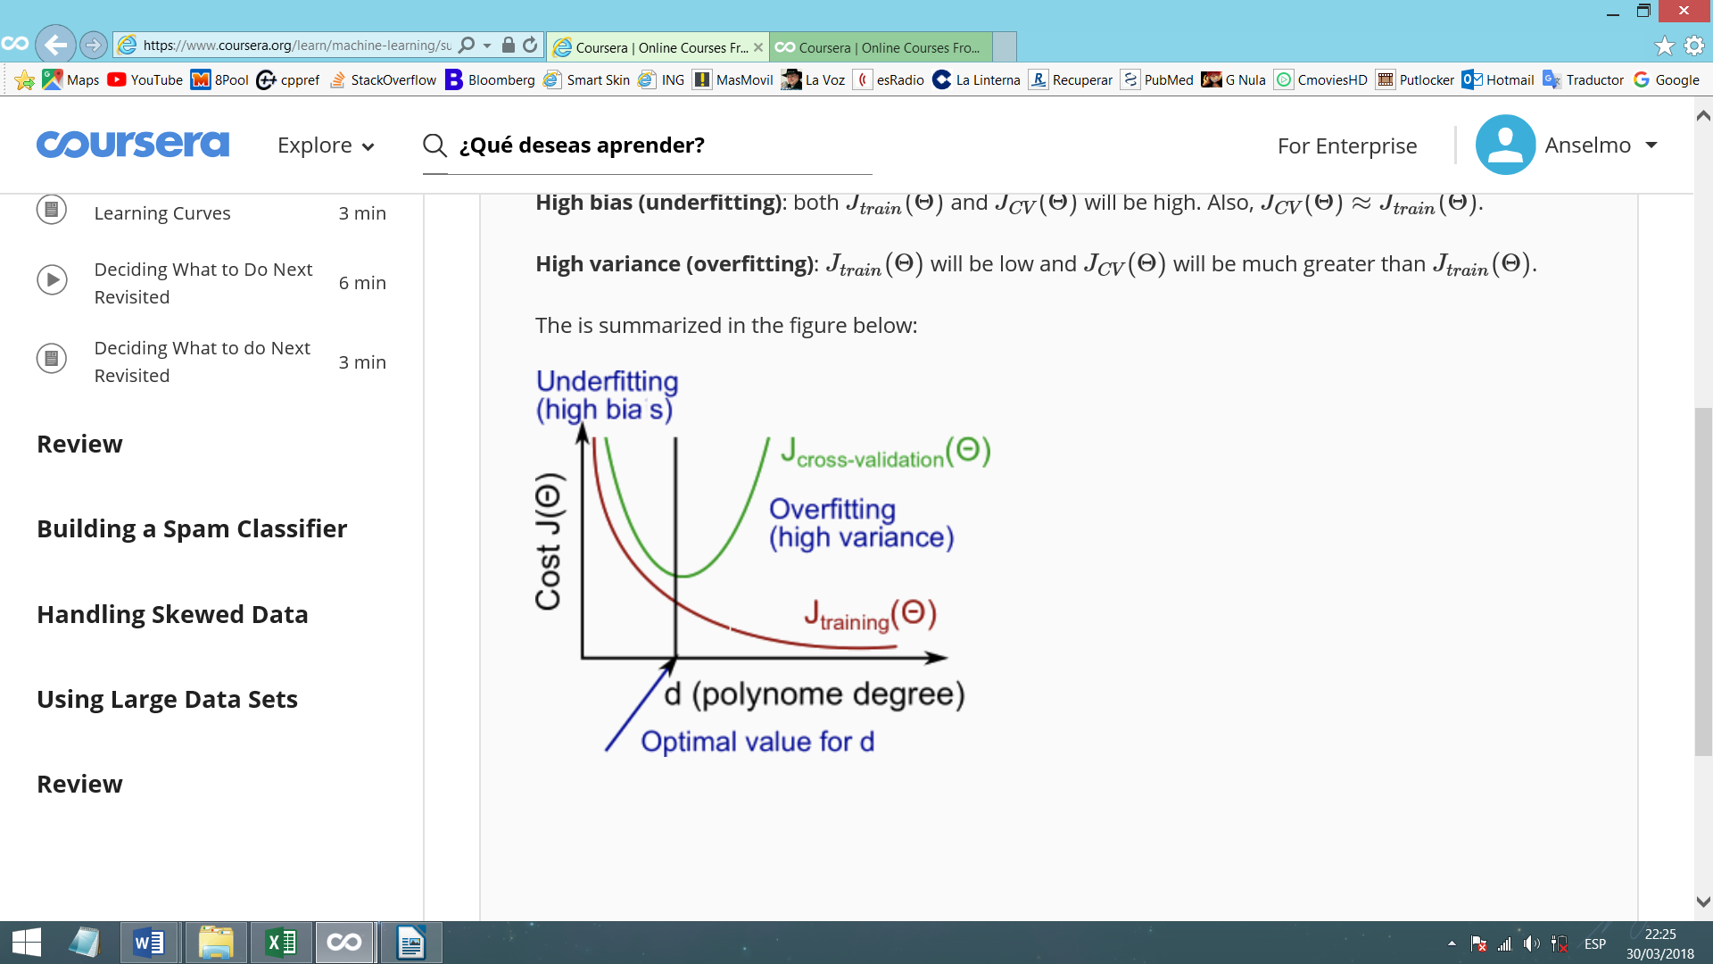Regularization can prevent overfitting. We enter an additional term (containing λ) in the cost function to keep parameters θ small.

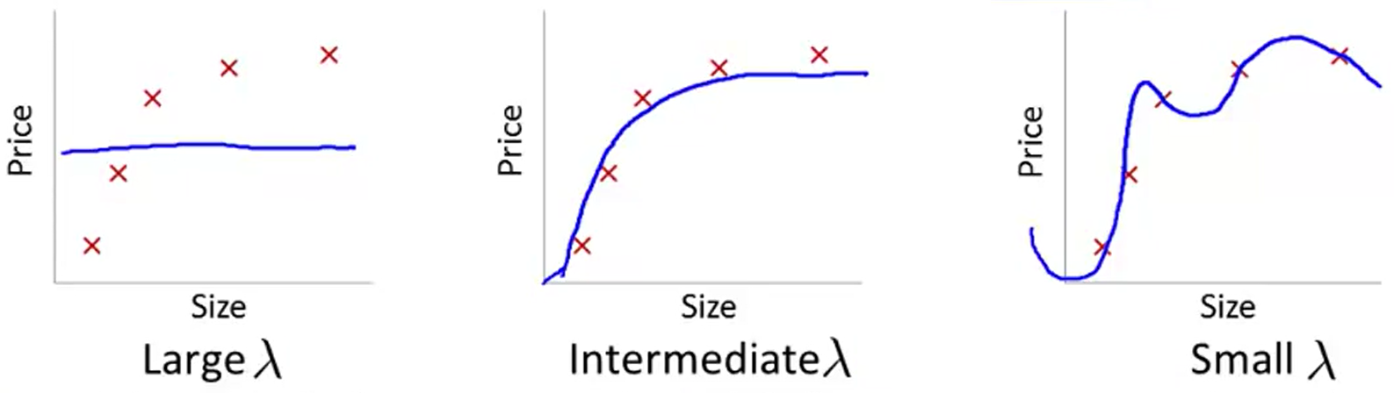

**How to automatically choose regularization parameter λ**

We define Jtrain(Θ) as the cost function of the training set, but without regularization term. Similarly, Jcv(Θ) and Jtest(Θ) don't have regularization term. We use regularization in our cost function when training our hypothesis to get the parameters θ. When computing the training set error and the cross-validation/test set error, use your cost function with a zero for λ. We want to measure the error in the hypothesis, without including any additional penalties for the θ values.

Model selection applied to selection of λ:

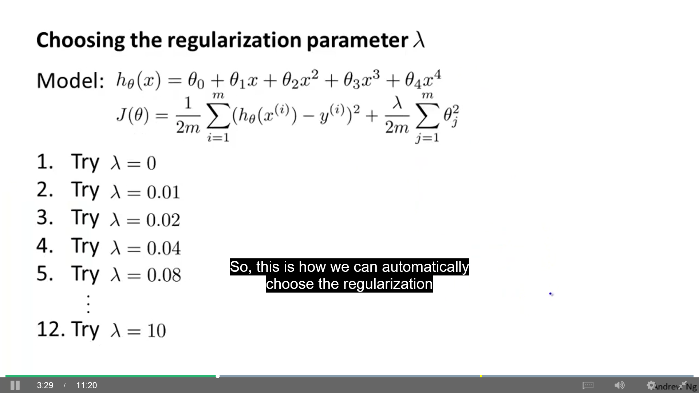1) Select a number of values for λ (Andrew usually set it up in multiples of 2) (negative values are also possible).

2) Minimize J(Θ) for every value of λ (you get different values of Θ for every λ).

3) Evaluate every hΘ(x) with the Jcv(Θ) and pick the λ of the one with lowest error.

4) To evaluate the error of the hΘ(x) with the chosen λ we use the Jtest(Θ).

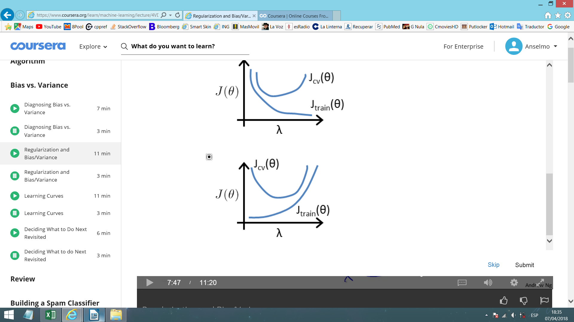How well does the hypothesis do (after learning Θ using λ) in the training set and in the cv set as you vary λ?

Jtrain(Θ): Low when λ is low (more overfitting), and high when λ is high.

Jcv(Θ): High when λ is too low or high. Intermediate value works best.

Real curves are messier and a bit noisier. Plotting this may help to verify that you are picking a good value for λ.

## Learning curve

Learning curve is useful to check that the algorithm is working correctly, improve its performance, and diagnose if it has a bias/variance problem or a bit of both (real curves are noisier and messier).

It's a plot of Jtrain(Θ) and Jcv(Θ) (or Jtest(Θ)) as a function of m (training set size). We use different m (artificially reduce training set size) to learn Θ (we can use λ) and then plot both errors (without λ).

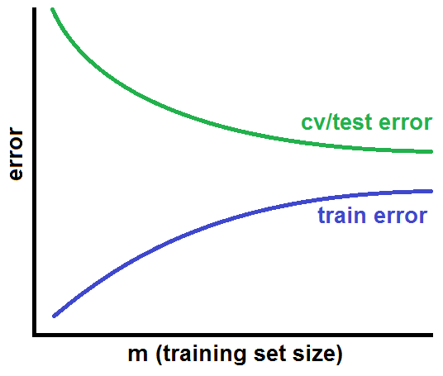**Jtrain(Θ):** With small m, hypothesis fits the data almost perfectly (perfect without regularization). When using more examples, it's harder for the hypothesis to fit all that data.

**Jcv(Θ):** When using a small training set to learn Θ, the hypothesis doesn't generalize well and then it can't fit the cv set very well. But, when using a lot of examples, hypothesis can generalize better.

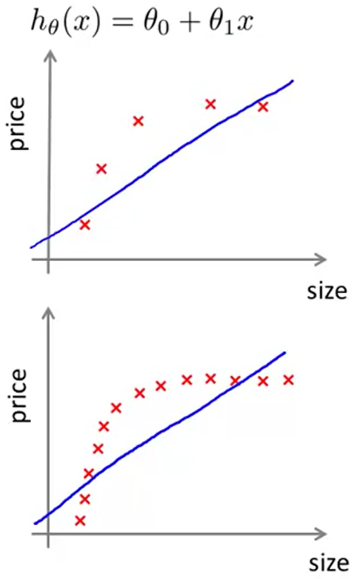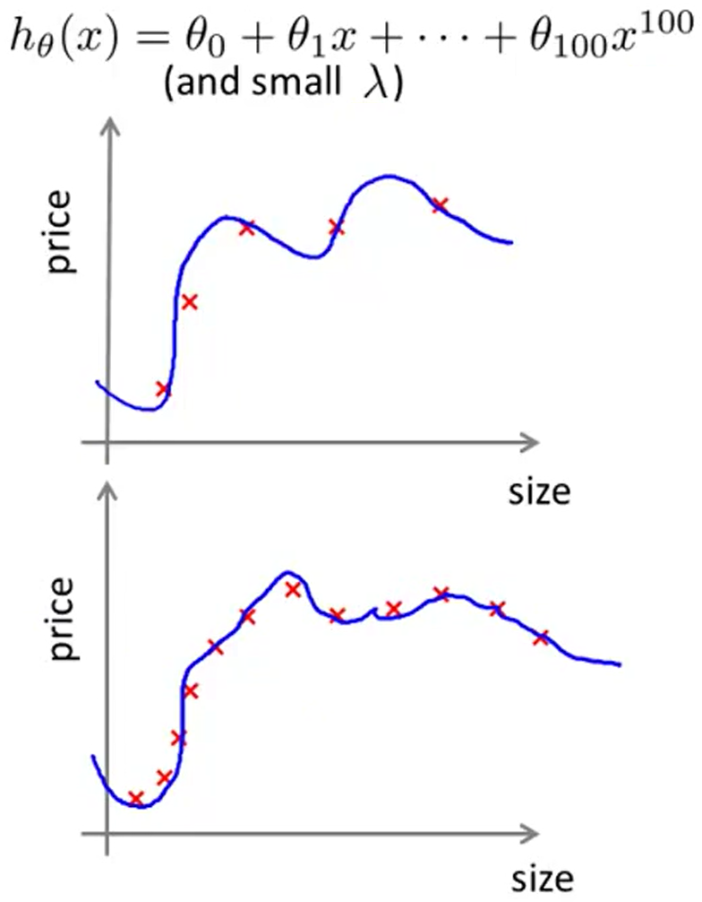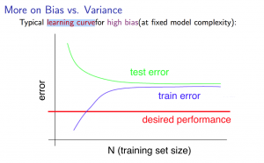**High bias:** Cv error (or test error) will flatten out pretty soon (the best possible hypothesis is reached and it can't improve the fitting). Training error will end up close to the cv error (we have so few parameters and so much data that the performance in both sets are very similar). Both error are high and similar. If a learning algorithm suffers from high bias, getting more training data will not (by itself) help much (hypothesis can't improve much).

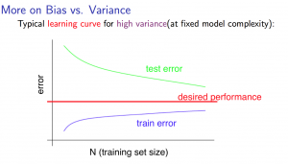**High variance:** Hypothesis can fit low m very well (low Jtrain(Θ)). It can also fit large m, but it's slightly harder to do this perfectly (bigger Jtrain(Θ), but not much). As this hypothesis is overfitting, Jcv(Θ) will be high. There is a gap between both errors. If a learning algorithm suffers from high variance, getting more training data is likely to help (gap gets smaller).

Learning curve helps you to debbug and make a good bias-variance diagnose and tradeoff.

In practice, especially for small training sets, when you plot learning curves to debug your algorithms, it's helpful to average across multiple sets of randomly selected examples to determine the training error and cross validation error.

1) Randomly select i examples from the training set and i examples from cv set.

2) Learn parameters θ using the randomly chosen training set.

3) Evaluate the parameters on the randomly chosen training set and cv set.

4) Repeat the above steps multiple times (say 50).

5) Averaged error should be used to determine the training and cv error for i examples.

## Neural network architecture

**Small NN**: Fewer parameters, more prone to underfitting, computationally cheaper.

**Large NN** (more hidden units and/or more hidden layers): More parameters, more prone to overfitting, computationally expensive.

Often, the larger, the better. Usually, using a larger NN and addressing overfitting with regularization is more efective than using a smaller NN.

Using one hidden layer is a reasonable default, but if you want to use more you can:

1) Get a train, cv and test set split.

2) Train a NN with 1, 2, 3, ... hidden layers.

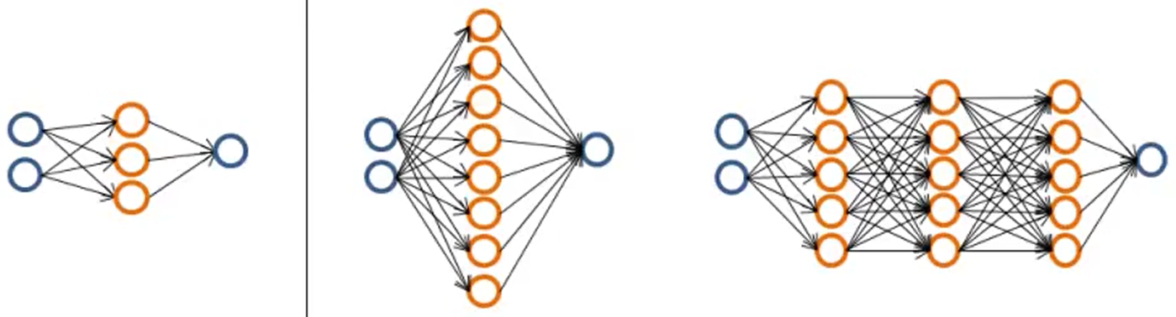3) Compute cv error on each one and pick the one with smaller error.

## Deciding what to do

Suppose we implement regularized linear regression to predict housing prices. But, when we test our hypothesis on a new set of houses, we get unacceptably large error in its predictions. Now, we may try one of the next options, but we should select the correct options (if not, we can spend a lot of time trying an option that can't help):

- **More training examples:** Fixes high variance.

- **Less features:** Fixes high variance.

- **More features:** Fixes high bias (usually, not always).

- **Adding polynomial features:** Fixes high bias.

- **Decreasing λ:** Fixes high bias.

- **Increasing λ:** Fixes high variance.

## Error analysis

In the case of a **spam classifier**, we have this training set:

x = features of email y = spam (1) or not-spam (0).

First decision: What features x can we choose in a supervised learning?

We can choose 100 words indicative of spam/not spam (deal, buy, discount, andrew, now, ...) and encode them alphabetically in a vector x. The corresponding y will have ones and zeros depending on which words appear (1) or not (0) in the email.

In practice, rather than manually pick 100 words, takes most frequently occurring n words (10.000-50.000) in training set and use those as your features.

What's the best way to make it have low error (more accuracy)?

- Collect lots of data (e.g. "Honeypot" project). As we learnt, this often help, but not always.

- More sophisticated features based on email routing information (from email header).

- More sophisticated features from message body (e.g. discount and discounts treated the same? Deal and dealer? Features about punctuation?).

- More sophisticated algorithm to detect misspellings (spam sometimes deliberatly misspell words [m0rtgage, med1cine, w4tches] to avoid spam classifiers).

While working in a machine learning problem, very often you can come up with many different features (like those before), but it's hard to guess in advance which features will be the most helpful (a team usually fixate in one of these and spend a lot of time on an unfruitful option). There are often many possible ideas for how to develop a high accuracy learning system, but don't choose by "gut feeling". Error analysis can help to sistematically make these decisions.

**Recommended approach:**

1) Start with a simple algorithm that you can implement quickly (like in one day). Implement it and test it on your cross-validation data.

2) Plot learning curves to decide if more data, more features, etc. are likely to help. This helps us to choose good options, let evidence guide our decisions.

3) **Error analysis:** Manually examine the mistakes your algorithm makes. Examine the examples (in cv set) that your algorithm made errors on. See if you spot any systematic trend/pattern in what type of examples it is making errors on. This can inspire you to design new features or how to improve the system. Make a list of possible new features to add (misspelling, email routing, unusual punctuation ...) and consider which ones worth to take into account.

We perform error analysis using cv set instead of test set because, if we develop new features by examining the test set, we may end up choosing features that work well specifically for the test set, so Jtest(Θ) is no longer a good estimate of how well generalize to new examples.

This quick implementation let you identify some errors and figure out what are the most difficult examples for an algorithm to classify (to focus your efforts on those).

**Error metrics: Numerical evaluation of the quick algorithm**

It's very helpful if you have a way of evaluating your learning algorithm that gives you back a single real number (accuracy or error). Helps to try different ideas and compare the performance.

Should discount/discounts/discounted/discounting be treated as the same word? Should we use "stemming" software (e.g. Porter stemmer) for that? This may work badly for some words (universe/university). Error analysis may not be helpful for deciding if this is likely to improve performance, so the only solution is to try it and see if it works. Here, we need numerical evaluation (e.g. cv error) of algorithm's performance with and without stemming (e.g. 3% vs 5% on cv set).

Should we distinguish uppercase/lowercase? Check it running the 2 versions (distinguishing and don’t) on the version with stemming (more correct than without, according to previous cv error).

**Error metrics for skewed classes**

In evaluation and error metrics there is a special case where is particularly tricky to come up with an appropriate error metric: skewed classes.

Example: We traing a logistic regression model hθ(x) (y=1 if cancer, y=0 otherwise). You find that you got 1% error on test set (99% accuracy). This looks a very good result. But, if we realize that only 0.5% of patients have cancer, this is not a good result. We can even ignore x and say y=0 for every patient and this will have only 0.5% error (better than the previous error!).

$Error=\frac{falsepositives+falsenegatives}{totalexamples}$ $Accuracy=\frac{truepositives+truenegatives}{totalexamples}$

**Skewed classes:** Those with many more examples from one class than from the other class. A ratio of positive and negative examples very close to one extreme. We require a different evaluation metric (one of such is Precision/Recall).

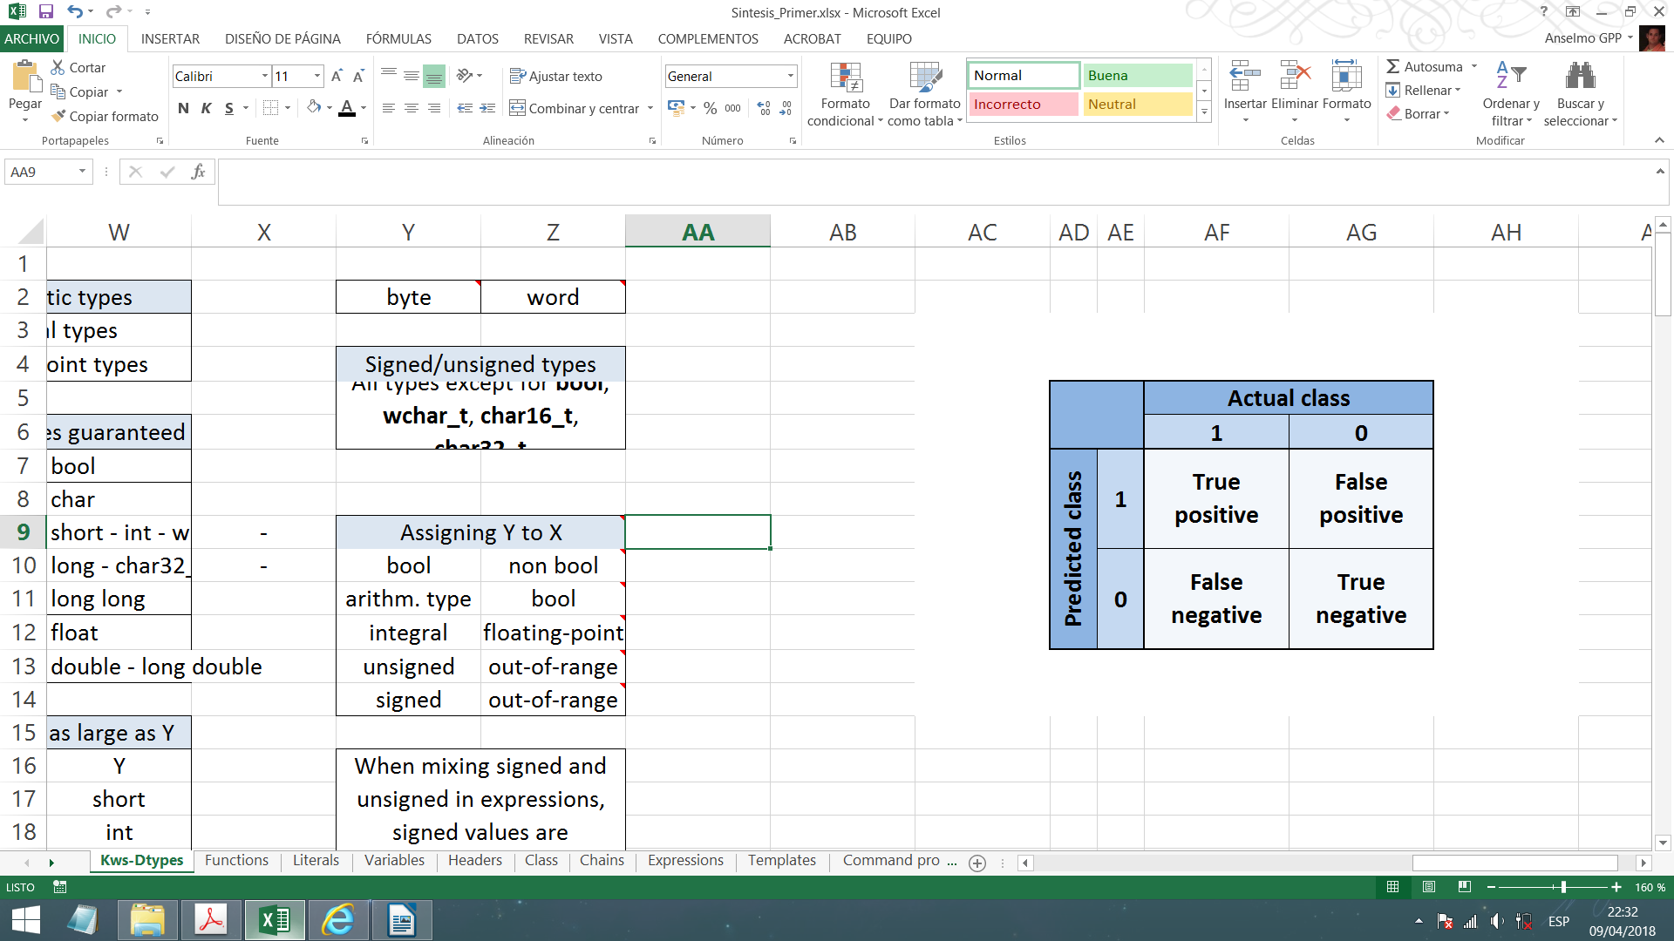**Precision/Recall:** Used to evaluate a classifier on the test set. Evaluation metric for classification problems with skewed constants. Usually gives better sense of how well our classifier is doing.

**-** Precision: Percentage of success in our predictions. Of all patients where we predicted y=1, what fraction actually has cancer?

- Recall: Percentage of success in reality (the actual class). Of all patients that actually have cancer, what fraction did we correctly detect as having cancer?

$$\frac{Truepositives}{Actualpositives}=\frac{Truepositives}{Truepos.+False\text{neg.}}$$

As a convention, we take y=1 in presence of the more rare class we want to detect (cancer, ...).

The higher the precision and the recall for a classifier, the better the classifier is. Precision/recall can't be cheated by algorithms that predict y=0 all the time or y=1 all the time.

Always y=0: Precision/recall=0. Always y=1: Precision=Near 0. Recall=1

**Trading-off Precision and Recall**

In a logistic regression where 0 ≤ hθ(x) ≤ 1, we can predict 1 if hθ(x)≥0.5 and predict 0 if hθ(x)<0.5. Here, the threshold is 0.5. So, we predict 1 if hθ(x) ≥ threshold.

- Suppose we want to predict y=1 (cancer) only if very confident. We increase the threshold (>0.5) and we obtain higher precision and lower recall.

- Suppose we want to avoid too many cases of cancer (avoid false negatives). We reduce the threshold (<0.5) and we obtain lower precision and higher recall.

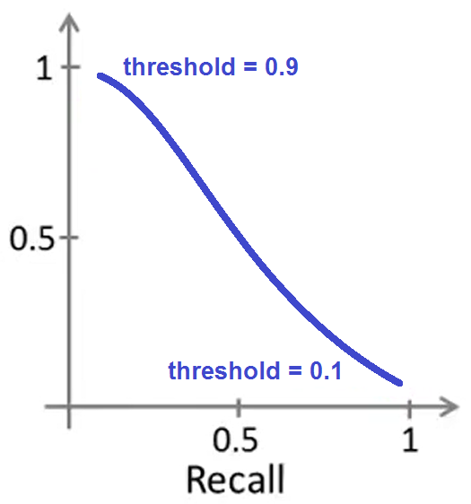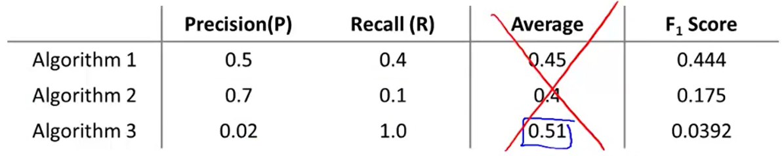How to choose this threshold automatically? We must know how to compare precision/recall numbers. We do so by using the **F1 score**:

Algorithm 3 predicts y=1 all the time (low threshold). Algorithm 2 has high threshold.

If P or R (or both) is 0, then F1 score is 0. If both are 1, then F1 is 1. To be large, both P and R must be large. There are many more formulas for combining P and R, but F1 score is traditionally used.

By varying the threshold, we control a trade-off between P and R. For a range of different values of threshold parameters, get different values of P and R in the **cv set** and choose the value of threshold that maximizes the F1 score.

## Large data sets

The more datayou use to train your algorithm, the more accuracy it will have. Even an "inferior algorithm" can beat a "superior algorithm" if it's trained with enought data. It's not who has the best algorithm that wins, it's who has the most data. But a large training set can't help if the **input x haven't got sufficient information** to predict y accurately. Given the input x, can a human expert confidently predict y? Given only the size of a house, an expert can't predict its price.

Using a learning algorithm with **many parameters** (e.g. logistic regression or linear regression with many features, neural network with many hidden units) we get low bias algorithm and small Jtrain(θ). And by using a **large training set**, that algorithm will be unlikely to overfit and Jtrain(θ) ≈ Jtest(θ) (low variance). The result is small Jtest(θ). To have a high performance learning algorithm we want not to have high bias or high variance, and these are the key ingredients:

To reduce bias > x have sufficient information + Many parameters

To reduce variance > Large training set.

# - Support Vector Machines -

## Optimization objective (cost function)

The performance of many learning algorithms is usually very similar. There are other things more important than the algorithm choosing (amount of data, features, regularization parameter ...). But there is a very powerful and widely used supervised algorithm: Support Vector Machine (SVM).

**Logistic regression:**

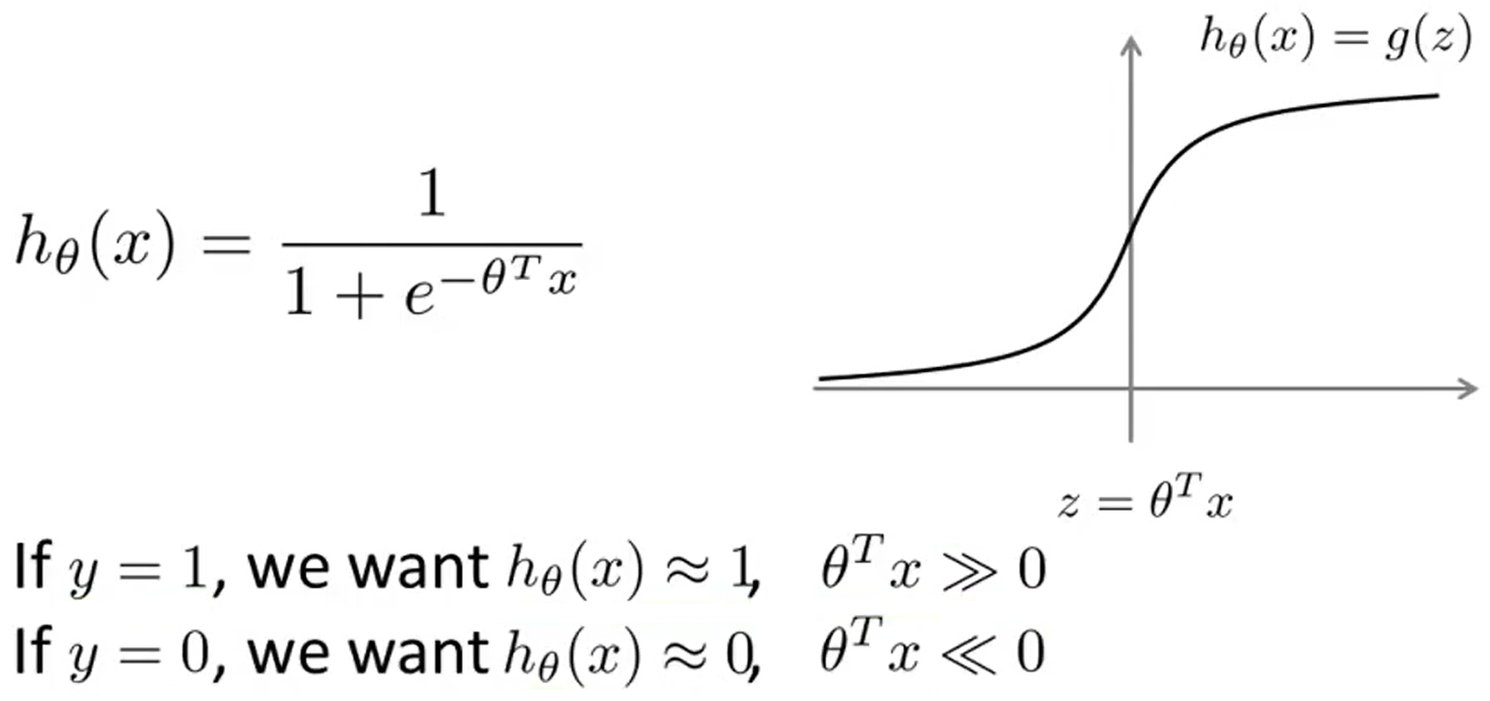

**Contribution of every example (x(i), y(i)) to the cost function:**

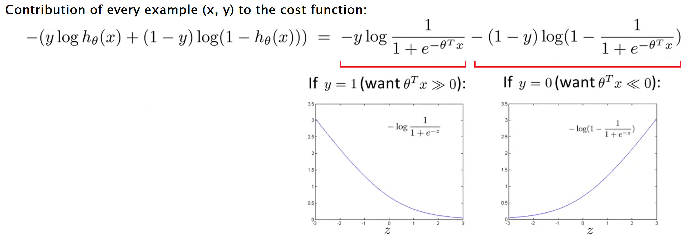When y=1, cost function is $−log\frac{1}{1+e^{−z}}$. When y=0, cost function is $−log\left(1−\frac{1}{1+e^{−z}}\right)$.

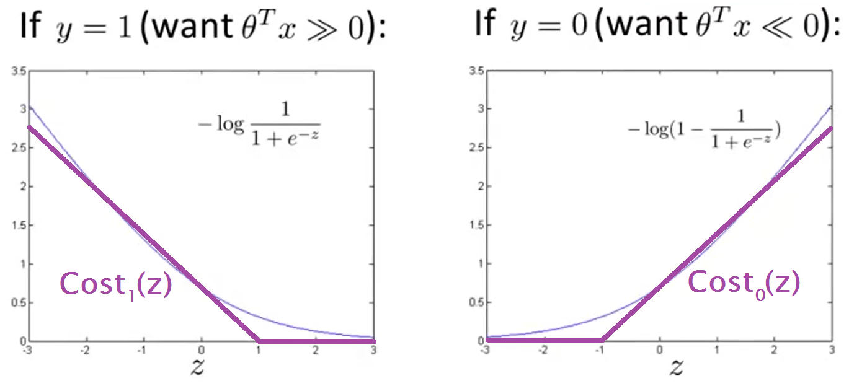**Building Support Vector Machine:**

We are going to change the cost function when y=1 and the cost function when y=0. This will give computational advantages and easier optimization.

- Logistic regression J(Θ):

- Support Vector Machine J(Θ):

- Removing m:

Example: $\min_{u}\left(10{\left(u−5\right)}^{2}+1\right)$ $u=5$

$\min_{u}\left(10{\left(u−5\right)}^{2}+1\right)⋅10$ $u=5$

Conclusion: Multiplying an expression we want to minimize by a constant doesn't change the result. So, by multiplying minθJ(θ) by m we can remove m and the result won't change.

- Another convention for expressing J(θ):

Until now, J(θ) was expressed as (**A + λB**). Here, increasing λ gives higher weight to B.

Now we use a different kind of regularization parameter and J(θ) will be (**CA + B**). Here, decreasing C gives higher weight to B. C is not the same as λ, but, if $C=\frac{1}{λ}$, then the result is the same in both kind of J(θ).

- Final optimization objective function for SVM:

$$\min_{θ}C\left[\sum_{i=1}^{m}{y^{\left(i\right)}}⋅{cost}_{1}\left(θ^{T}x^{\left(i\right)}\right)+\left(1−y^{\left(i\right)}\right)⋅{cost}_{0}\left(θ^{T}x^{\left(i\right)}\right)\right]+\frac{1}{2}\sum_{j=1}^{n}{θ_{j}^{2}}$$

After learning θ with this J(θ), the SVM hypothesis only outputs 1 or 0: $h_{θ}\left(x\right)\left\{\begin{aligned}1 \\ 0\end{aligned}\right.\begin{aligned}ifθ^{T}x≥0 \\ ifθ^{T}x<0\end{aligned}$

## Large margin intuition (SVM)

**Value of z**

If y=1, we want θTx ≥ 1 (not just ≥ 0) to make cost1(z)=0 (and, therefore, J(θ)=0).

If y=0, we want θTx ≤ -1 (not just < 0) to make cost0(z)=0 (and, therefore, J(θ)=0).

Classic logistic regression wants θTx ≥ 0 or θTx ≤ 0. But SVM adds this extra safety margin factor.

**SMV decision boundary**

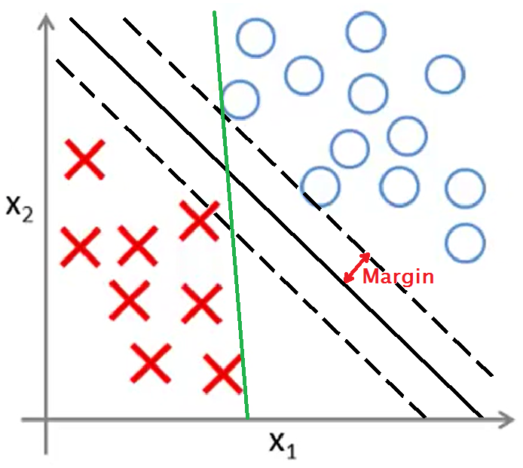If we make C very large, the optimization objective that C is multiplying becomes very close to 0. Also, if y(i)=1 and θTx(i) ≥ 1, or y(i)=0 and θTx(i) ≤ -1, the optimization objective becomes 0. In both cases, the J(θ) we have to minimize is:

$$\min_{θ}\frac{1}{2}\sum_{i=1}^{n}{θ_{j}^{2}}$$

When you minimize this, you get an interesting **decision boundary**. In a linearly separable case (the picture), there are many possible lines that can separate both kind of examples (many of them don't look very good, like the green). But SVM uses a line (black) that separates the examples keeping a margin between itself and the examples (larger margin possible). So, the SVM looks better. That's why SVM is called **Large Margin Classifier**.

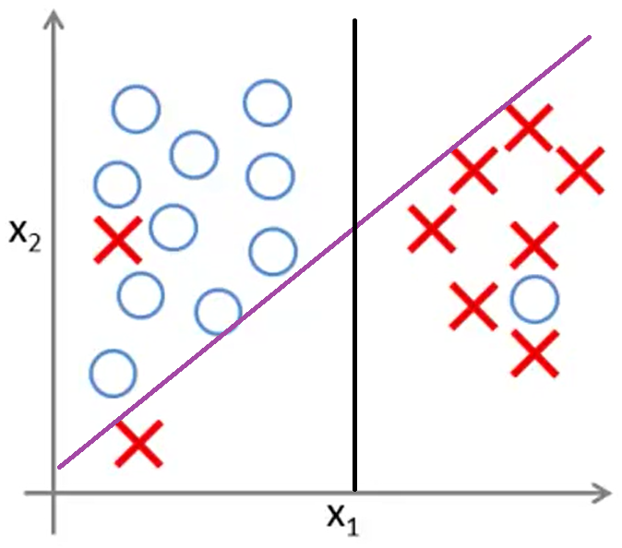

In the presence of **outliers**, if we have big C, the line will fit the outliers (purple line). If we have small C, then the decision boundary will be more regular, omitting the examples that worth less attention (black line). Remember: C is similar to 1/λ.

If the data is not linearly separable (some positive examples in the middle of the negative examples, and vice versa), the SVM will still do right/reasonable things.

## Mathematics behind Large Margin Classification

**Vector inner product**

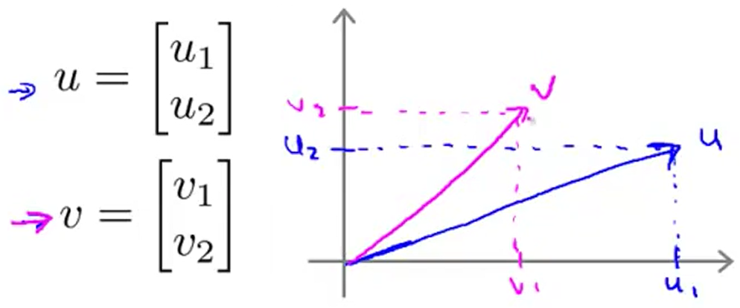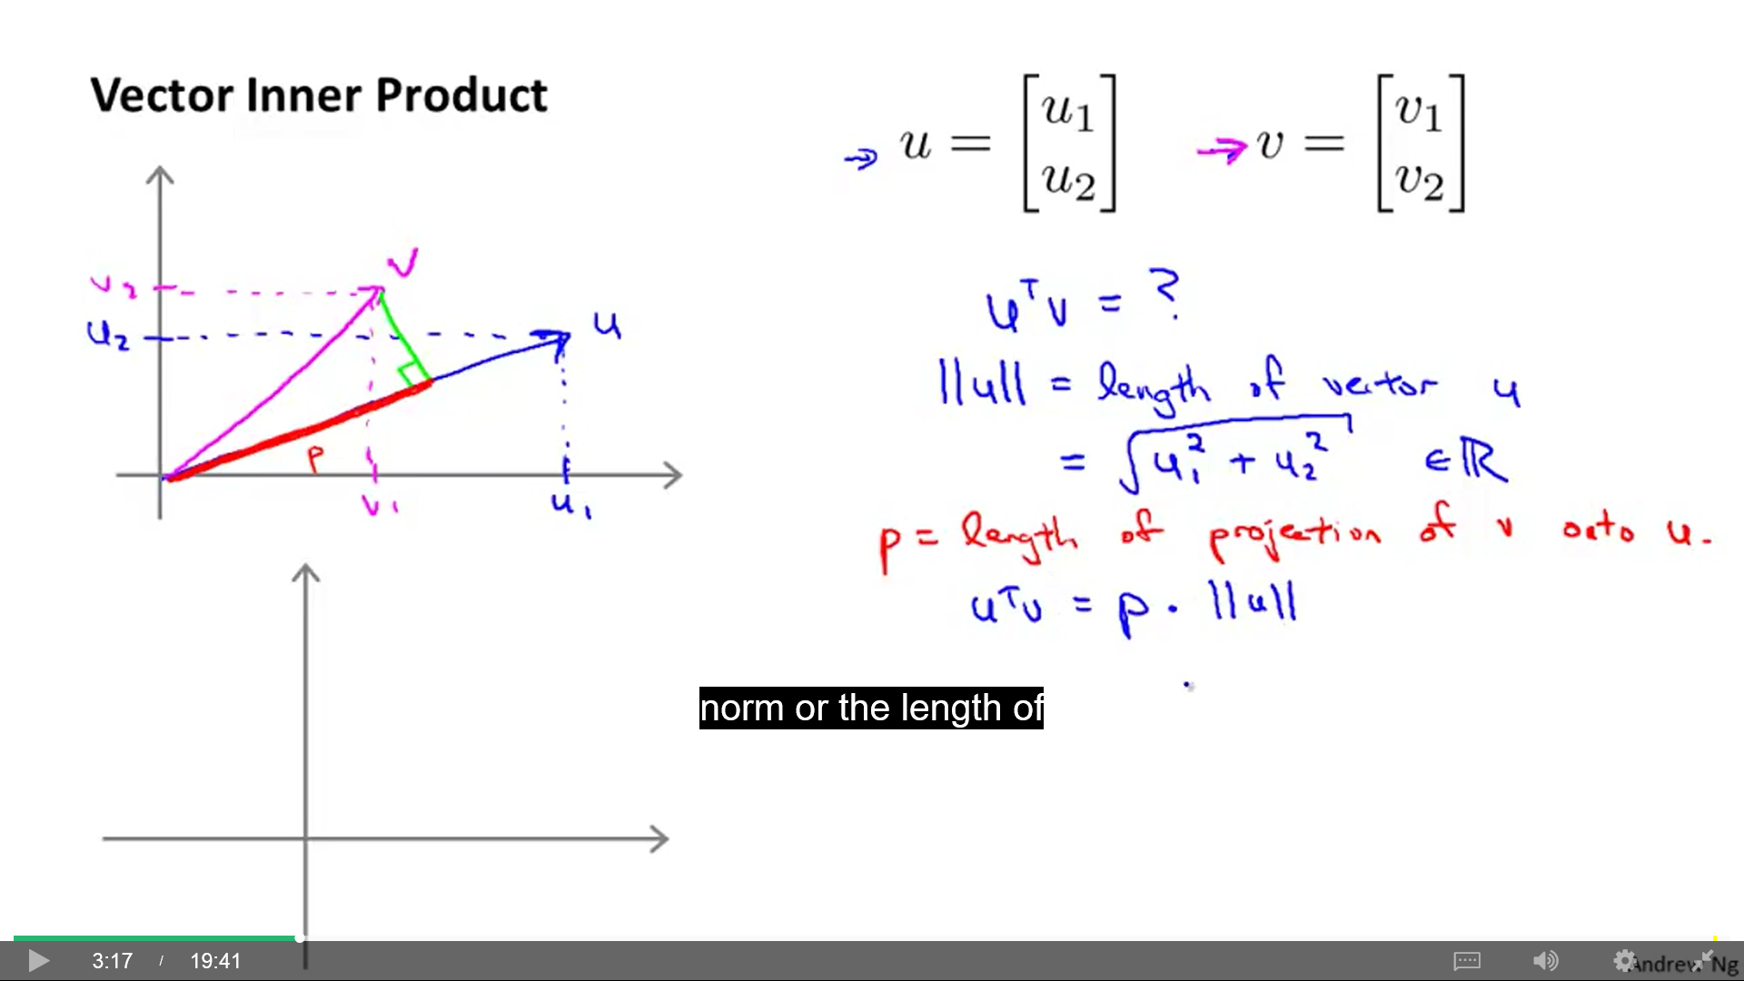

Inner product: $u^{T}⋅v=u_{1}v_{1}+u_{2}v_{2}$ = $p⋅\text{||}u\text{||}$

$\text{||}u\text{||}=\sqrt{u_{1}^{2}+u_{2}^{2}}$ = Length (norm) of vector u

p: Length of the projection of vector v onto vector u (or its extension [then p would be neg.]).

$v^{T}⋅u=p⋅\text{||}v\text{||}$ where p is the projection of u onto v. $u^{T}⋅v=v^{T}⋅u$

**SVM decision boundary**

For simplification, lets suppose Θ0=0 and n=2.

$$\min_{θ}\frac{1}{2}\sum_{i=1}^{n}{θ_{j}^{2}}=\frac{1}{2}\left(Θ_{1}^{2}+Θ_{2}^{2}\right)=\frac{1}{2}{\left(\sqrt{Θ_{1}^{2}+Θ_{2}^{2}}\right)}^{2}=\frac{1}{2}\text{||}u{\text{||}}^{2}$$

s.t. θTx(i) ≥ 1 if y(i)=1 (s.t.: subjec to)

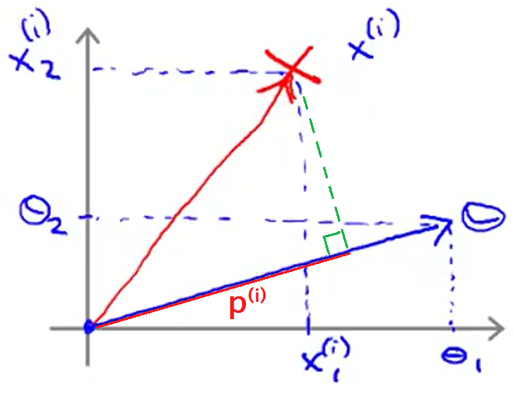θTx(i) ≤ -1 if y(i)=0

We can plot θ and x as vectors.

θT·x (equivalent to uT·v) is the projection of vector x onto vector θ (p(i)).

Now, we can rewrite our previous cost function:

(θ0 = 0)

s.t. p(i)·||θ|| ≥ 1 if y(i)=1 (p(i): proyection of x(i) onto vector θ)

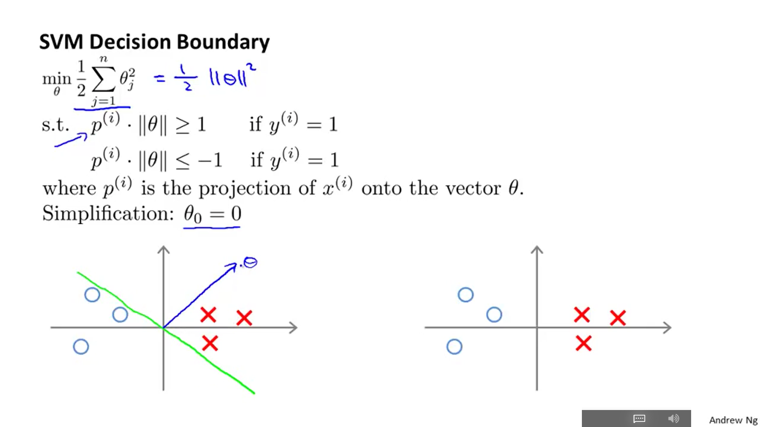 p(i)·||θ|| ≤ -1 if y(i)=0

Facts:

1) θ0 = 0 means that the decision boundary passes through the origin (0, 0).

2) Vector θ is perpendicular to the decision boundary.

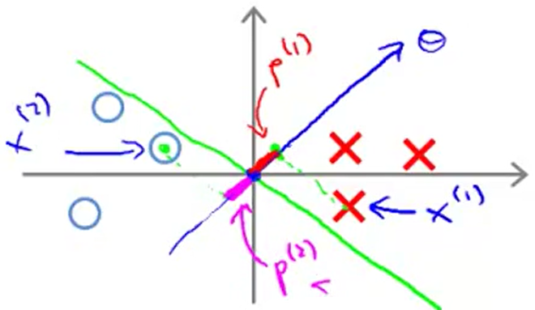The projections (p(i)) of the examples (x1, x2) onto θ will be pretty small. Then, θ must be very large. Remember:

p(i)·||θ|| ≥ 1 p(i)·||θ|| ≤ -1

But, what we do in the optimization objective is trying to find a set of parameters where θ is small. So this decision boundary (green line) has a direction of θ that is not the most convenient.

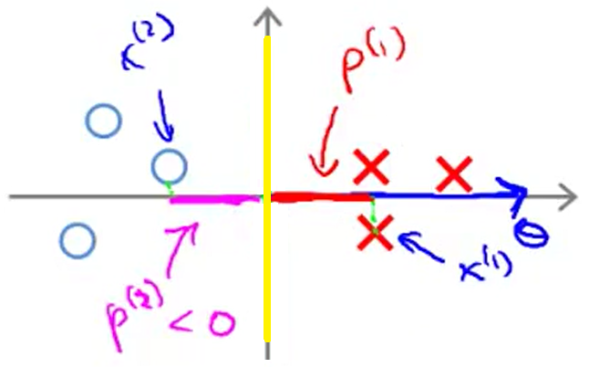This other boundary (yellow line) makes the projections p(i) bigger and, therefore, θ is smaller.

This is how SVM, by choosing this decision boundary, makes the large margin classification effect. We want the projections of the examples to be large, so the boundary is surrounded by a margin, whose length is p1, p2, p3, etc. By making θ length smaller, the values of p(i) are bigger.

## Kernels

**Kernel functions**

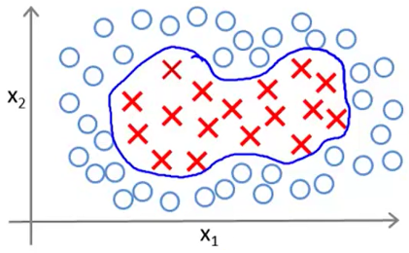Kernels: Technique used to adapt SVM to complex non-linear classifiers.

To find a non-linear decision boundary we come up with a set of non-polynomial features. Example:

Predict y=1 if

$$θ_{0}+θ_{1}x_{1}+θ_{2}x_{2}+θ_{3}x_{1}x_{2}+θ_{4}x_{1}^{2}+θ_{5}x_{2}^{2}+…≥0$$

Predict y=0 otherwise

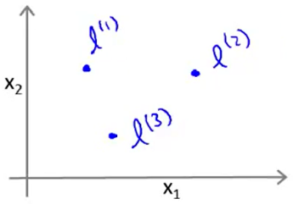Using higher order polynomials becomes very computationally expensive.

New notation: $f_{1}=x_{1},f_{2}=x_{2},f_{3}=x_{1}x_{2},f_{4}=x_{1}^{2},f_{5}=x_{2}^{2},…$

How can we define this new **f features**? Given x, we will take some points l(i) (**landmarks**) and define “similarity functions” that define the similarity of x to a certain landmark l(i). These functions are **Kernel functions** (concretely, **Gaussian Kernel**). So, given x, we have:

$f_{1}=k\left(x,l^{\left(1\right)}\right)=exp\left(\frac{−{\left\|\left.x−l^{\left(1\right)}\right\|\right.}^{2}}{2σ^{2}}\right)=exp\left(\frac{\sum_{j=1}^{n}{{\left(x_{j}−l_{j}^{\left(1\right)}\right)}^{2}}}{2σ^{2}}\right)$ ( exp(a): e to the power of a )

$f_{2}=k\left(x,l^{\left(2\right)}\right)=exp\left(\frac{−{\left\|\left.x−l^{\left(2\right)}\right\|\right.}^{2}}{2σ^{2}}\right)=exp\left(\frac{\sum_{j=1}^{n}{{\left(x_{j}−l_{j}^{\left(2\right)}\right)}^{2}}}{2σ^{2}}\right)$

$$f_{3}=…$$

For simplification, we are ignoring x0 (x0=0).

If x ≈ l(1) :

If x is far from l(1) :

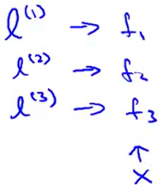So, if difference is small, k tends to 1. If difference is big, k tends to 0.

Each of the landmarks (l(1), l(2), l(3)) defines a new feature (f1, f2, f3).

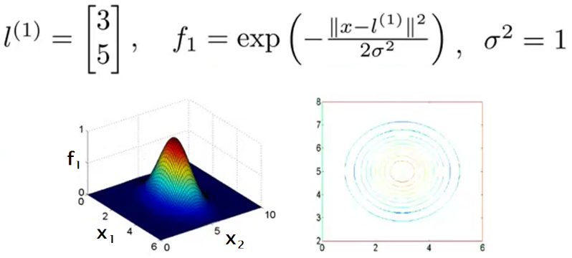Example:

If , then f1 = 1.

If x moves away, then f1 tends to 0.

How does change the plot when varying σ?

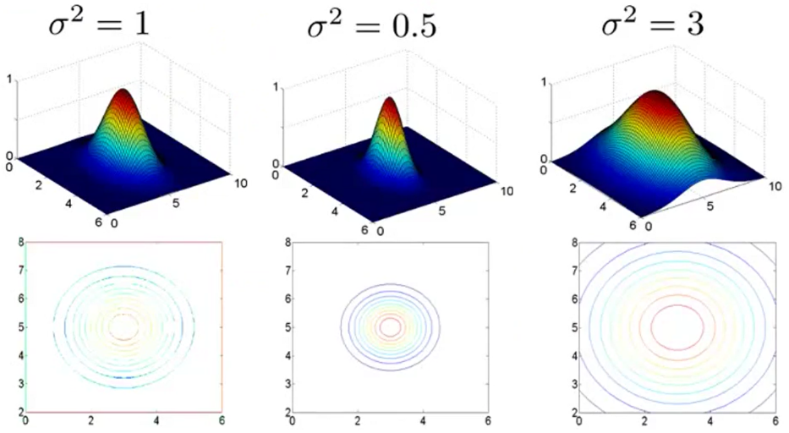

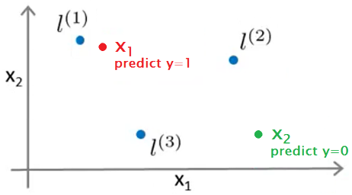Given this definition of the features, let’s see what source of hypothesis we can learn: Given a training example x, we first compute the features f1, f2, f3, etc.

hθ(x) predicts “1” when θ0 + θ1f1 + θ2f2 + θ3f3 ≥ 0

Let’s say we have two examples, and the parameters values are:

θ0 = -0,5 θ1 = 1 θ2 = 1 θ3 = 0

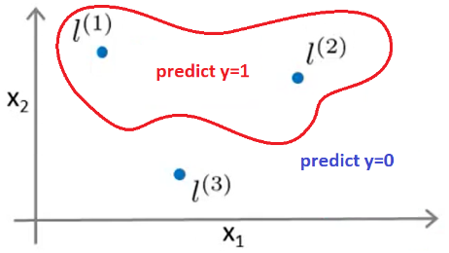And the predictions of hθ(x) are:

x1) -0,5 + 1(≈1) + 1(≈0) + 0(≈0) = 0,5 ≥ 0 hθ(x1) = 1

x2) -0,5 + 1(≈0) + 1(≈0) + 0(≈0) = -0,5 < 0 hθ(x2) = 0

This hypothesis will define a decision boundary (y=1 on one side, y=0 on the other).

**Landmarks**

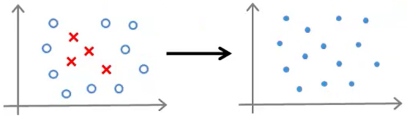For every training example we have, we will put landmarks in exactly their same locations.

Given (x(1), y(1)), (x(2), y(2)), … (x(m), y(m)),

choose l(1) = x(1), l(2) = x(2), … l(m) = x(m).

Given x(i), we compute features f(i) ∈ Rm+1

**Hypothesis**

Predicts “y=1” if θTf ≥ 0 θTf = θ0f0 + θ1f1 + … + θmfm (θ ∈ Rm+1) (n = m)

**Parameters θ**

$$\min_{θ}C\left[\sum_{i=1}^{m}{y^{\left(i\right)}}⋅{cost}_{1}\left(Θ^{T}f^{\left(i\right)}\right)+\left(1−y^{\left(i\right)}\right)⋅{cost}_{0}\left(Θ^{T}f^{\left(i\right)}\right)\right]+\frac{1}{2}\sum_{j=1}^{n}{θ_{j}^{2}}$$

In SVM, the last term $\left(\frac{1}{2}\sum_{j=1}^{n}{θ_{j}^{2}}\right)$ is implemented a little differently:

$θ^{T}Mθ$ (ignoring θ0)

M: matrix that depends on the kernel you use. It gives slightly different distance metric. Instead of minimizing exactly ||θ||2, it minimizes something very similar (like a rescale version of parameter vector θ that depends on the kernel). This implementation allows SVM software to run much more efficiently. Allows to scale to much bigger training sets. If you have X examples, then you also have X landmarks, and θ becomes X dimensional. If X is big, it may be expensive for the SVM optimization software.

SVMs and kernels tend to go particularly well together. We don’t apply kernel’s idea to other learning algorithms (like logistic regression) because the computational tricks that apply for SVM don’t generalize well to other algorithms (you can implement it, but it will run very slow).

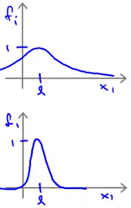**SVM parameters**

$C\left(\frac{1}{λ}\right)$ Large C: High variance (lower bias). (corresponds to small λ)

Small C: Higher bias (low variance). (corresponds to large λ)

$σ^{2}$ Large σ2: Features fi vary more smoothly. Higher bias (lower variance).

Small σ2: Features fi vary less smoothly. Higher variance (lower bias).

## Using SVM

**SVM parameters**

I wouldn’t recommend writing code to invert a matrix or compute a square root. Also, you don’t need to write software to minimize the previous cost function (to get parameters θ) because you can find very good off-the-shelf software packages/libraries (numerically optimized for years) for doing so (e.g. liblinear, libsvm, SVMLight, …). But, you have to specify:

* **C** parameter choice
* **Kernel** to use with SVM. The most common are:
  + No kernel (also called “linear kernel”): Gives standard linear classifier (liblinear…).

Predicts “y=1” if θTx ≥ 0 θTx = θ0 + θ1x1 + … + θnxn ≥ 0

Useful with small m and large n.

* + Gaussian kernel: Need to choose σ2. Gives complex non-linear decision boundaries.

$f_{i}=exp\left(\frac{−{\left\|\left.x−l^{\left(i\right)}\right\|\right.}^{2}}{2σ^{2}}\right)$ where l(i) = x(i)

Useful with large m and small n.

**Feature scaling**

Perform feature scaling before using the Gaussian kernel. If not, bigger features would dominate and smaller ones will be ignored (x1 >> x2).

When computing ||x-l||2, we are computing the norm of vector [x-l]:

||x-l||2 = (x1-l1)2 + (x2-l2)2 + … + (xn-ln)2

**Implementing the kernel**

Depending on what SVM software package you use, it may ask you to implement the kernel function (to compute a particular feature of the kernel, fi). Example:

function f = kernel(x1, x2) // where x1=x(i) and x2=l(j)=x(j)

; // f is a single real number

return

Other SVM packages may include the Gaussian kernel and other kernels.

**Other choices of kernel**

Not all similarity functions ( k(x,l) ) make valid kernels. They need to satisfy “Mercer’s theorem” to make sure SVM packages’ optimizations run correctly and don’t diverge. This theorem makes sure that the SVM packages can use the large class of optimizations and get parameter θ very quickly. Linear kernel and Gaussian kernel satisfy the theorem. Other off-the-shelf kernels available:

* Polynomial kernel: k(x, l) = (xT · l + a)b (it has 2 parameters: a, b)

When x and l are very close to each other, inner product tends to be large. Usually runs worse than Gaussian kernel. Usually used when x and l are strictly non-negative, so inner product is never negative.

* More esoteric:
  + String kernel: Used when input data is text strings or other types of strings.
  + Chi-square kernel
  + Histogram intersection kernel
  + …

If we are trying to decide among a few different choices of kernel and also choosing parameters such as C, σ2, etc. we should choose whatever performs best on the cv-data.

**Multi-class classification**

If you have K classes, how can SVM output a decision boundary between them?

Many SVM packages already have built-in multi-class classification functionality. If not, use the one-vs-all method:

* Train K SVMs, one to distinguish y=i from the rest (i =1, 2, … K).
* Get θ(1), θ(2), … θ(K).
* Pick class i with largest (θ(i))T x

**Logistic regression vs. SVMs**

* Logistic regression or linear kernel:
  + Large n (relative to m): E.g. n=10.000, m = 10-1.000 (n ≥ m)
  + Small n, large m: E.g. n=1-1.000, m = 50.000+
* SVM with Gaussian kernel:
  + Small n, intermediate m: E.g. n=1-1.000, m = 10-50.000
* Neural networks:
  + They are likely to work well for most of these settings, but may be slower to train (specially, in the SVM with Gaussian kernel regime).

n = number of features (x ∈ Rn+1) m = number of training examples

SVM with Gaussian kernel can struggle when working with massive training sets (50.000 +). The power of SVM with kernel is to learn complex non-linear functions. SVM has a convex optimization problem, so good SVM optimization software packages will always find the global minimum, or very close (however, local optimum is not a huge problem for a neural network).

Logistic regression and Linear kernel are very similar (depending on implementation details, one can be more efficient than the other).

# - Unsupervised learning -

## Clustering

**Supervised learning:** A labelled training set (x, y) is given and the goal is to find the decision boundary that separates the positive and the negative label examples.

**Unsupervised learning:** Only the input (x) is given, without any associated labels. We ask the algorithm to find some structure in the data for us. There are different UL algorithms.

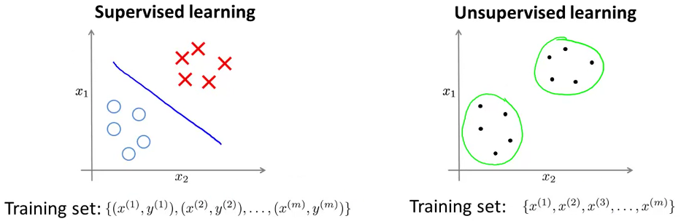

**Clustering algorithm:** One type of unsupervised learning algorithm that detects groups of data and groups them in clusters (green circles). Some applications: market segmentation, social network analysis, organize computing cluster (data centers), astronomical data analysis (understand galaxy formation). The most popular clustering algorithm is the **K-means**.

## K-means algorithm

K-means is an iterative algorithm. First, we randomly initialize K points (same dimensions as examples x) called cluster centroids (μ1, μ2, …, μK ∈ Rn), because we want to group our data into K clusters. Next, the 2 iterative steps are (use inside a loop):

* Cluster assignment: The nearer data points to each cluster centroid are assigned to each one.
* Move centroid: Move cluster centroids to the average (of the location) of their data points.
* Repeat these 2 steps until cluster centroids reach equilibrium.

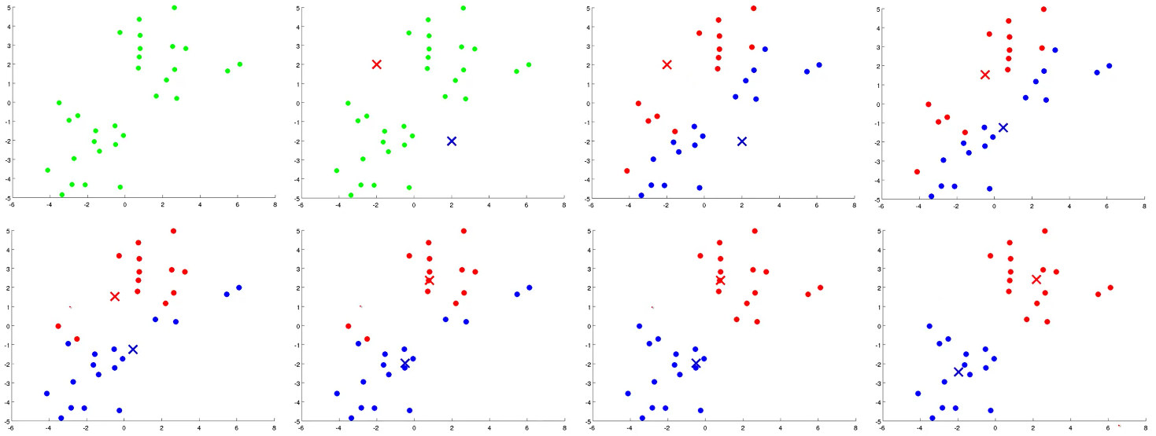

Input: - K (number of clusters)

- Training set {x(1), x(2), … , x(m)} x(i) ∈ Rn (drop x0=1 convention)

**Cluster assignment:** We want to minimize: mink ||x(i)-μk||2 (to the power of 2, by convention)

$\text{||}x_{j}\text{||}=\sqrt{{\left(x_{j}^{\left(1\right)}\right)}^{2}+{\left(x_{j}^{\left(2\right)}\right)}^{2}+…+{\left(x_{j}^{\left(n\right)}\right)}^{2}}$

$${x_{j}−μ_{k}∨}^{2}={\left(x | j^{\left(1\right)}−μ_{k}^{\left(1\right)}\right)}^{2}+{\left(x_{j}^{\left(2\right)}−μ_{k}^{\left(2\right)}\right)}^{2}+…+{\left(x_{j}^{\left(n\right)}−μ_{k}^{\left(n\right)}\right)}^{2}$$

for i=1 to m

**c(i)** := Cluster to which x(i) is currently assigned (index from 1 to K).

**Move centroid:** If a cluster centroid has zero points assigned to it, the most common think to do is to eliminate that centroid. But, if you want K clusters, you can randomly reinitialize that centroid.

$$μ_{k}≔\frac{1}{\left|C_{k}\right|}\sum_{i∈C_{k}}{x^{\left(i\right)}}$$

Ck: Number of examples assigned to centroid k.

for k=1 to K

**μk** := Cluster centroid. Average (mean) of points assigned to cluster k.

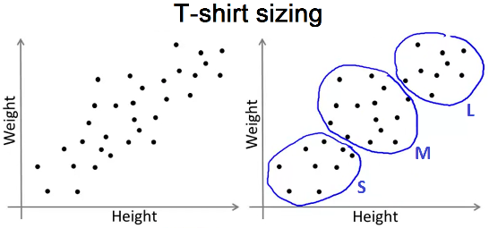**K-means for non-well-separated clusters:** Sometimes, our data is not clearly separated, but we may want to separate it. In the example, we separate our market in 3 different segments (market segmentation) to design products separately (small, medium, large). So, we create 3 clusters.

## Optimization objective

All supervised learning algorithms we have seen have an optimization objective (cost function) that the algorithm tries to minimize. K-means also has optimization objective, which can help us to ensure that k-means is running correctly, and we can use it to find better clusters and avoid local optima.

$μ_{c^{\left(i\right)}}=$ Centroid of the cluster assigned to example x(i).

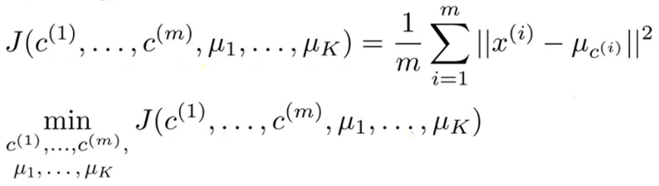**Optimization objective** (cost function that K-means is minimizing), also called Distortion of K-means algorithm:

$$J\left(c^{\left(1\right)},…,c^{\left(m\right)},μ_{1},…,μ_{K}\right)=\frac{1}{m}\sum_{i=1}^{m}{{\left\|x^{\left(i\right)}−μ_{c^{\left(i\right)}}\right\|}^{2}}$$

The cost function is the average of the sum of the square distances from every x(i) to their $μ_{c^{\left(i\right)}}$.

K-means is trying to define parameters c and μ to minimize this cost function. We are already minimizing it when applying the 2 iterative steps:

Cluster assignment minimizes J(…) with respect to c(1), c(2), …, c(m), while holding fixed μ1, …, μk.

Move centroid step minimizes J(…) with respect to μ1, μ2, …, μk.

We can plot the cost function as a function of the number of iterations to debug K-means and make sure it is converging and running properly. It’s not possible for the cost function to sometimes increase (except if there is a bug in the code).

## Random initialization

There are a few different ways to randomly initialize the cluster centroids, but this option is much recommended:

* Should have K < m
* Randomly pick K training examples
* Set μ1, …, μK, equal to these K examples

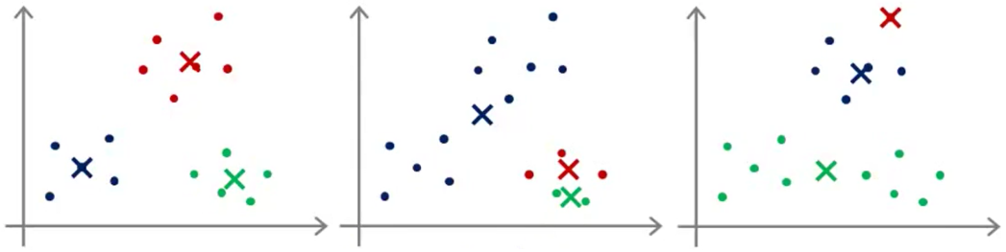Unlucky random initialization can make the cost function to get stuck at a bad local optima and make K-means have a bad result.

To increase the odds of finding the best clustering, we can try multiple random initializations.

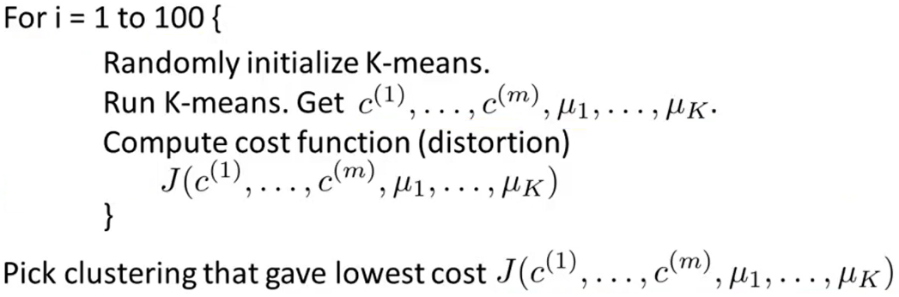

Typical number of random initializations: 50 - 1000.

If you run K-means with a **small** number of clusters (K=2-10), multiple random initializations can help much to make sure you find the better clustering data. But, if K is very **large** (much greater than 10, like hundreds), it’s less likely to make a huge difference, just small improvements.

If we run K-means using k=2 and k=5, and we find that cost function is much higher for k=5 than for k=3, this means that, in the run with k=5, k-means got stuck in a bad local minimum (you should try re-running k-mean with multiple random initializations).

## Number of clusters

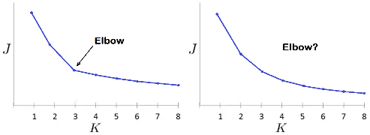There isn’t great way to choose K automatically. Most common way: to do this **manually** (by looking visualizations, looking the output of clustering algorithm, etc). Often, it’s ambiguous the number of clusters that there are in the data.

**Elbow method:** When plotting cost functions as a function of K (number of clusters), we get a curve. The best value for K should be at the “elbow” of the curve. The problem is that fairly often the curve doesn’t have a clear elbow.

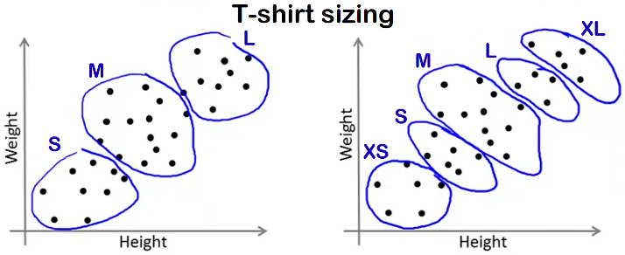**Evaluation metric:** Sometimes you’re running K-means to get clusters to use for some later/downstream purpose. Evaluate K-means based on a metric for how well it performs for that later purpose (see how well different number of clusters serve that later downstream purpose). Ask yourself for what purpose are you running K-means and then think what is the number of clusters K that serve better that later purpose.

Example: How many types of T-shirt sizes? After evaluating the results, we take a decision from the point of view of the business and the customer.

## Dimensionality reduction

**Data compression**

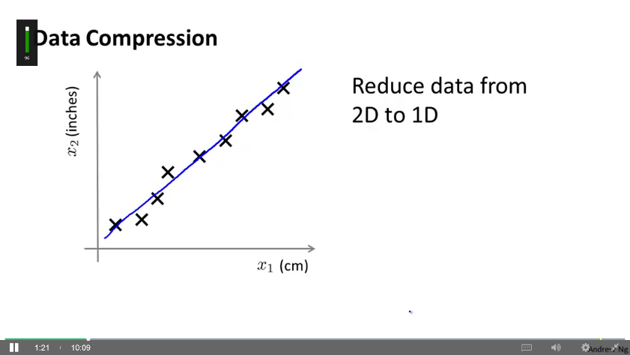Dimensionality reduction is a second type of unsupervised learning problem. Compression of data allows data to occupy less memory and to speed up our learning algorithms.

Example: We may have one feature that consists in some distance in cm (x1) and another feature is that same distance in inches (x2). We can reduce both features to a single feature (reducing data from 2 dimensions to 1).

When we have hundreds/thousands of features it’s often easy to lose track and have redundant data.

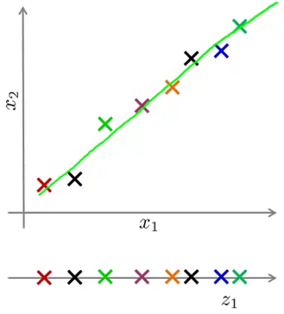Example 2: When working with pilots of autonomous helicopters, we can get 2 features: pilot skill (x1) and pilot enjoyment (x2). These two features may be highly correlated. We can reduce them to one dimension: pilot aptitude.

To reduce the dimensions we draw a line following the points and project those points onto the line. Then, we measure the position of the points on the line and we get a new feature.

Example 3: We may have 3 dimensional points that seems to be in a plane. We define that plane and project the poins over it. Now we have reduced 3 dimensional data to 2 dimensional. In reality, we could have 1000 data and reduce it to 100 data.

If we apply dimensionality reduction to a dataset of m examples {x(1), x(2), … , x(m)}, where x(i) ∈ Rn, we get a lower dimensional dataset {z(1), z(2), … , z(m)} of m examples where z(i) ∈ Rk for some value of k and k ≤ n.

**Data visualization**

Dimensionality reduction can also help us to visualize large amounts of data. We can reduce a high dimension data to a **2 or 3 dimension** data and plot it, which may help to understand better the data.

Example: We have 50 features per country. We can reduce the data to 2 features per country (2D) and plot it. These 2 features don’t have a clear meaning, it’s up to us to figure out roughly what these features means.

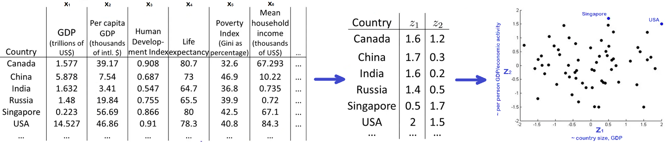

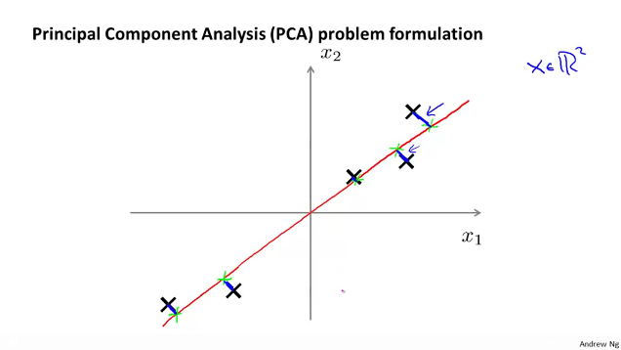**Principal component analysis (PCA)**

This is the most popular algorithm for dimensionality reduction. It tries to find a low dimensional surface (line, plane) onto which to project our data so as to minimize the **projection error** (the closer distance between the data points and the surface, the blue lines).

Reduce from n-dimension to k-dimension: Find **k** vectors **u(1), u(2),…, u(k)** onto which to project the data, so as to minimize the projection error.

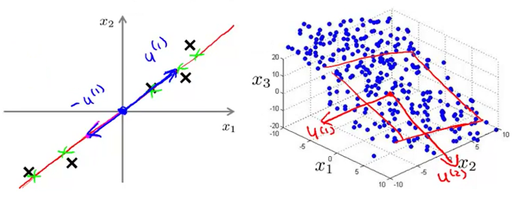One vector (u(1) ∈ Rn) can give you a vector. It can be positive or negative, it doesn’t matter (both can define the same line). Two vectors (u(1), u(2)) can define a plane. Etc.

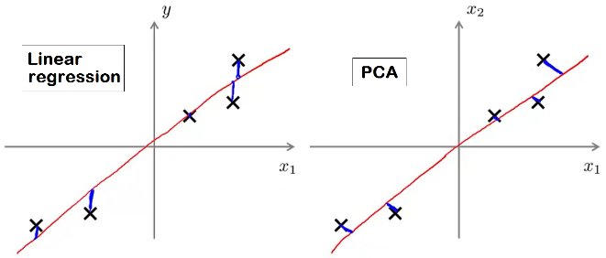Differences between Linear Regression and PCA: In LR we minimize vertical distances, in PCA we minimize orthogonal distances. In LR, we want to predict y, in PCA there is no especial variable.

By convention, we choose vector u(i) so the length of that vector is equal to 1.

$$\left\|u^{\left(1\right)}\right\|=\sqrt{{\left(u_{1}^{\left(1\right)}\right)}^{2}+{\left(u_{2}^{\left(1\right)}\right)}^{2}}=1$$

Given a training set (x(1), x(2), …, x(m)), before applying PCA, you should always perform **mean normalization** and, depending on your data, also **feature scaling**. It’s the same procedure than in supervised learning, except that now we apply it to unlabelled data.

* Mean normalization: $μ_{j}=\frac{1}{m}\sum_{i=1}^{m}{x_{j}^{\left(i\right)}}$ Replace each $x_{j}^{\left(i\right)}$ with $x_{j}−μ_{j}$.
* Feature scaling: If different features (x1, x2,…) have different scales, scale features to have comparable range of values.

Substitute $x_{j}^{\left(i\right)}$ by $\frac{x_{j}^{\left(i\right)}−μ_{j}}{s_{j}}$ (μj: mean)

(sj: Some measure of range of values of features j. It can be max-min, standard deviation…)

Now, let’s reduce data from n-dimensions to k-dimensions. Two steps:

- Compute **Covariance matrix (Σ)**: $Σ=\frac{1}{m}\sum_{i=1}^{n}{\left(x^{\left(i\right)}\right){\left(x^{\left(i\right)}\right)}^{T}}$ stored in Sigma (nxn matrix)

Vectorized implementation:

- Compute **Eigenvectors** of matrix Σ: [U, S, V] = svd(Sigma) (3 matrices)

There are different ways to compute eigenvectors. In Octave you can use **svd()** (more numerically stable) or **eig()**. Both give the same answer. (svd: Singular Value Decomposition)

If you are using another programming language, look for a linear algebra library that computes svd. Covariance matrix always satisfies a “symmetric positive semidefinite”, that’s why different functions (svd, eig) gives the same result.

From the eigenvectors computation we get the U matrix (nxn), where every column is one of the vectors we are looking for (u(1), u(2), …, u(n)).

to reduce our n dimensions to k, we take the first k vectors

Now, we have matrix Ureduce (nxk). To get the coordinates of an example x (1xn), compute:

$z^{\left(i\right)}={\left(U | reduce\right)}^{T}∙{\left(x | \left(i\right)\right)}^{T}$

Result is z (kx1), the coordinates of x(i) projected on the k-dimension surface defined by Ureduce.

Vectorized implementation: z=(Ureduce)T·x

## Applying PCA

**Reconstruction from compressed representation**

We have seen how PCA compress data. But there is a way to go from that compressed data back to an approximation of your original high-dimensional data.

$x≈x_{}=U_{reduce}∙z'$ z (1xk), Ureduce (nxk)

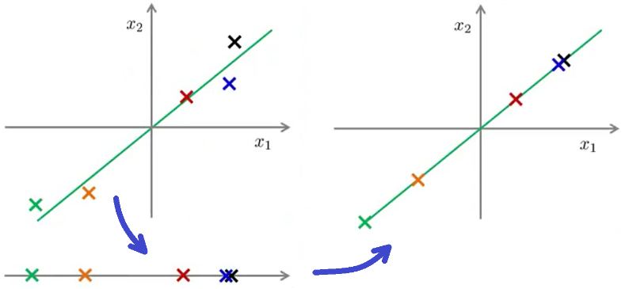

If we run PCS with k=n, then Ureduce will be nxn matrix, xapprox = x for every example x, and the percentage of variance retained $\left(\frac{\sum_{i=1}^{k}{S_{ii}}}{\sum_{i=1}^{n}{S_{ii}}}\right)$ will be 100%.

**Choosing Number of Principal Components (k)**

Typically, choose k to be smallest value so that

$$\frac{Averagesquaredprojectionerror}{Totalvariation∈thedata}=\frac{\frac{1}{m}\sum_{i=1}^{m}{{\left\|x^{\left(i\right)}−x_{}^{\left(i\right)}\right\|}^{2}}}{\frac{1}{m}\sum_{i=1}^{m}{{\left\|x^{\left(i\right)}\right\|}^{2}}}≤0.01\left(1\text{\%}\right)$$

(choose k so 99% of variance is retained) (most common range of values: 0.01-0.05)

Very often many data is highly correlated and you can reduce dimensions of the data significantly and still retain 99%-95% of the variance. Also, very often you can compress by x5 to x10.

Algorithm:

1. Try PCA with k = 1
2. Compute $U_{reduce}$
$$z^{\left(1\right)},z^{\left(2\right)},…,z^{\left(m\right)}$$

$$x_{}^{\left(1\right)},x_{}^{\left(2\right)},…,x_{}^{\left(m\right)}$$

3. Check if $\frac{\frac{1}{m}\sum_{i=1}^{m}{{\left\|x^{\left(i\right)}−x_{}^{\left(i\right)}\right\|}^{2}}}{\frac{1}{m}\sum_{i=1}^{m}{{\left\|x^{\left(i\right)}\right\|}^{2}}}≤0.01?$ if it is >0.01, we try again with k=2, etc.

We can simplify step 3 if we get the matrix S from the computation svd(Sigma).

[U, S, V]=svd(Sigma) where $S=\left[\begin{matrix}s_{11} \\ 0 \\ \begin{matrix}0 \\ 0 \\ 0\end{matrix}\end{matrix}\begin{matrix}0 \\ s_{22} \\ \begin{matrix}0 \\ 0 \\ 0\end{matrix}\end{matrix}\begin{matrix}0 \\ 0 \\ \begin{matrix}s_{33} \\ 0 \\ 0\end{matrix}\end{matrix}\begin{matrix}0 \\ 0 \\ \begin{matrix}0 \\ ⋱ \\ 0\end{matrix}\end{matrix}\begin{matrix}0 \\ 0 \\ \begin{matrix}0 \\ 0 \\ s_{nn}\end{matrix}\end{matrix}\right]$

So, for a given k we have that

$$\frac{\frac{1}{m}\sum_{i=1}^{m}{{\left\|x^{\left(i\right)}−x_{}^{\left(i\right)}\right\|}^{2}}}{\frac{1}{m}\sum_{i=1}^{m}{{\left\|x^{\left(i\right)}\right\|}^{2}}}≤0.01?=1−\frac{\sum_{i=1}^{k}{s_{ii}}}{\sum_{i=1}^{n}{s_{ii}}}≤0.01=\frac{\sum_{i=1}^{k}{s_{ii}}}{\sum_{i=1}^{n}{s_{ii}}}≥0.99$$

**Using PCA for supervised learning speedup**

If we have a computer vision algorithm that takes an image of 100x100 pixels, then x(i)∈R10000. These are a lot of features (dimensions). Fortunately, we can compress this data.

- Training set: (x(1), y(1)), (x(2), y(2)), …, (x(m), y(m))

- Extract inputs: x(1), x(2), …, x(m) ∈ R10000

- Apply PCA to it: z(1), z(2), …, z(m) ∈ R1000

- New training set: (z(1), y(1)), (z(2), y(2)), …, (z(m), y(m))

- Feed this new training set to a learning algorithm (logistic regression, neural network, etc.)

Mapping x(i)→z(i) should be defined by running PCA only on the training set. As a result, you obtain some data from mean normalization, feature scaling, Ureduce, etc. This mapping you got can be then applied as well to the examples $x_{cv}^{\left(i\right)}$ and $x_{test}^{\left(i\right)}$ in the cv and test sets.

**Bad use of PCA:**

* To prevent overfitting

We may use z(i) instead of x(i) to reduce the number of features (k < n). Thus, fewer features, less likely to overfit. This might work ok, but isn’t a good way to address overfitting. Use regularization instead. Reason: PCA throws away some information from input (x) without knowing which are the values of the output (y), so it may throw away some valuable information. Regularization, instead, knows the values of x and y, so it’s less likely to throw away some valuable information.

* Considering use PCA from the beginning

Sometimes, when a ML system is designed, someone may include the PCA step. However, a better approach should be run whatever you want with the original/raw data x(i). Only if that doesn’t do what you want (slow learning algorithm, large memory requirements, etc.), then consider using z(i) and implement PCA.

Main uses of PCA: Speed up learning algorithm, reduce memory requirements, visualize data.

# Anomaly detection

## Density estimation

Example:

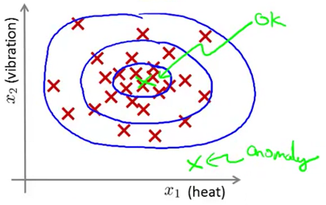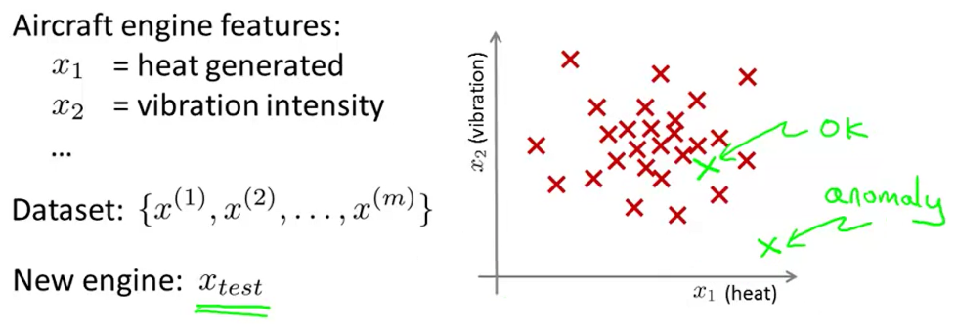

Given a dataset (unlabelled training set), we build a model for p(x) (probability of x) where:

$$\begin{matrix}p\left(x_{test}\right)<ε→x_{test}hasanomaly \\ p\left(x_{test}\right)≥ε→x_{test}isok\end{matrix}$$

If this system flags too many things as anomalous that are not actually so, we should try decreasing ε.

**Some applications**

* Fraud detection: Evaluating some features of users activities and identify unusual users (x1: how often log in, x2: number of transactions, x3: number of posts, x4: typing speed, …).
* Manufacturing: Like aircraft manufacturing.
* Monitoring computers in a data center (x1: memory use, x2: disc accesses/sec, x3: CPU load, x4: CPU load/network traffic, …).

**Gaussian (Normal) distribution**

[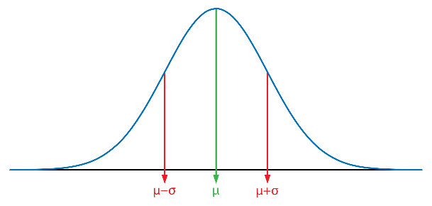](https://www.google.es/url?sa=i&rct=j&q=&esrc=s&source=images&cd=&cad=rja&uact=8&ved=2ahUKEwiS4MzLxuzaAhUOesAKHeXRBuoQjRx6BAgBEAU&url=https://commons.wikimedia.org/wiki/File:Gaussian_distribution.svg&psig=AOvVaw2Lxyt1sPwXSSvCIig-9_ux&ust=1525540263696659)It has 2 parameters: mean (μ), variance (σ2). (σ: Standard deviation)

$xN\left(μ,σ^{2}\right)$: x (raw number) is distributed as a Normal distribution.

p(x; μ, σ2): Probability of x, parameterized by μ and σ2.

We can plot the Normal distribution (probability density):

The formula for the Normal distribution is:

$$p\left(x;μ,σ^{2}\right)=\frac{1}{σ\sqrt{2π}}exp⁡\left(\frac{−{\left(x−μ\right)}^{2}}{2σ^{2}}\right)$$

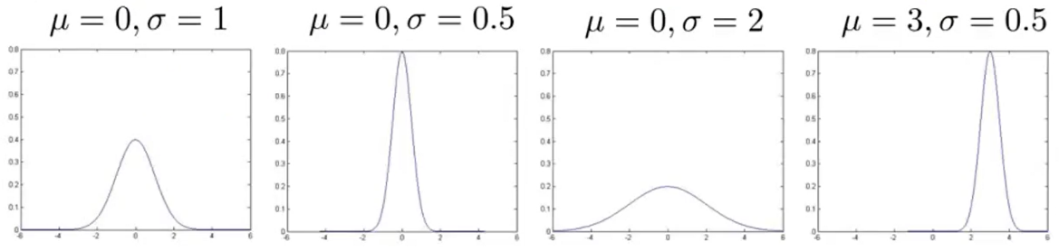

The area of the Normal distribution must always integrate to 1.

**Parameter estimation**

We have a data set {x(1), x(2) , … , x(m)} (x(i) ∈ R).

I suspect $x^{\left(i\right)}N\left(μ,σ^{2}\right)$, so I calculate the values of μ and σ2:

(vector versions also possible)

These estimates are the maximum likelihood estimates of parameters μ and σ2.

In the formula of σ2, in statistics it’s usually used $\frac{1}{m−1}$, but in machine learning it’s usually used $\frac{1}{m}$.

**Anomaly detection algorithm**

We have an unlabelled training set {x(1), x(2) , … , x(m)} (x(i) ∈ R).

We assume that every x(i) has its own Normal distribution:

$x^{\left(i\right)}N\left(μ_{1},σ_{1}^{2}\right)$, $x^{\left(i\right)}N\left(μ_{2},σ_{2}^{2}\right)$, $x^{\left(i\right)}N\left(μ_{2},σ_{2}^{2}\right)$, …

$$p\left(x\right)=p\left(x_{1};μ_{1},σ_{1}^{2}\right)∙p\left(x_{2};μ_{2},σ_{2}^{2}\right)∙p\left(x_{3};μ_{3},σ_{3}^{2}\right)…p\left(x_{n};μ_{n},σ_{n}^{2}\right)=\prod_{j=1}^{n}{p\left(x_{j};μ_{j},σ_{j}^{2}\right)}$$

This equation corresponds to an independence assumption on the values of the features x1 to xn. But, in practice, this works fine even if the independence assumption is not true.

So, the algorithm is:

1. Choose features xi that you think might be indicative of anomalous examples.
2. Calculate parameters $μ_{1},…,μ_{n},σ_{1}^{2},…,σ_{n}^{2}$.
3. Given a new example x, compute $p\left(x\right)=\prod_{j=1}^{n}{p\left(x_{j};μ_{j},σ_{j}^{2}\right)}$. Anomaly if p(x) < ε.

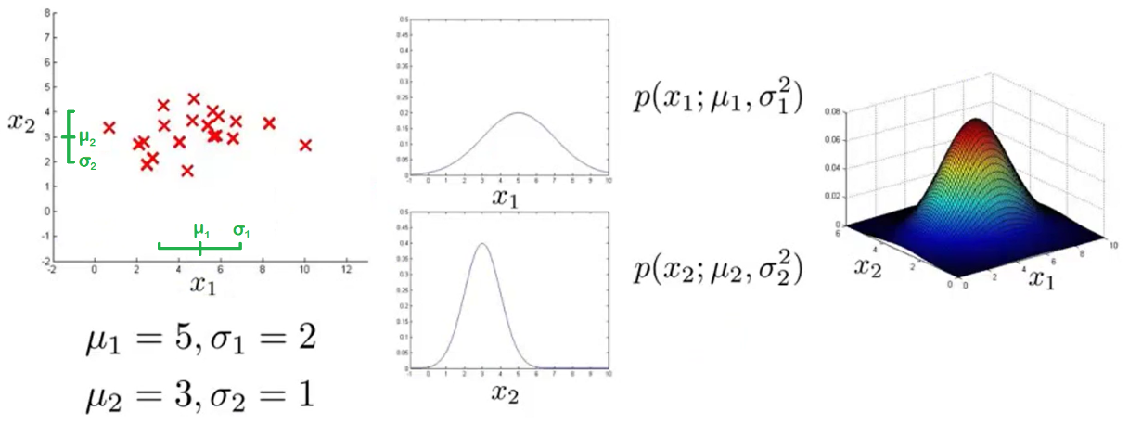

The 3D plot is $p\left(x\right)=p\left(x_{1};μ_{1},σ_{1}^{2}\right)∙p\left(x_{2};μ_{2},σ_{2}^{2}\right)$. Given a new example x, p(x) gives the probability of x. The value of ε determines the boundary of normal-anomalous examples in the left plot. It would be a certain height in the right 3D plot .

## Building an anomaly detection system

**Developing and evaluating it**

When developing a learning algorithm (choosing features, etc.), making decisions is much easier if we have a way of evaluating it (with some single number evaluation method). We have 3 datasets:

* Training set: $x^{\left(1\right)},x^{\left(2\right)},…,x^{\left(m\right)}$ (assume not anomalous examples)
* Cross validation set: $\left(x_{cv}^{\left(1\right)},y_{cv}^{\left(1\right)}\right),…,\left(x_{cv}^{\left(m_{cv}\right)},y_{cv}^{\left(m_{cv}\right)}\right)$
* Test set: $\left(x_{test}^{\left(1\right)},y_{test}^{\left(1\right)}\right),…,\left(x_{test}^{\left(m_{test}\right)},y_{test}^{\left(m_{test}\right)}\right)$

CV and test set are labelled (y=0 if normal, y=1 if anomalous). In training set, all its examples are labelled as normal (don’t worry if a few slip into this set, like 0.5% or less). To build this, we can take the examples from training set and assign 60% to training set (all normal, or almost all), 20% in cv set (including some anomalous), 20% in test set (including the rest of anomalous). It’s not good practice to include the same examples in the cv and test set.

Algorithm evaluation:

* Fit model p(x) on training set.
* Predict x on a cv or test example
$$y=\left\{\begin{aligned}1ifp\left(x\right)<ε\left(anomaly\right) \\ 0ifp\left(x\right)≥ε\left(normal\right)\end{aligned}\right.$$

* Possible evaluation metrics:
  + True positive, false positive, false negative, true negative.
  + Precision/Recall
  + F1 score
  + ~~Classification accuracy~~: Not a good evaluation method because the data is squewed (y=0 is much more common).

One way to choose ε can be using the cv set. Try different values of ε and choose the value that maximizes the chosen evaluation metric.

More generally, every time we have to take decision about our algorithm (choose ε, add new feature, …), we evaluate our algorithm on the cv set. Once we take our decision, we can do the final evaluation of the chosen model on the test set.

**Anomaly detection vs. Supervised learning**

Apply Anomaly detection when:

Very small number of positive examples (y=1) (0-20, maybe up to 50, is common) and large number of negative examples (y=0). We save the positive examples for the cv/test set. To estimate p(x) we only need negative examples.

There may be many different types of anomalies and is hard for a learning algorithm to learn from positive examples what the anomalies look like. Future anomalies may look nothing like any of the anomalous examples we’ve seen so far.

Applications: Fraud detection, manufacturing (aircraft engines, etc.), monitoring machines in a data center, etc.

Apply Supervised learning when:

Large number of positive and negative examples. There are enough positive examples for the algorithm to get a sense of what positive examples are like. Future positive examples are likely to be similar to the ones in the training set.

Applications: Email spam classification, weather prediction, cancer classification, etc.

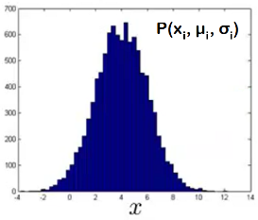**Choosing features to use**

You may plot a histogram (hist) of a feature to see if it look Gaussian or not.

However, anomaly detection also works well with non-Gaussian data. But, if you want the algorithm to work a little better, you can apply a transformation to make the data look Gaussian. We do this by replacing feature x with

$$log\left(x\right)log\left(x+c\right)\sqrt{x}=x^{1/2}x^{1/3}etc.$$

Try plotting different modifications of the same feature until you get a Gaussian plot.

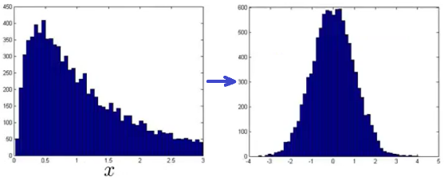> hist(x, 50) (x being mx1)

> hist(x.^0.5, 50)

> hist(x.^0.2, 50)

> xNew = x.^0.2

Error analysis for anomaly detection: Train an algorithm and run it in a cv set. Then

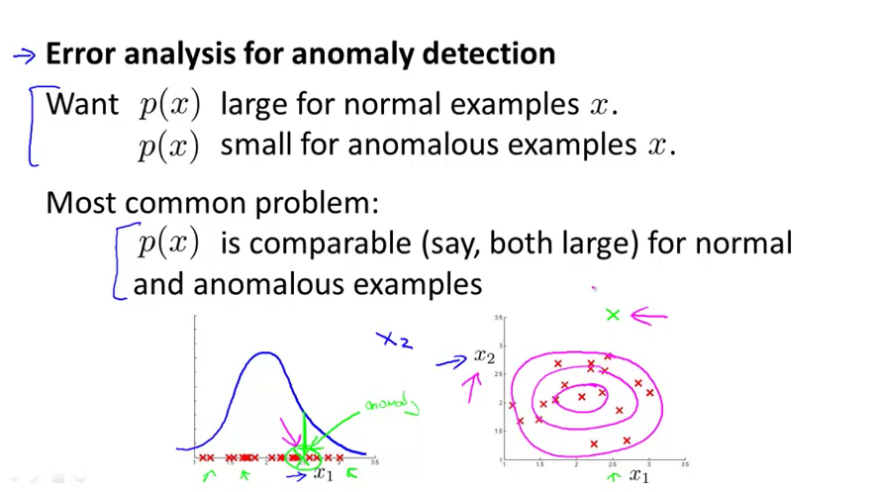Train an algorithm and run it in a cv set. What you expect is p(x) to be large for normal examples and small for anomalous examples. If p(x) is comparable (say, both large) for some normal and anomalous examples, we can look the examples that went wrong to come up with extra features that may help the algorithm to work better on those wrong examples.

Example: We have an anomalous example with large p(x). We examine it to come up with some extra feature that may indicate that it’s anomalous.

What features to choose: Choose features that might take on unusually large or small values in the event of an anomaly. Example: [x=CPU load/network traffic] or [x=(CPU load)^2/network traffic] may indicate if some server is stuck in an infinity loop.

## Multivariate Gaussian distribution

We may have a plot like the one in the left, where the non-anomalous area is an ellipse. However, the anomaly detection algorithm only creates a spherical area. Some anomalous examples may be detected as non-anomalous.

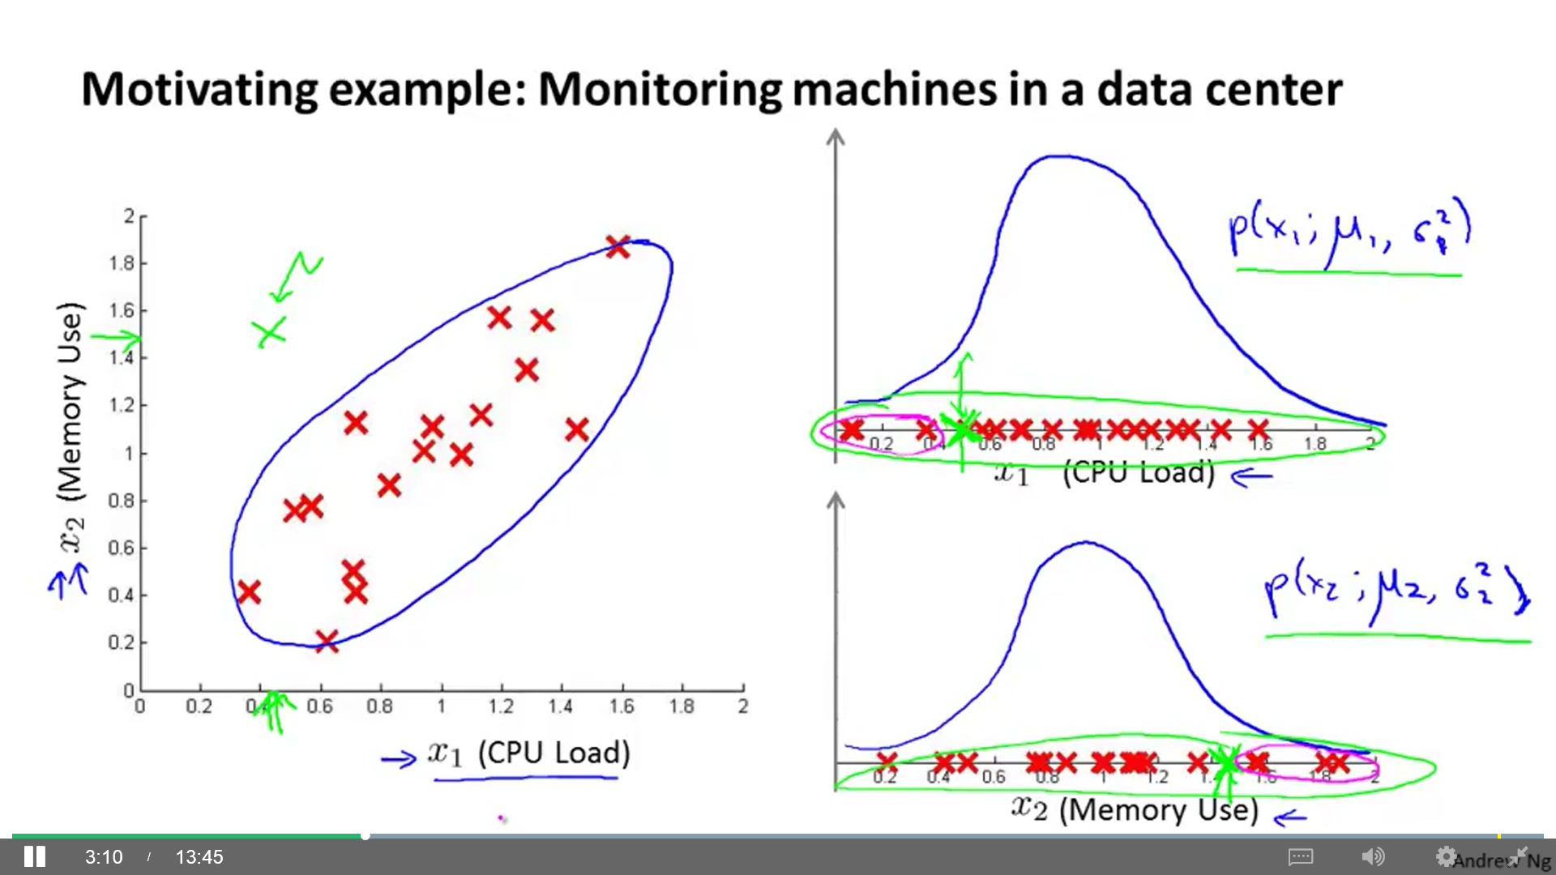 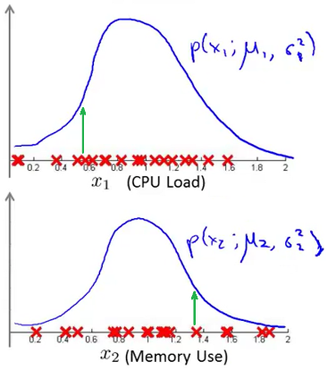 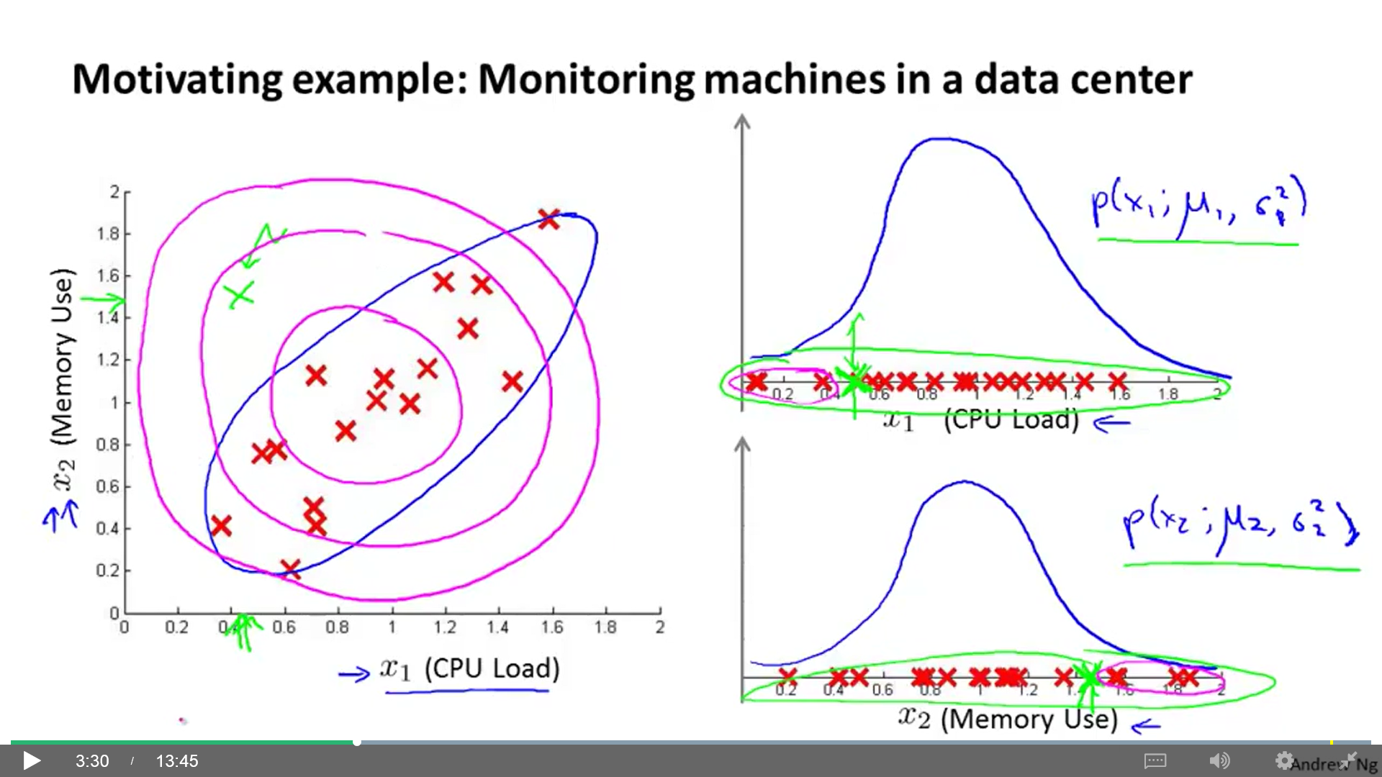

To fix this we develop a modified version of the anomaly detection using Multivariate Gaussian (Normal) distribution. Here, we don’t model p(x1), p(x2), etc. separately. Instead, we model p(x) all in one go. Parameters used: μ (nx1, mean), Σ (nxn, covariance matrix).

$$p\left(x;μ,Σ\right)=\frac{1}{{\left(2π\right)}^{n/2}{\left|Σ\right|}^{1/2}}exp⁡\left(\frac{−1}{2}{\left(x−μ\right)}^{T}Σ^{−1}\left(x−μ\right)\right)$$

$\left|Σ\right|=DeterminantofΣ$ det(sigma)

Modifying the covariance matrix and the mean we can alter the Gaussian distribution to model correlations between the data (example: when x1 and x2 are correlated).

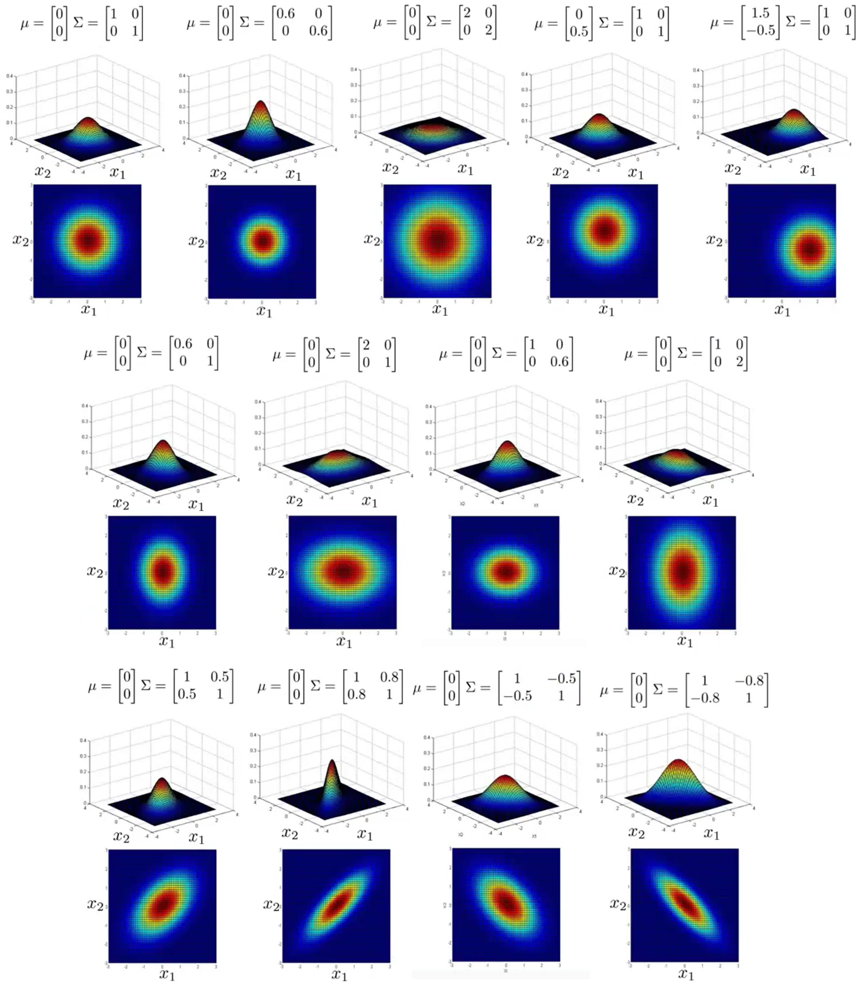



So, the algorithm is:

1. Fit model p(x) by setting:

$μ=\frac{1}{m}\sum_{i=1}^{m}{x^{\left(i\right)}}$ $Σ=\frac{1}{m}\sum_{i=1}^{m}{{\left(x^{\left(i\right)}−μ\right)\left(x^{\left(i\right)}−μ\right)}^{2}}$

1. Given a new example x, compute p(x). Anomaly if p(x) < ε.

There is a relationship between the original Gaussian model and the Multivariate Gaussian model. The original model is a special case of a Multivariate model where the ellipse contour is aligned with one of the x axis (x1, x2, …). If covariance matrix has zeros on the off diagonal elements, both model are equal. The original model is used more often but can’t model the correlation between different features.

**Original model vs Multivariate Gaussian**

* Original model:
  + You have to create extra features to capture anomalies where x1, x2 take unusual combinations of values (correlations).
 $$x_{1}=CPUloadx_{2}=Memoryusex_{3}=\frac{CPUload}{Memoryuse}$$

 + Computationally cheaper (thus, scales better to large n, even when x=100.000).
  + Works well even if m (training set size) is small (50-100).
* Multivariate Gaussian:
  + Automatically captures correlations between features.
  + Computationally more expensive (computes Σ-1).
  + Must have m > n, or else Σ is non-invertible (recommended m ≥ 10n).

If Σ-1 is non-invertible (singular) in Multivariate Gaussian, this may be caused because:

* Fails to satisfy m > n
* Redundant features (linearly dependent features): x1=x2 | x1=x2+x3 | x1=2x3

# Recommender systems

Imagine users rates movies using 0 to 5 stars (? → non-watched film):

|  |  |  |  |  |
| --- | --- | --- | --- | --- |
| **Movie** | **Alice (1)** | **Bob (2)** | **Carol (3)** | **Dave (4)** |
| Love at last | 5 | 5 | 0 | 0 |
| Romance forever | 5 | ? | ? | 0 |
| Cute puppies | ? | 4 | 0 | ? |
| Nonstop car chases | 0 | 0 | 5 | 4 |
| Swords vs. karate | 0 | 0 | 5 | ? |

nu = Number of users (4)

nm = Number of movies (5)

r(i, j) = 1 if user j has rated movie i. Otherwise, 0.

y(i, j) = Rating given by user j to movie i (defined only if r(i, j)=1)

A recommender system provides a learning algorithm that can automatically fill the missing values (?) (how would they have rated movies they haven’t seen yet) so we can look the movies the user has not yet watched and recommend new movies to him.

## Content based recommendations

This is one type of recommender system algorithm (because the features have content of the examples). Let’s say we have some values that indicates the gender of a movie (n = 2):

|  |  |  |
| --- | --- | --- |
| **Movie** | **x1 (romance)** | **x2 (action)** |
| Love at last | 0.9 | 0 |
| Romance forever | 1.0 | 0.01 |
| Cute puppies | 0.99 | 0 |
| Nonstop car chases | 0.1 | 1.0 |
| Swords vs. karate | 0 | 0.9 |

Also add **x0 = 1**.

By applying Linear regression, we learn a parameter **θ(j) ∈ Rn+1** for each user j.

For user j, the predicted rating for movie i is ${\left(θ^{\left(j\right)}\right)}^{T}x^{\left(i\right)}$ stars.

θ(j) = Parameter vector for user j. x(i) = Feature vector for movie i.

m(j) = Number of movies rated by user j.

To learn θ(j) we minimize $J\left(θ^{\left(j\right)}\right)$ (regularization term included):

$$minθ^{\left(j\right)}\frac{1}{2m^{\left(j\right)}}\sum_{i:r\left(i,j\right)=1}{{\left({\left(θ^{\left(j\right)}\right)}^{T}x^{\left(i\right)}−y^{\left(i,j\right)}\right)}^{2}+\frac{λ}{2m^{\left(j\right)}}\sum_{k=1}^{n}{{\left(θ_{k}^{\left(j\right)}\right)}^{2}}}$$

$$minθ^{\left(j\right)}\frac{1}{2}\sum_{i:r\left(i,j\right)=1}{{\left({\left(θ^{\left(j\right)}\right)}^{T}x^{\left(i\right)}−y^{\left(i,j\right)}\right)}^{2}+\frac{λ}{2}\sum_{k=1}^{n}{{\left(θ_{k}^{\left(j\right)}\right)}^{2}}}$$

$\left[i:r\left(i,j\right)=1\right]$: All the values of i so r(i, j)=1 (all the movies user i has rated).

Given $x^{\left(i\right)},…,x^{\left(n_{m}\right)}$ (and movie ratings), to learn $θ^{\left(1\right)},…,θ^{\left(n\right)}$, we minimize $J\left(θ^{\left(1\right)},…,θ^{\left(n_{u}\right)}\right)$:

$$minθ^{\left(1\right)},…,θ^{\left(n_{u}\right)}\frac{1}{2}\sum_{j=1}^{n_{u}}{\sum_{i:r\left(i,j\right)=1}{{\left({\left(θ^{\left(j\right)}\right)}^{T}x^{\left(i\right)}−y^{\left(i,j\right)}\right)}^{2}}}+\frac{λ}{2}\sum_{j=1}^{n_{u}}{\sum_{k=1}^{n}{{\left(θ_{k}^{\left(j\right)}\right)}^{2}}}$$

$\left[j=1 | n_{u}\right]$: Every user j.

You can use this derivative in any optimization algorithm (gradient descent, conjugate gradient, LBFGS, etc.):

$$\frac{δ}{δθ_{k}^{\left(j\right)}}J\left(…\right)=\sum_{i:r\left(i,j\right)=1}{\left({\left(θ^{\left(j\right)}\right)}^{T}x^{\left(i\right)}−y^{\left(i,j\right)}\right)x_{k}^{\left(i\right)}}+λθ_{k}^{\left(i\right)}$$

Gradient descent update:

$$θ_{k}^{\left(j\right)}≔θ_{k}^{\left(j\right)}−α\sum_{i:r\left(i,j\right)=1}{\left({\left(θ^{\left(j\right)}\right)}^{T}x^{\left(i\right)}−y^{\left(i,j\right)}\right)x_{k}^{\left(i\right)}\left(fork=0\right)}$$

$$θ_{k}^{\left(j\right)}≔θ_{k}^{\left(j\right)}−α\left(\sum_{i:r\left(i,j\right)=1}{\left({\left(θ^{\left(j\right)}\right)}^{T}x^{\left(i\right)}−y^{\left(i,j\right)}\right)x_{k}^{\left(i\right)}}+λθ_{k}^{\left(j\right)}\right)\left(fork≠0\right)$$

## Collaborative filtering (or Low rank matrix factorization)

This recommender system algorithm does Feature learning (can learn for itself what features to use). Here, we don’t have content based features (x1, x2). Instead, we ask each user how much they like romantic movies and action movies and we get a vector **θ(j) ∈ Rn+1** for each one.

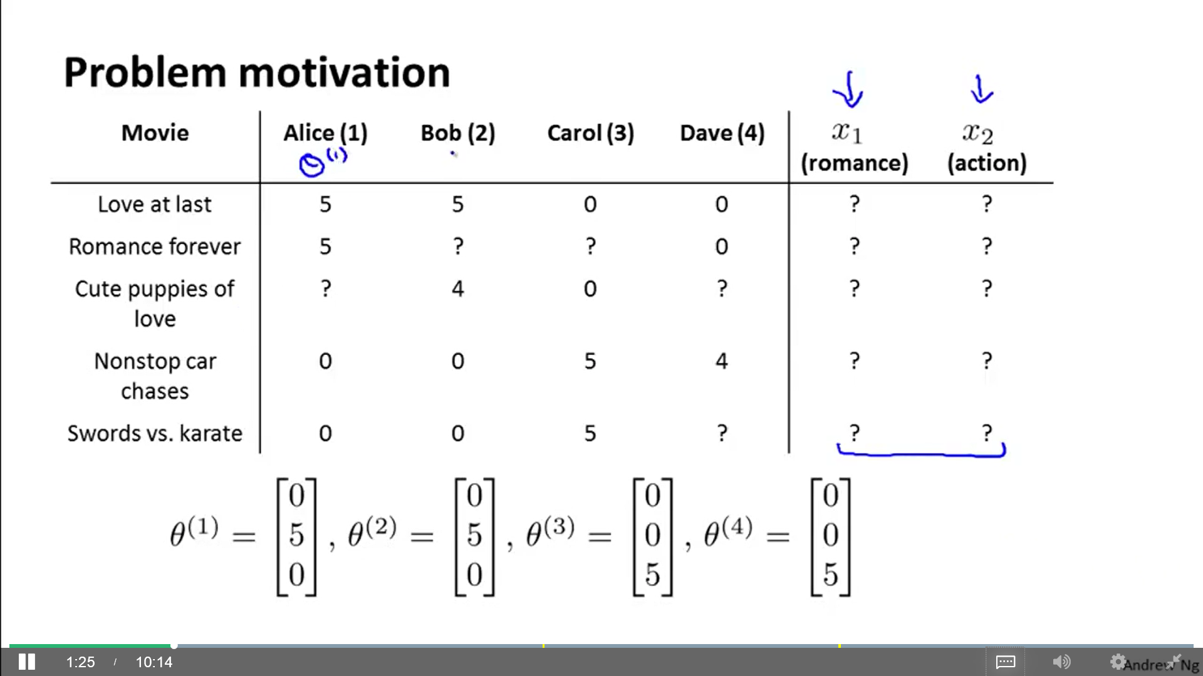

With this information, we can infer the content based features. Example: In the case of the first movie, the value of x1 is such that should satisfy:

${\left(θ^{\left(1\right)}\right)}^{T}x^{\left(1\right)}≈5$ ${\left(θ^{\left(2\right)}\right)}^{T}x^{\left(1\right)}≈5$ ${\left(θ^{\left(3\right)}\right)}^{T}x^{\left(1\right)}≈0$ ${\left(θ^{\left(4\right)}\right)}^{T}x^{\left(1\right)}≈0$

**Optimization algorithm**

Given $θ^{\left(1\right)},…,θ^{\left(n_{u}\right)}$, to learn $x^{\left(i\right)}$:

$$minx^{\left(i\right)}\frac{1}{2}\sum_{j:r\left(i,j\right)=1}{{\left({\left(θ^{\left(j\right)}\right)}^{T}x^{\left(i\right)}−y^{\left(i,j\right)}\right)}^{2}}+\frac{λ}{2}\sum_{k=1}^{n}{{\left(x_{k}^{\left(i\right)}\right)}^{2}}$$

Given $θ^{\left(1\right)},…,θ^{\left(n_{u}\right)}$, to learn $x^{\left(i\right)},…,x^{\left(n_{m}\right)}$:

$$minx^{\left(i\right)},…,x^{\left(n_{m}\right)}\frac{1}{2}\sum_{i=1}^{n_{m}}{\sum_{j:r\left(i,j\right)=1}{{\left({\left(θ^{\left(j\right)}\right)}^{T}x^{\left(i\right)}−y^{\left(i,j\right)}\right)}^{2}}}+\frac{λ}{2}\sum_{i=1}^{n_{m}}{\sum_{k=1}^{n}{{\left(x_{k}^{\left(i\right)}\right)}^{2}}}$$

$\left[i=1 | n_{m}\right]$: Every movie i.

$\left[j:r\left(i,j\right)=1\right]$: All the values of j so r(i, j)=1 (all the users that have rated movie i).

Gradient descent:

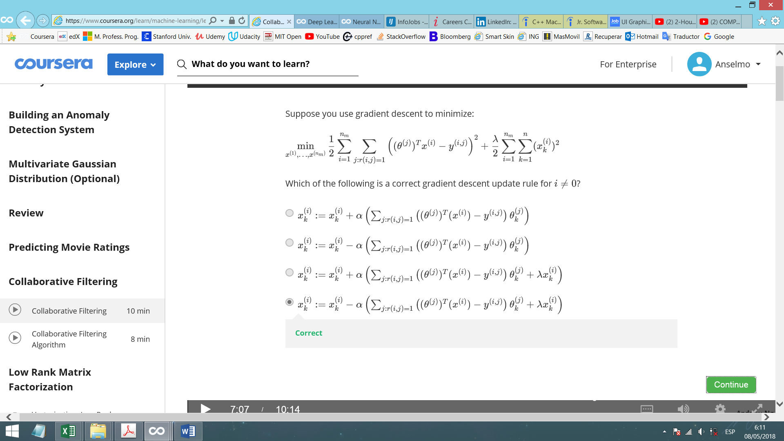

- Content based recom.: Given $x^{\left(i\right)},…,x^{\left(n_{m}\right)}$ (and movie ratings), can estimate .

- “Upside down”: Given $θ^{\left(1\right)},…,θ^{\left(n_{u}\right)}$ (and movie ratings), can estimate $x^{\left(i\right)},…,x^{\left(n_{m}\right)}$.

Combining this 2 methods we can randomly guess values for θ, then calculate x, then θ, then x, etc. causing the algorithm to converge to reasonable features for the movies and a reasonable set of parameters for different users (random θ → x → θ → x → …). Every user collaborates helping the system learn better features for the common good.

We initialize $x^{\left(1\right)},…,x^{\left(n_{m}\right)}$ and $θ^{\left(1\right)},…,θ^{\left(n_{u}\right)}$ to random values to break symmetry (similar to the random initialization of NNs parameters) and to ensure the algorithm learns features $x^{\left(1\right)},…,x^{\left(n_{m}\right)}$ that are different from each other.

Minimizing $x^{\left(1\right)},…,x^{\left(n_{m}\right)}$ and $θ^{\left(1\right)},…,θ^{\left(n_{u}\right)}$ simultaneously (combination of the 2 methods):

$$J\left(x^{\left(1\right)},…,x^{\left(n_{m}\right)},θ^{\left(1\right)},…,θ^{\left(n_{u}\right)}\right)=\frac{1}{2}\sum_{\left(i,j\right):r\left(i,j\right)=1}{{\left({\left(θ^{\left(j\right)}\right)}^{T}x^{\left(i\right)}−y^{\left(i,j\right)}\right)}^{2}}+\frac{λ}{2}\sum_{i=1}^{n_{m}}{\sum_{k=1}^{n}{{\left(x_{k}^{\left(i\right)}\right)}^{2}}}+\frac{λ}{2}\sum_{j=1}^{n_{u}}{\sum_{k=1}^{n}{{\left(θ_{k}^{\left(j\right)}\right)}^{2}}}$$

$\left[\left(i,j\right):r\left(i,j\right)=1\right]$: All values of (i, j) so r(i, j)=1 (all user-movie pairs for which you have a rating).

In that formula, you can solve Content based recommendation (keep x constant and minimize θ) and “Upside down” (keep θ constant and minimize x). But, instead of minimizing θ → x → θ → x → …, we will minimize θ and x simultaneously (use an optimization algorithm that optimizes θ and x at the same time, like gradient descent, L-BFGS, conjugate gradient, etc.).

Here, we don’t include x0=1 because we are now learning all the features, so if the algorithm need a feature x0=1, it will learn it for itself.

**Collaborative filtering algorithm**

1. Initialize $x^{\left(1\right)},…,x^{\left(n_{m}\right)}$, $θ^{\left(1\right)},…,θ^{\left(n_{u}\right)}$ to small random values.
2. Minimize $J\left(x^{\left(1\right)},…,x^{\left(n_{m}\right)},θ^{\left(1\right)},…,θ^{\left(n_{u}\right)}\right)$ using gradient descent (or an advanced optimization algorithm). Don’t include x0=1. Example: for every j = 1, …, nu, i = 1, …, nm:

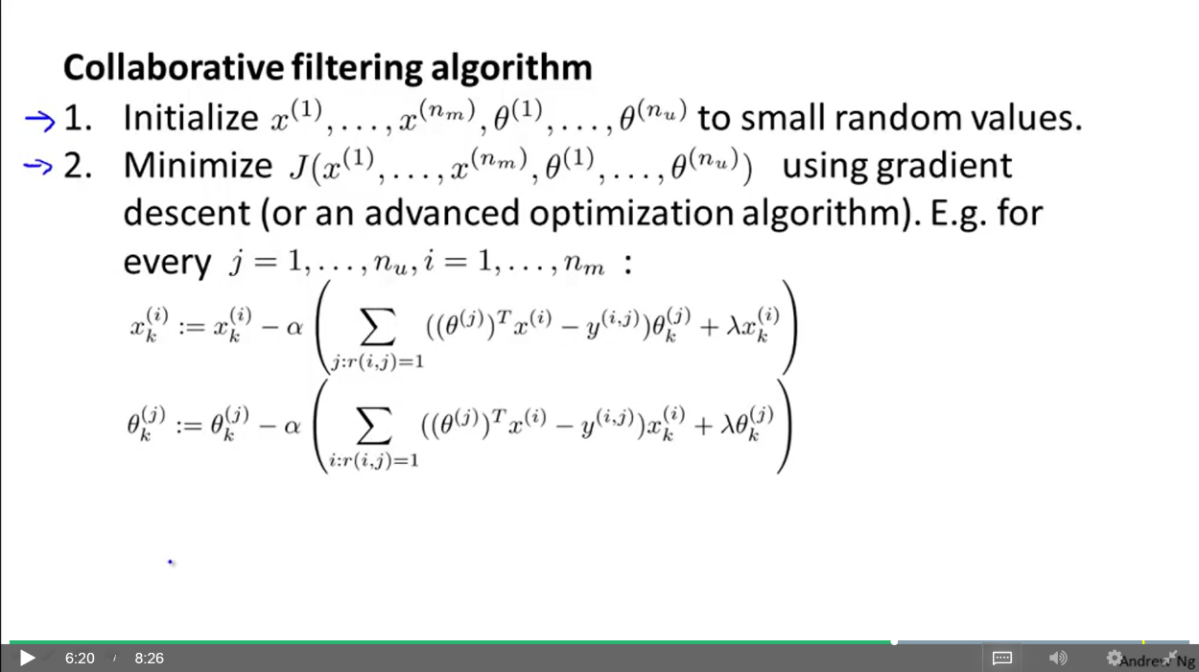

1. For a user with parameters θ and a movie with features x, predict a star rating of ${\left(θ^{\left(j\right)}\right)}^{T}x^{\left(i\right)}$.

**Vectorization**

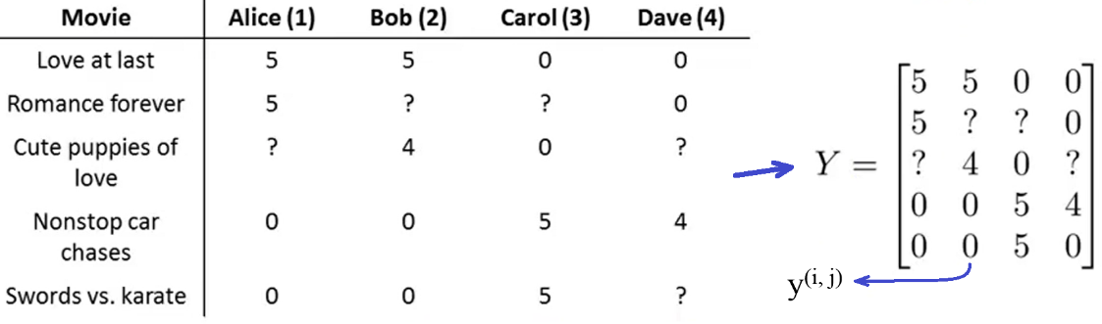

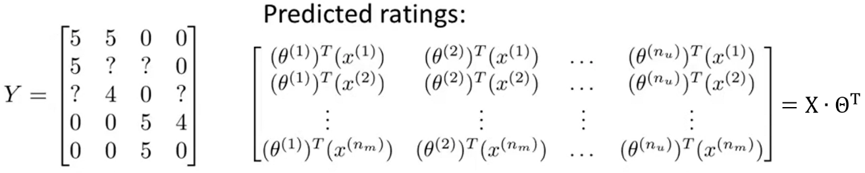

$X=\left[\begin{matrix}\begin{matrix}⋯ & {\left(x^{\left(1\right)}\right)}^{T} & ⋯\end{matrix} \\ \begin{matrix}⋯ & {\left(x^{\left(2\right)}\right)}^{T} & ⋯\end{matrix} \\ \begin{matrix}\begin{matrix}⋮ & ⋮ & ⋮\end{matrix} \\ \begin{matrix}⋯ & {\left(x^{\left(n_{m}\right)}\right)}^{T} & ⋯\end{matrix}\end{matrix}\end{matrix}\right]$ $Θ=\left[\begin{matrix}\begin{matrix}⋯ & {\left(θ^{\left(1\right)}\right)}^{T} & ⋯\end{matrix} \\ \begin{matrix}⋯ & {\left(θ^{\left(2\right)}\right)}^{T} & ⋯\end{matrix} \\ \begin{matrix}\begin{matrix}⋮ & ⋮ & ⋮\end{matrix} \\ \begin{matrix}⋯ & {\left(θ^{\left(n_{u}\right)}\right)}^{T} & ⋯\end{matrix}\end{matrix}\end{matrix}\right]$

**Find related/similar products**

For each product (movie) i, we have learnt a feature vector x(i) ∈ Rn.

How to find movies j related to movie i? The smaller the distance $\left\|x^{\left(i\right)}−x^{\left(j\right)}\right\|$, the more “similar” they are. The 5 most similar movies to movie i are the 5 with the smallest distance.

$$\left\|u\right\|=\sqrt{{\left(u_{1}\right)}^{2}+{\left(u_{2}\right)}^{2}}$$

**Mean normalization**

What if a user has not seen any movie?

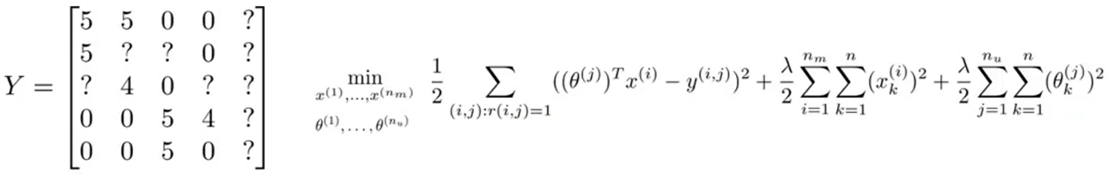

Suppose **n = 2**. Then, **θ(5) ∈ R2**, and J(…) is:

$$min\frac{λ}{2}\sum_{j=1}^{n_{u}}{\sum_{k=1}^{n}{{\left(θ_{k}^{\left(j\right)}\right)}^{2}=\frac{λ}{2}\left[{\left(θ_{1}^{\left(5\right)}\right)}^{2}+{\left(θ_{2}^{\left(5\right)}\right)}^{2}\right]}}→θ^{\left(5\right)}=\left[\begin{matrix}0 \\ 0\end{matrix}\right]→{\left(θ^{\left(5\right)}\right)}^{T}x^{\left(i\right)}=0$$

So, according to this, prediction says that user 5 would rate all films with 0. But this is not very useful for recommend films to user 5.

Computing mean normalization we get a vector with the means of the ratings of every film. Then, we subtract these means to the ratings (Y), so we make the average rating of every movie to be 0.

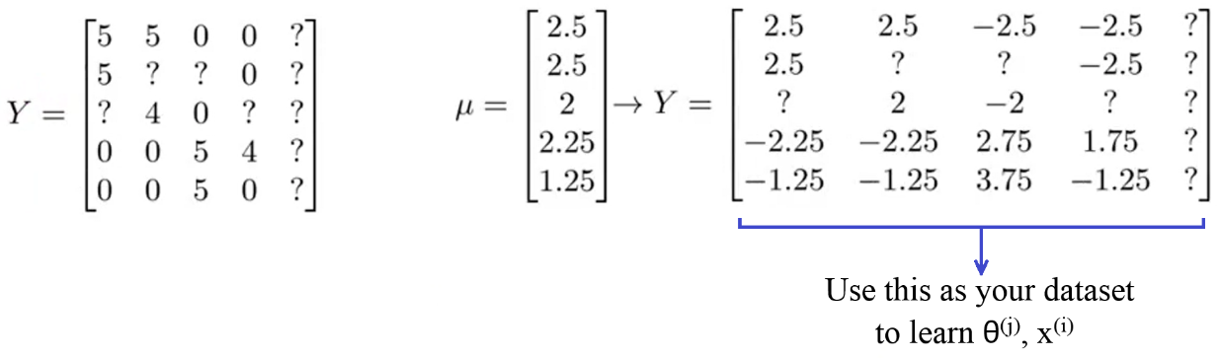

For user j, on movie i, the prediction is:

${\left(θ^{\left(j\right)}\right)}^{T}x^{\left(i\right)}+μ_{i}$ (we subtracted μ in the dataset, now we add back μ)

For user 5, on movie i, the prediction is: ${\left(θ^{\left(5\right)}\right)}^{T}x^{\left(i\right)}+μ_{i}=μ_{i}$

So, mean normalization is useful for users with no ratings. In the case of no-rated movies, you can normalize the columns to have mean zero, instead of the rows. However, this last case don’t seems to be as important (recommend a no-rated movie) as the first (users with no ratings).

We didn’t apply feature scaling because the movie ratings are already comparable (similar scales).

# Large scale machine learning

## Gradient descent with large datasets

One of the best ways to get a high performance machine learning system is to take a low-bias learning algorithm and train it on a lot of data.

“It’s not who has the best algorithm that wins. It’s who has the most data”.

But learning with large data sets comes with computational problems. If we train a linear/logistic regression model where m = 108 using Gradient descent, the algorithm will have to sum 108 entries in every step.

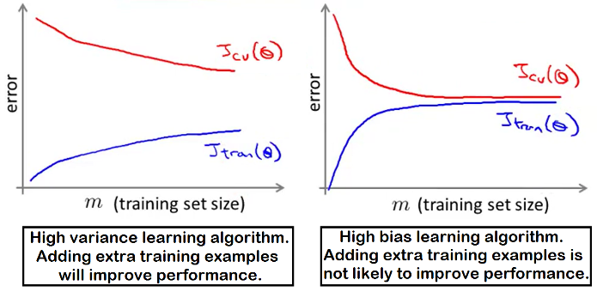We can try first with a subset of 1000 taken from m = 108.

How can we tell that using all the data is likely to perform better than using a small subset of the data? Plot a learning curve for a range of values of m and verify that the algorithm has high variance when m is small.

## Stochastic Gradient descent

This is a modification to Batch Gradient descent that allows it to work better with much bigger training sets. This applies to the algorithms based in Gradient descent (linear/logistic regression, NNs, etc.). Example with linear regression:

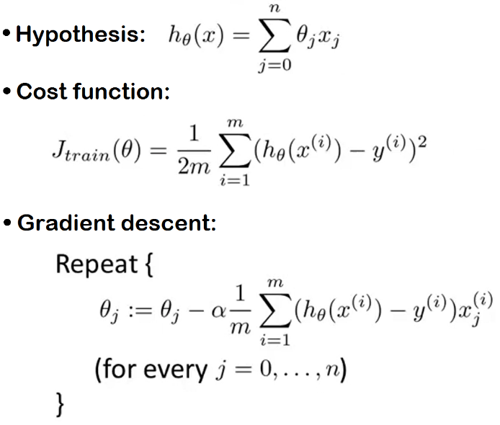 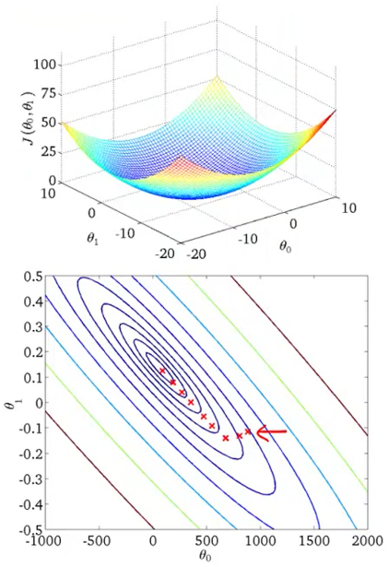

In Batch Gradient descent, if m is too large, computing the gradient $\frac{δ}{δθ_{j}}J_{train}\left(θ\right)$ can be very expensive (it has to sum all m examples). You can’t store a huge number of examples (like 3 * 108) in computer memory, so you have to stream all the records through your computer (slowly accumulate the sum) in order to compute the derivative terms you will use in only one step. The algorithm will take a long time to converge.

Stochastic gradient descent doesn’t need to look at all the examples in every iteration, it only needs to look at a single training examples in one iteration. The minimized cost function is:

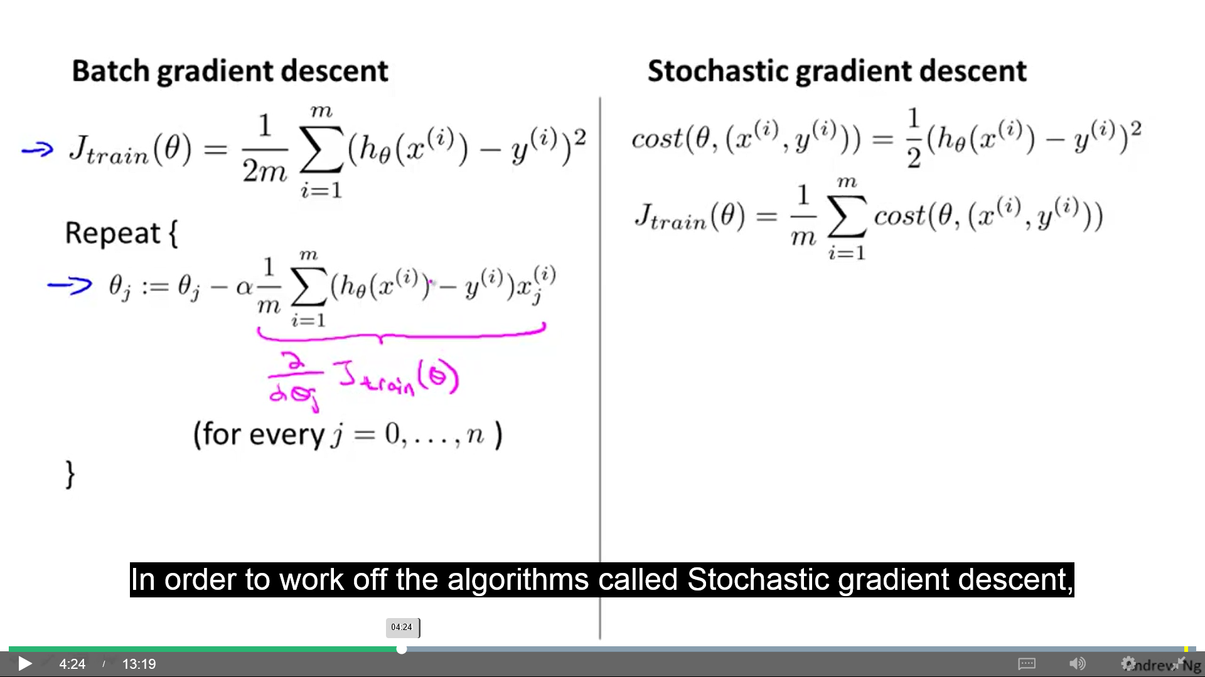

**cost(θ, (x(i), y(i))):** Cost of parameter θ with respect to x(i) and y(i). This measures how well the hypothesis is doing on a single example x(i), y(i).

Steps of the Stochastic gradient descent:

1. Randomly shuffle the dataset.
2. Repeat {

for i = 1, …, m {

$θ_{j}≔θ_{j}−α\left(h_{θ}\left(x^{\left(i\right)}\right)−y^{\left(i\right)}\right)x_{j}^{\left(i\right)}$ (for j = 0, …, n)

}

}

Batch GD scans through all the training examples. Stochastic GD, first looks at your first training example (x(1), y(1)) and takes a little gradient descent step with respect to the cost of just that first training example. In the **inner-loop**, it modifies the parameters a little bit just to fit the first training example a little bit better. Then, in the second inner-loop, it modifies the parameters to try to fit just the second training example a little bit better (x(2), y(2)). And so on, until you get through the entire training set.

The **outer-loop** may take multiple passes over the entire training set.

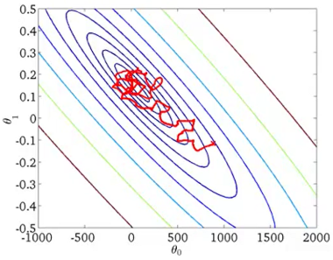It’s similar to Batch GD, but rather than wait to sum up these gradient terms over all m training examples to make a little step towards a global minimum, we take just one example at a time and modify the parameters a bit towards the global minimum.

When you run Stochastic GD, the parameters moves towards global minimum in a more random way than Batch GD (which goes directly towards it), so it takes more steps to converge. It doesn’t converge in the same sense as Batch GD, it wanders around continuously in some region close to the global minimum, without getting that point and staying there. In practice, this isn`t a problem because it ends up pretty close to global minimum, hypothesis is good enough for most practical purposes.

How many times do we repeat the outer-loop? Typically, 1-10 loops. It depends on the size of the training set. For very large datasets (like 3*108), a single outer-loop may give a perfectly good hypothesis.

## Mini-batch gradient descent

This can sometimes work faster than Stochastic gradient descent.

* Batch GD: Uses all m examples in each iteration.
* Stochastic GD: Uses 1 example in each iteration.
* Mini-batch GD: Uses b examples in each iteration.

**b** = Mini-batch size. Typically, 10. Typical range, 2-100. We do a Gradient descent update using these b examples.

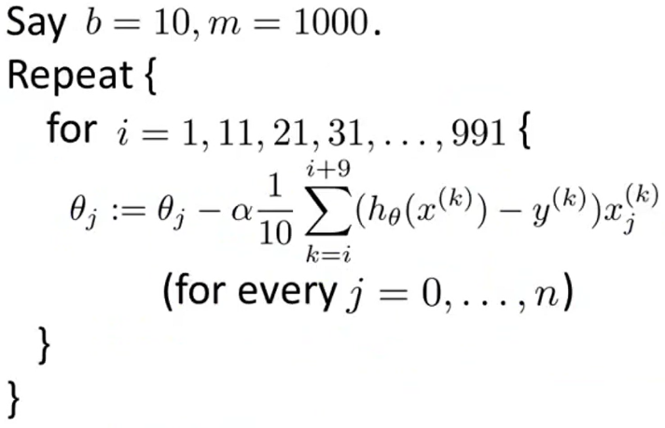

Mini-batch GD also makes progress much faster than Batch GD.

Mini-batch GD is likely to outperform Stochastic GD only if you have a good vectorized implementation (this allows to parallelize your gradient computations over the b examples). In that case, the sum over the b examples can be performed in a vectorized way.

One disadvantage of Mini-batch GD is the extra parameter b, which you may have to fiddle with, which may take time.

## Stochastic Gradient descent convergence

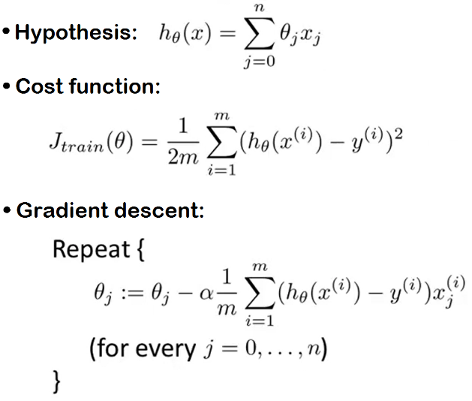**Checking for convergence**

With Batch GD, we check that the algorithm is converging by plotting Jtrain(θ) as a function of the number of iterations of GD. When training set size is very large, the computation of the sum (of the entire training set size) inside Jtrain(θ) can take time, and you don’t want to pause your algorithm periodically when you compute Batch or Stochastic GD.

In Stochastic GD, we can do this instead:

1. During learning, compute cost(θ, (x(i), y(i))) before updating θ using (x(i), y(i)). If we do this after training, cost would be better and that wouldn’t be representative.
2. 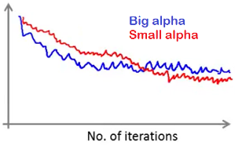Every 1000 iterations (say), plot cost(θ, (x(i), y(i))) averaged over the last 1000 examples processed by the algorithm.

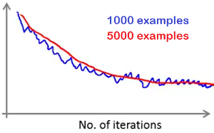Algorithm using a small learning rate (α): It learns more slowly, but may result in a slightly better solution (red line). This happens because Stochastic GD doesn’t converge to global minimum, but oscillates around it, so smaller α implies smaller oscillations.

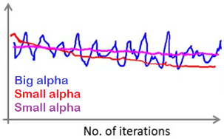Increasing number of examples averaged over: Results in smoother lines. Disadvantages: The feedback you get on how well the learning algorithm is doing is more “delayed” because you use more examples to plot a single point.

The plot looks flat: Maybe, increasing the number of examples averaged over (smoothening the plot) you can better see the trend. If the plot is still flat, maybe you have to change α, the features or something else about the algorithm.

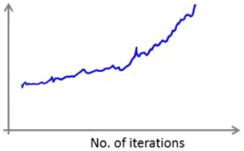

The plot is increasing: The algorithm is diverging. You should use smaller α.

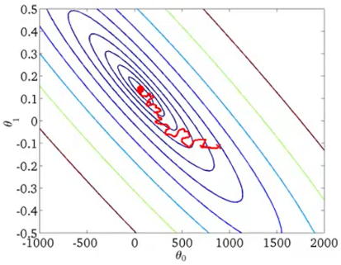**Selecting Learning rate (α)**

Learning rate (α) is typically held constant. But we can slowly decrease α over time if we want θ to converge slightly better.

Example: $α=\frac{const1}{iterationNumber+const2}$

iterationNumber: Number of examples you have seen.

const1, const2: Additional parameters you have to play with.

Decreasing α over time is usually not done because it requires time to play with const1 and const2, makes the algorithm more finicky, and we usually are pretty happy with any parameter value that is near the global minimum.

## Online learning

The Online learning setting allows to model problems where we have a continuous stream of data coming in and we want a learning algorithm to learn from that. Many of the largest websites use different versions of online learning algorithms to learn from the flood of users (user preferences, etc.).

**Example 1:** Shipping service website where user comes, specifies origin and destination, you offer to ship their package for some asking price, and user sometimes chooses to use your shipping service (y=1), sometimes not (y=0). We want a learning algorithm that helps us to optimize the price we offer to our users (increment probabilities of y=1 and gives us a fair profit).

Features x capture properties of user, origin/destination and asking price. We want to learn **p(y=1|x;θ)** to optimize price (we can use logistic regression, NN, …).

Repeat forever {

Get example (x, y) (corresponding to user)

Update θ using (x, y):

θj := θj – α (hθ(x) – y) xj (j = 0, …, n)

}

}

We look at one example at a time, we learn from it and discard it (we never use it again). Usually, as there is an unlimited amount of data coming in (continuous stream of data), there is no need to look at one example twice. However, if you have a small number of users, maybe you might be better off saving away all your data in a fixed training set and then run some algorithm over it.

This algorithm can adapt to changing user preferences (like changes in offer and demand).

**Example 2:** Learn to search products in an online store of phones (give good search listings to a user). When a user makes a searching (“android phone 1080p camera”), we want to return 10 different results/phones (there are 100 phones in store).

x = Features of the phone we extract from the query (how many words in user query match name of phone, how many words in query match description of phone, etc.).

For each one of the 100 phones, a value for y is given (0, 1). y=1 if user clicks on link, y=0 otherwise. We want to learn **p(y=1|x; θ)** (probability of user clicking on a link you offer him). This problem is called problem of predicting the Click-Through Rate (CTR).

We can estimate the predicted CTR for any particular phone and show the user the 10 phones he is most likely to click on.

Every time a user does a search, we return 10 results. So, this gives us 10 examples (x, y) every time a user does a search (we give him 10 phones and we observe a value for y). Our online learning algorithm update parameters θ making 10 steps of gradient descent on these 10 examples and then we through that data away.

This is a product search problem, learning to rank phones, learning to search phones.

**Other examples:**

* Choosing special offers to show user: Similar to example 2.
* Customized selection of news articles: Similar to example 2, where you show the user the news articles he is most likely to click on.
* Product recommendation: Imagine a collaborative filtering system giving you additional features to feed into a logistic regression algorithm classifier to try to predict the CTR for different products that you might recommend to a user.
* Etc.

Any of these problems could also have been formulated as a standard machine learning problem (fixed training set), but these are a sort of problems you see in large companies where you get so much data that there’s no need to save away a fixed training set, and instead you can use an online learning algorithm to just learn continuously from the data your user are generating.

The online learning algorithm is very similar to stochastic GD, only instead of scanning through a fixed training set, it gets a training example from the user, learns from it and discard it. This algorithm is good for when you have a continuous stream of data and/or when the things you try to predict are slowly changing (tastes, …).

## Map Reduce

Some machine problems are too big to be run in a single computer. Map Reduce allows to work on a very big problem with multiple machines (say m= 4*108).

Let’s say we want to fit a linear or logistic regression model (say m=400) using a Batch GD.

We split the training set in n different subsets, depending on the number of computers where we want to run the algorithm. Each subset is used in different computers to do the summation of the Batch GD algorithm (data parallelizing). This system lets a computer to do a fraction of the work and, presumably, the computation is about n times as fast (slightly less because of network latency, overhead of combining the results, etc.). The results are sent to a centralized master server and it combines them to compute the Batch GD.



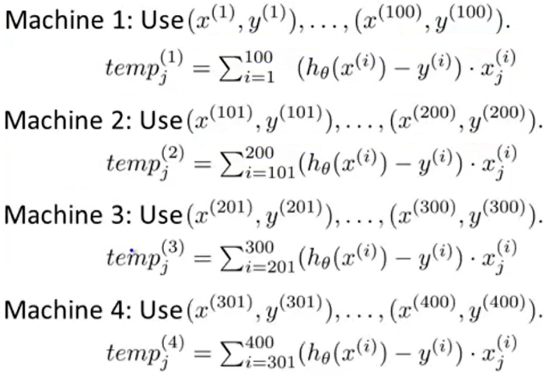

**Combine:**

$θ_{ji}≔θ_{j}−α\frac{1}{400}\left({temp}_{j}^{\left(1\right)}+{temp}_{j}^{\left(2\right)}+{temp}_{j}^{\left(3\right)}+{temp}_{j}^{\left(4\right)}\right)$ $\left(j=0,…,n\right)$

Many learning algorithms can be expressed as a summation over the training set, and the computational expense of running them on large datasets is because they need to sum over a very large training set. Example: When using an **advanced optimization** algorithm (LBFGS, Constant gradient, etc.) with logistic regression, we need to compute Cost function and Gradients.

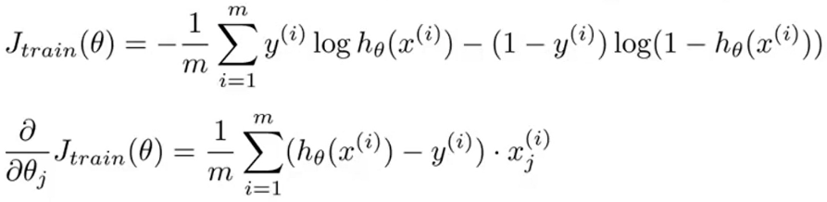

Here, each computer has to compute the summation from the **Cost function** and the summation from the **Gradient** (${temp}^{\left(i\right)},{temp}_{j}^{\left(i\right)}$).

So, by taking other learning algorithms and expressing them in summation form, you can use the Map-reduce technique to parallelize **other learning algorithms** as well, and scale them to very large training sets (example: parallelize the mean normalization of the training set).

To apply Map-reduce to train a NN on 10 machines, in each iteration each machine will compute FP and BP on 1/10 of the data to compute the derivative with respect to that 1/10 of the data.

Map-reduce allows to parallelize over multiple computers, but can also be used in a single computer when it has **multiple processing cores** (computer can have multiple CPUs, and each one can have multiple processing cores). You can split the training set between the processing cores (no network latency). Certain numerical linear algebra libraries can automatically parallelize the operations across multiple cores within the machine (if you have a good vectorized implementation and you have a multi-core machine).

There exist many good open source implementations of Map-reduce (Hadoop, etc.).

# Photo OCR

## Description and pipeline

How to get our computers to understand the content of the pictures better?

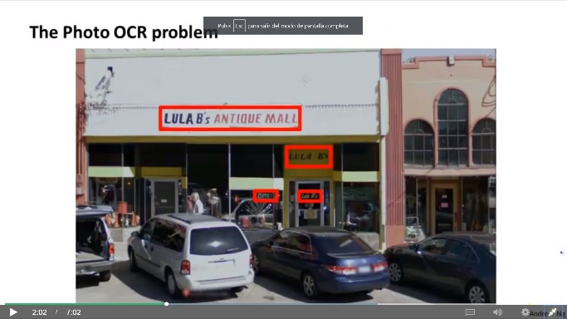**Photo OCR** (Photo Optical Character Recognition) problem focuses on how to get computers to read the text to the purest in images that we take. Photo OCR problem look through the image, detect where there is text in the picture and read the detected text (used with cameras for blind people, car navigation systems that detects street signs).

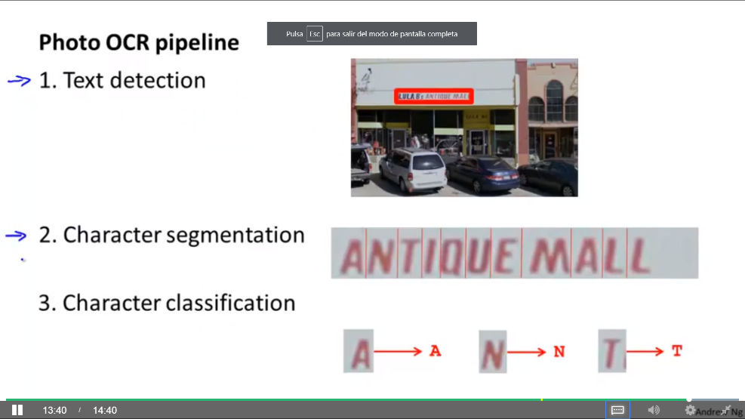**Pipeline:** System with many stages/components, several of which may use machine learning. In complex machine learning systems, a pipeline is very pervasive.

**Modules** of the Photo OCR pipeline:

1. Text detection: Where is the text?
2. Character segmentation: Where are the characters?
3. Character classification: What characters are them?

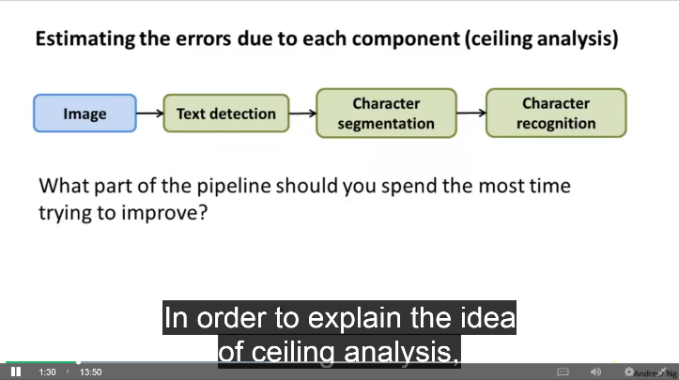Other Photo OCR systems can do more complex things (spelling correction, etc.).

When designing your machine learning pipeline, you choose the modules you will put in it. The performance of each module often have a big impact in the final performance of your algorithm.

Different individuals/teams may be assigned to work on each module.

## Sliding windows

**Pedestrian detection** may be easier than text detection because all pedestrians have similar aspect and the rectangles may have the same height/width ratio.

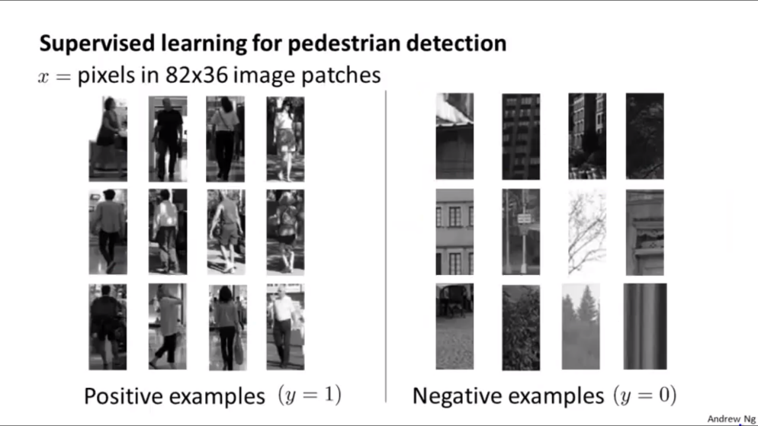First, collect a training set of images of same size with positive and negative examples and train a supervised learning algorithm to detect pedestrians in these images.

In this example we have 24 examples, but usually the number of examples here is 1.000, 10.000 or more.

Then, we take a test image where we want to detect the pedestrians. We make the algorithm to examine a patch of the image with the same size as the examples and let it determine if there is a pedestrian or not. Then, we move that rectangle a bit and run the algorithm again. And so on. The amount we shift the patch is called **step-size** or **stride**. If the step size is one pixel, it performs best but is more computationally expensive.

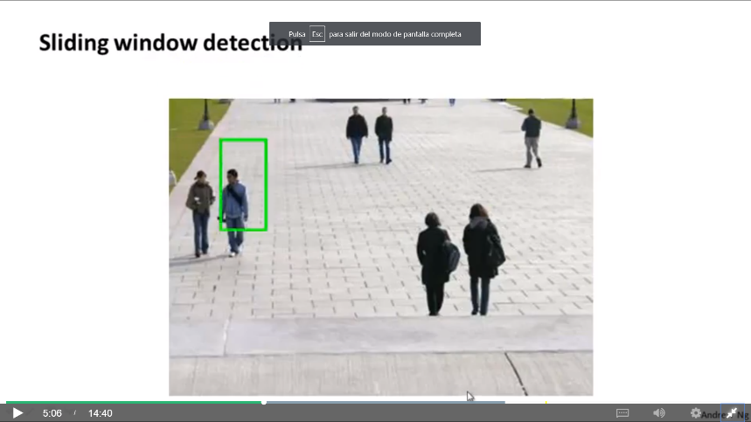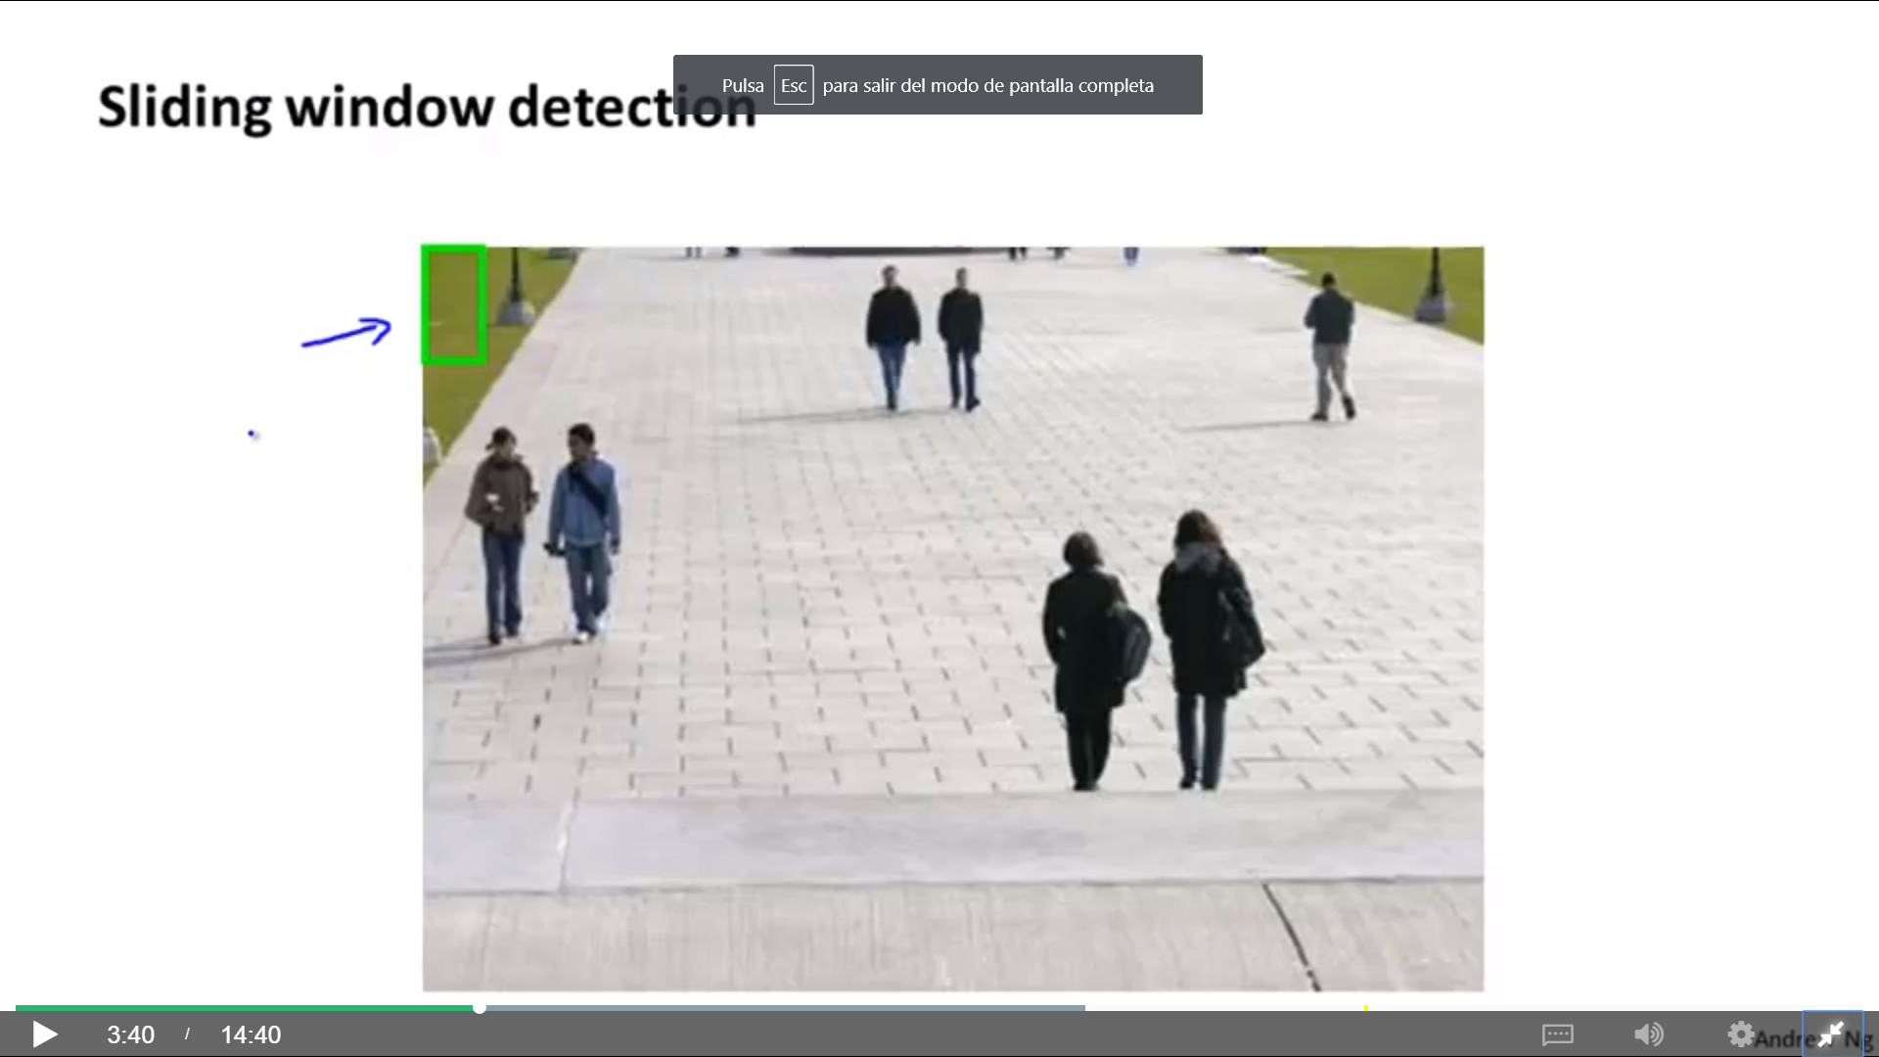 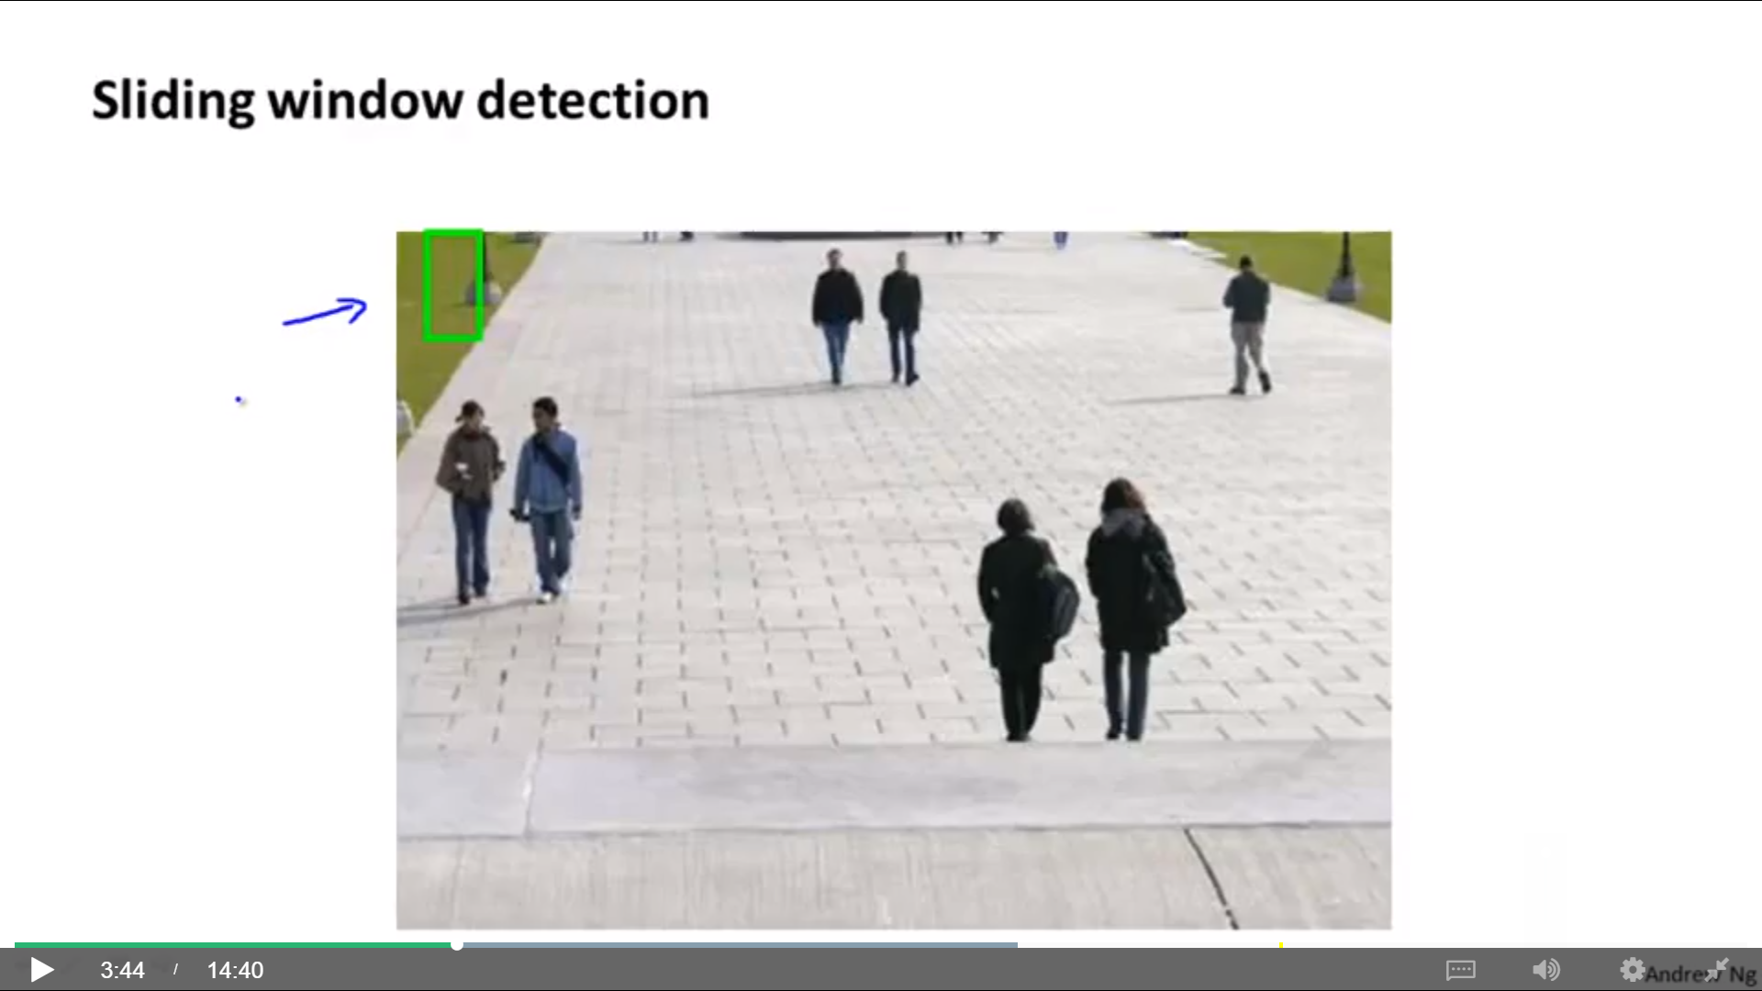 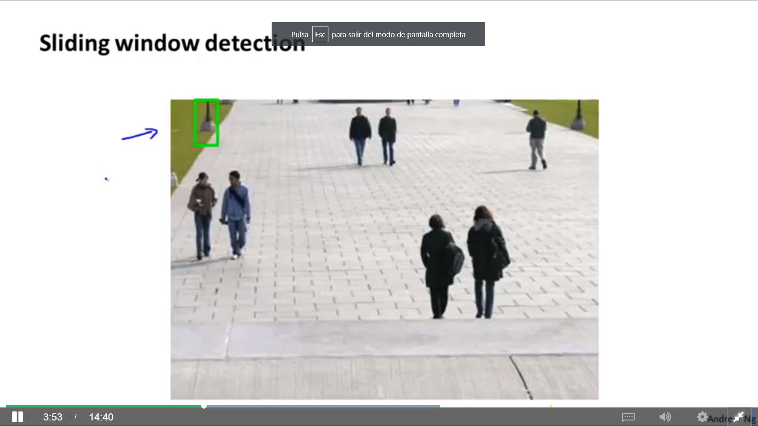

We do this with different patch sizes.

The patches taken from the image must be resized (usually reduced) to pass it to the classifier to decide if there is a pedestrian or not.

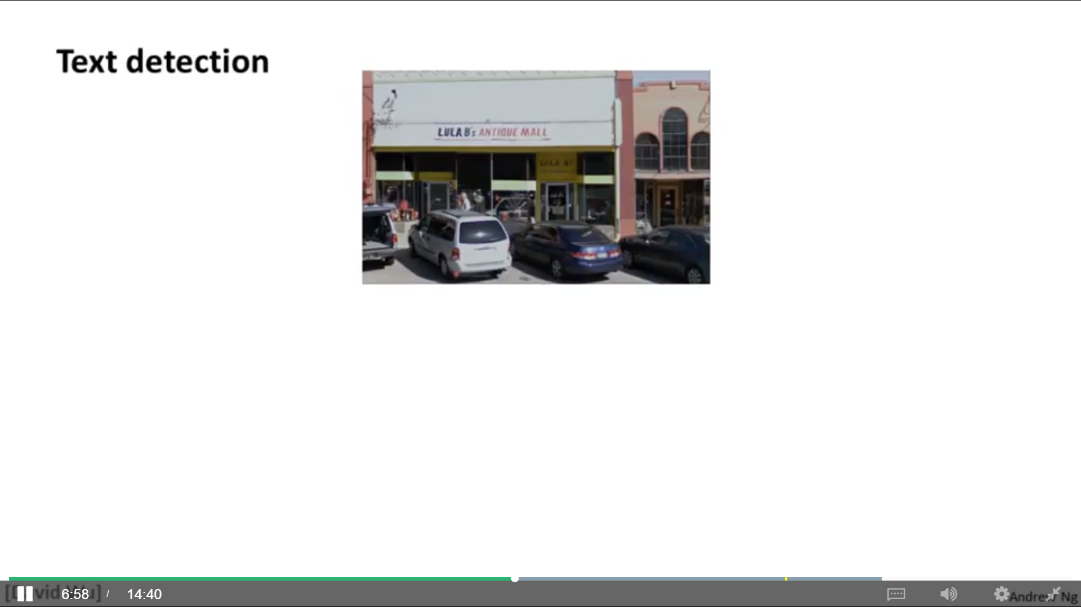**Text detection** is similar to pedestrian detection. We create a training set with positive and negative examples. Then, examine little patches of different size looking for text. The black image show white positions where the algorithm predicted text, and grey or black otherwise, depending on the predicted probability.

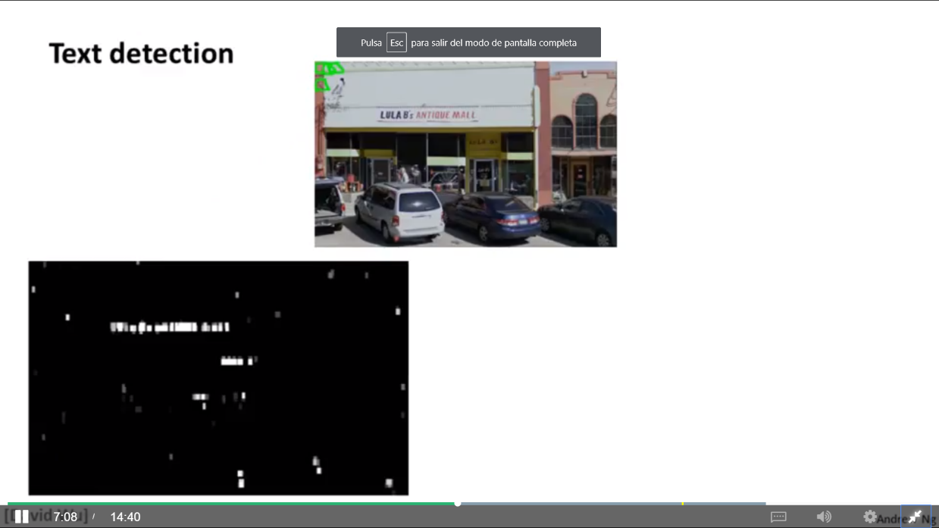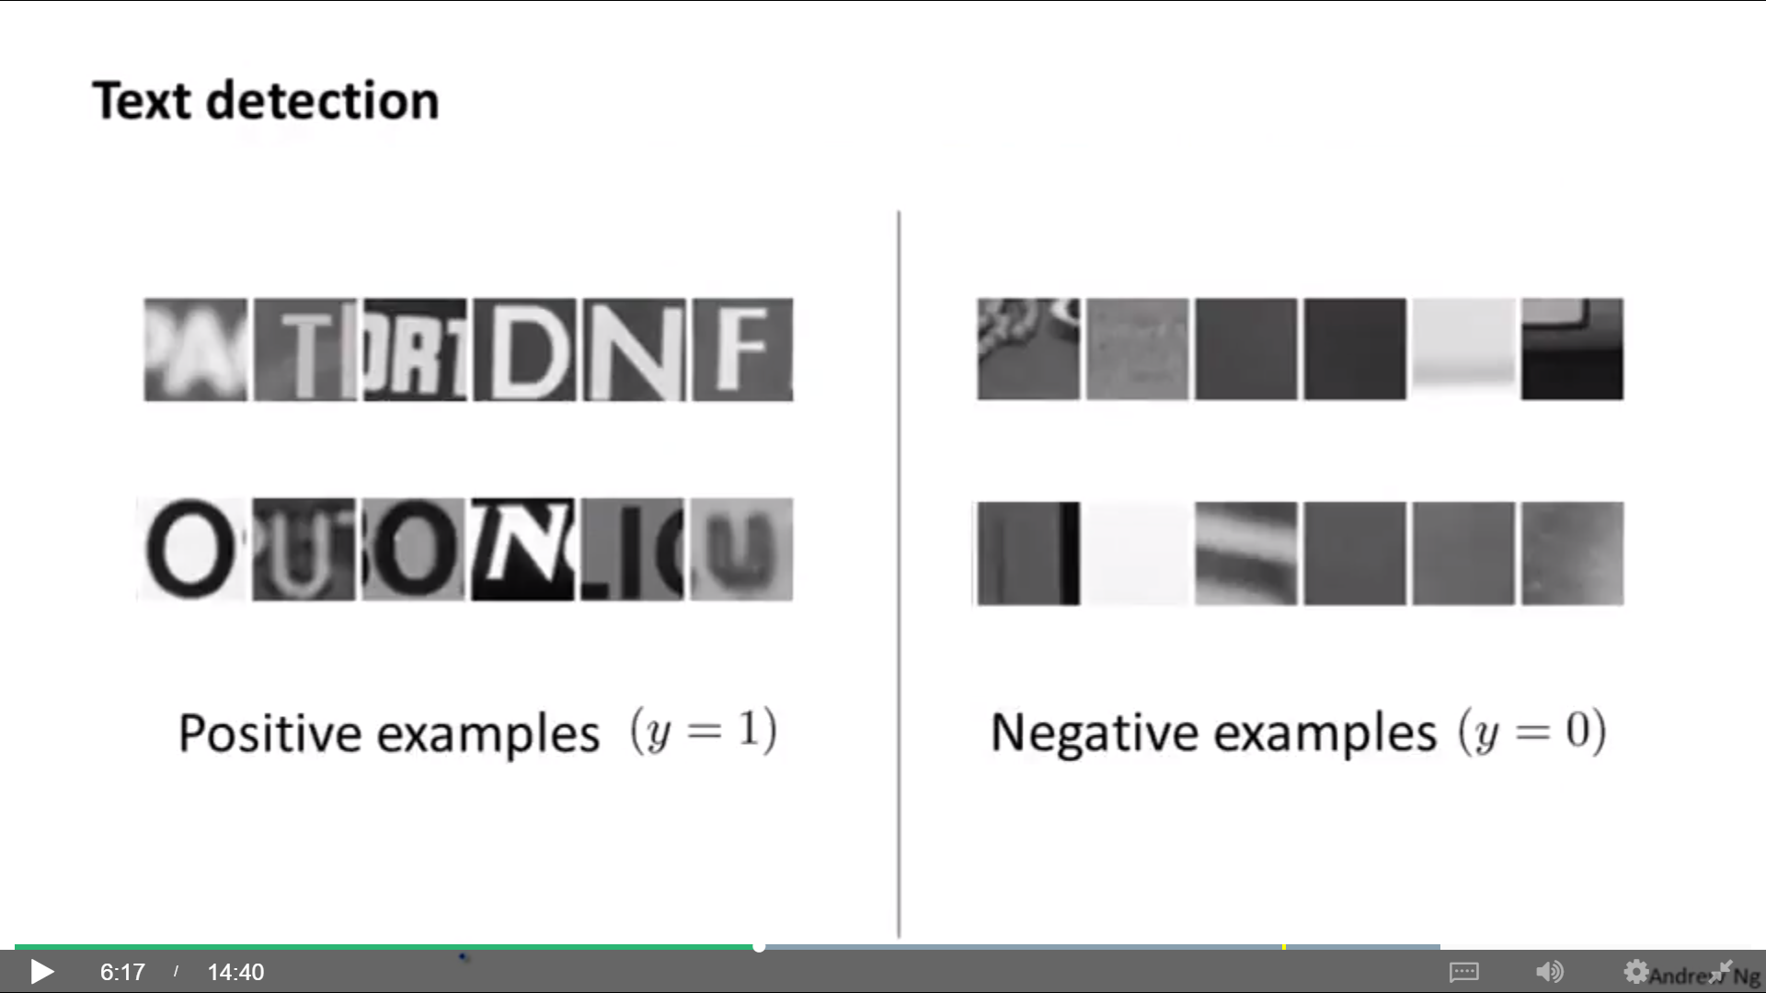

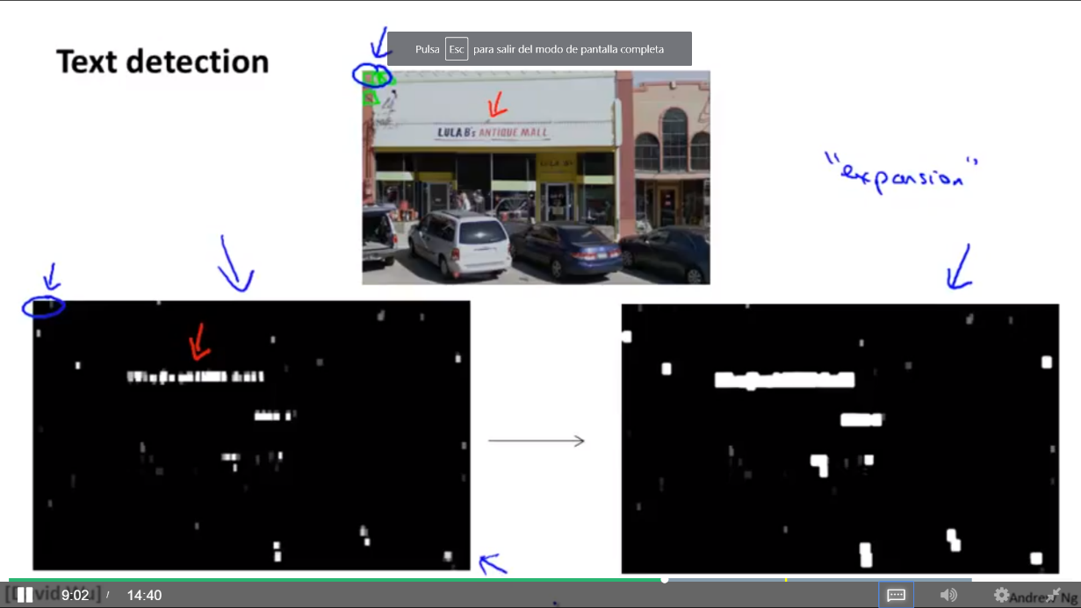We take the output of the classifier and apply an “expansion operator” (it expands the white regions): If a specific pixel is within n pixels (say 5 or 10) from another white pixel, then we also colour that pixel white.

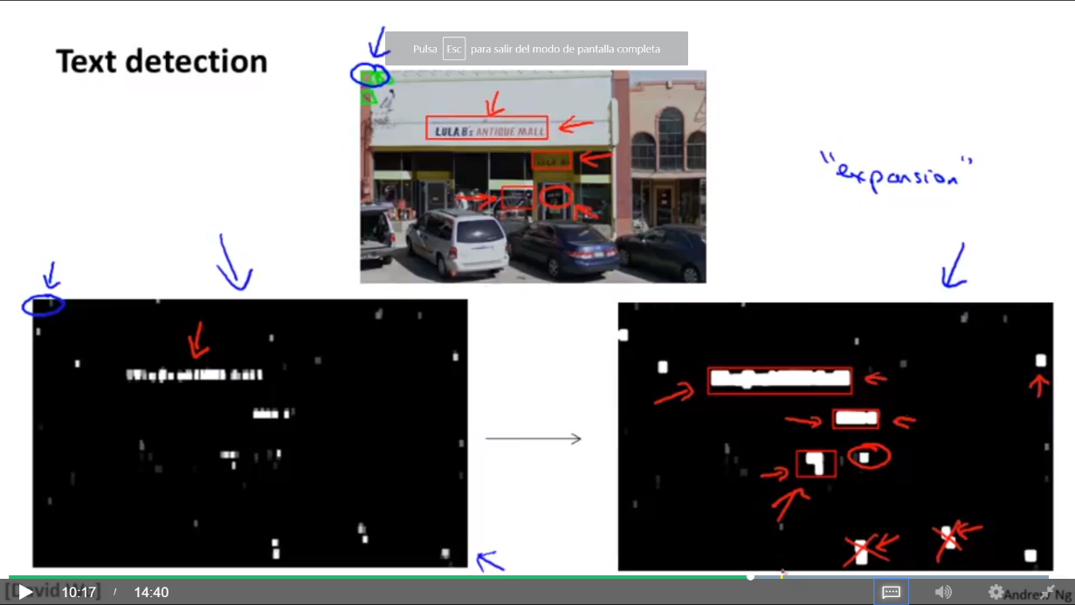Using simple heuristic to rule out rectangles, its aspect look funny (boxes around text should be much wider than they are tall). We discard the tall and thin white blocks and draw rectangles around those whose aspect ratio (height/width) looks right for text regions. One correct piece of text is discarded because the aspect ratio looks wrong (red circle).

Now we can cut out these text regions and then use later stages of pipeline to try to meet the texts.

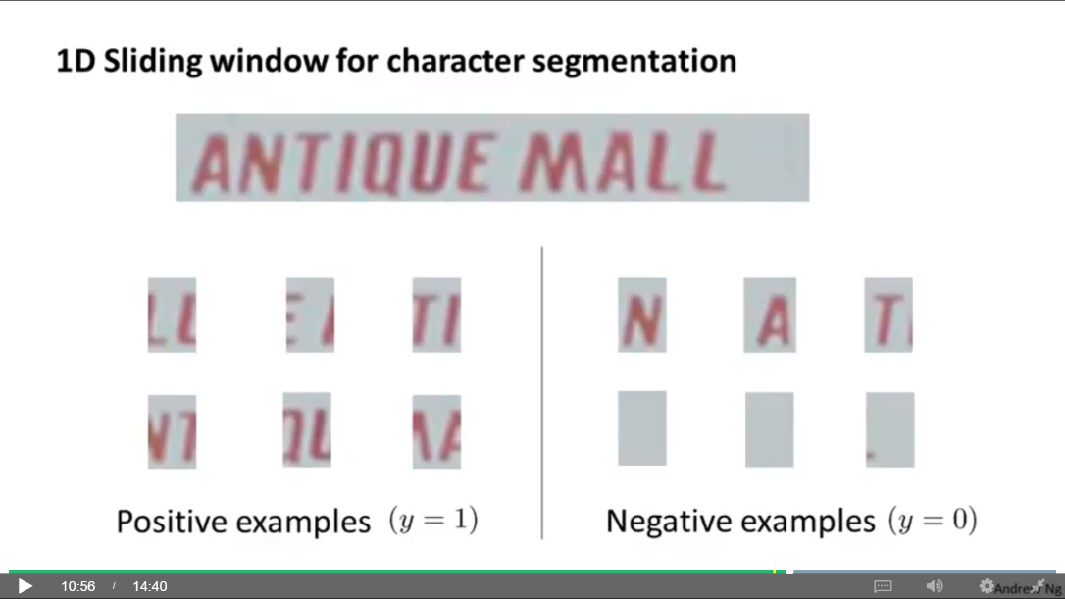**Character segmentation** may be done using a supervised learning algorithm (NN, etc.) with some set of positive and negative examples. Positive examples are images where two characters can be split.

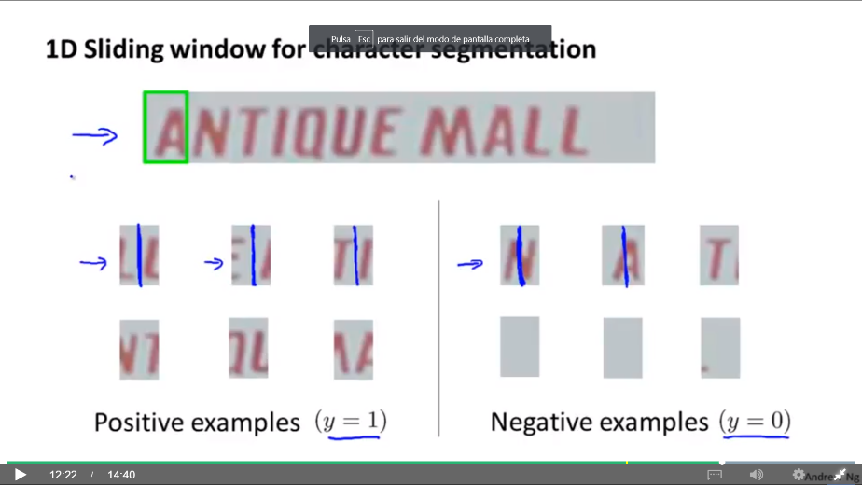Then, we apply 1D sliding window for character segmentation.

If the algorithm outputs 1, we draw a line between the characters in the patch.

## Artificial data synthesis

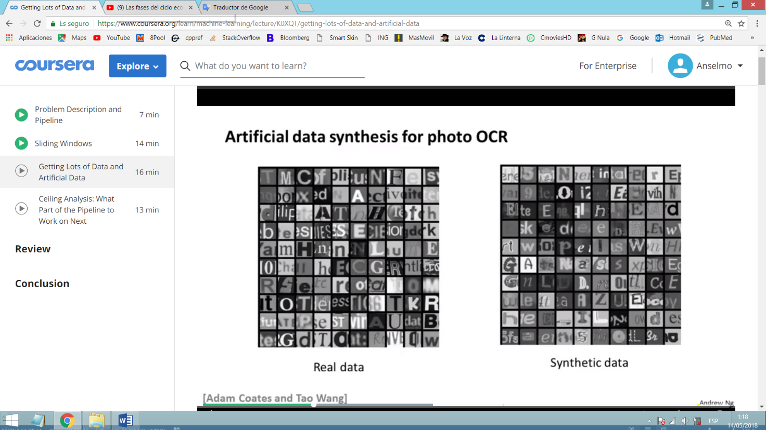One of the most reliable ways to get a high performance machine learning system is to take a low bias learning algorithm and to train it on a massive training set. There are two ways to create artificial new data. It takes thought, innovation, insight. If you do a sloppy job, it won’t work well.

**Creating new data from scratch**

In the case of characters recognition, we can use the different fonts existing in Microsoft Word or Internet. Then, we can paste them against random backgrounds, apply blurring, filters, distortions, sharing, rotation, etc. This way you can create synthetic data (unlimited training examples).

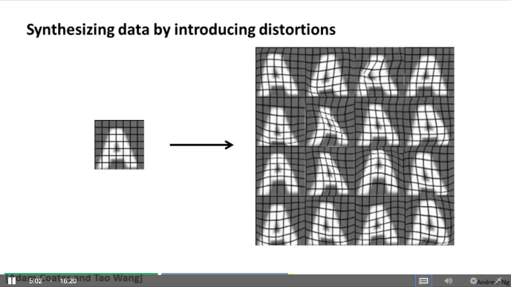**Creating new data from existing data**

You take a real examples and create additional data. In character recognition, you take an existing example and add some warping/distortion.

In speech recognition, you can take the original data and create audio on bad cell phone connection, noisy background (crowd, machinery, …), etc.

Distortion introduced should be representative of the type of noise/distortions in the test set. Usually, adding purely random/meaningless noise to our data doesn’t help (brightness, gaussian random noise, …).

**Other recommendations**

Make sure you have a low bias classifier before expending the effort (plot learning curves to check if more data will help). Example: Increase the number of features/hidden units in NN until you have low bias classifier.

Ask yourself how much work would it be to get 10x as much data as we currently have. Some options to get additional data:

* Artificial data synthesis
* Collect/label it yourself
* Crowd source (inexpensively hire people on the web to label data for you) (Example: Amazon Mechanical Turk) (disadvantage: what is the labeller reliability?).

## Ceiling analysis

Ceiling analysis (estimating the error due to each component) helps to know on what part of the pipeline (module) you should spend the most time trying to improve. It is helpful to have a single raw number evaluation metric (example: the fraction of characters in a test image that we recognize correctly). Suppose we have this pipeline:

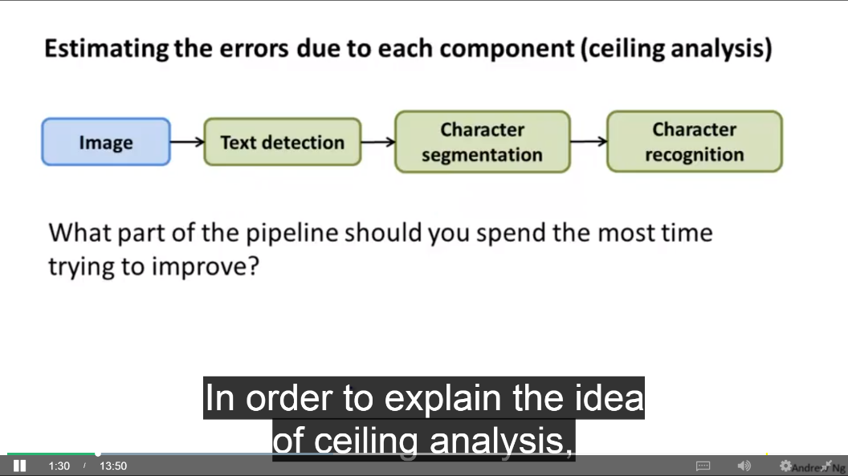

1. Determine the overall system accuracy with the test set using some evaluation metric.
2. Provide the correct output for every test example in the first module (text detection) by manually taking perfect output values for it, and determine the accuracy of the system (it’s like simulating what happens when first module has 100% accuracy).
3. Take manually perfect values also for second module (char. segmentation) and determine the accuracy of the system (it’s like first and second module have 100% accuracy).
4. 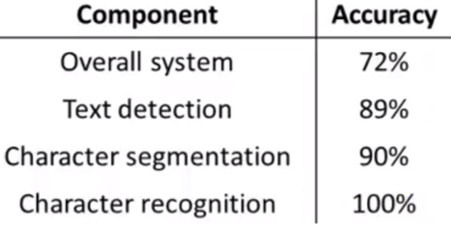Now you can compute the potential for improving in every module:

Text detection → 17 %

Character segmentation → 1 %

Character recognition → 10 %

Another example (face recognition, artificial example, non-real):

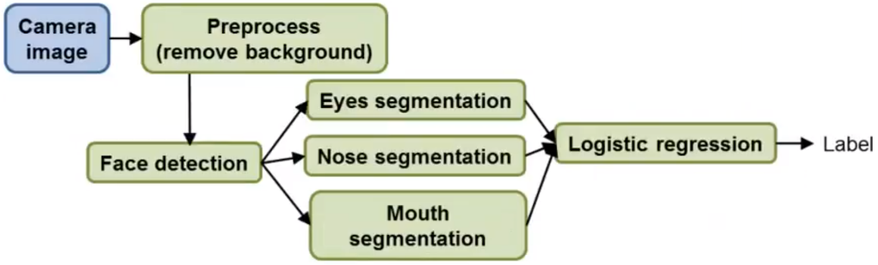

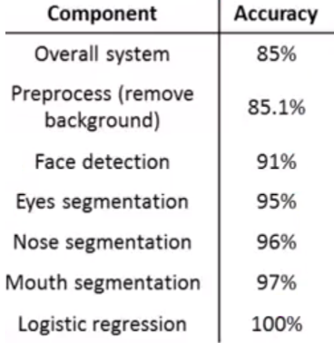Simulate 100% accuracy for Preprocess → Simulate 100% accuracy for Face detection → [Simulate 100% accuracy for Eyes seg. → Simulate 100 % accuracy for Nose seg. → Simulate 100% accuracy for Mouth seg.] (put the order you want for these 3 modules) → Simulate 100% accuracy for Logistic regression.

Results:

Preprocess (0.1%), Face detection (5,9%), Eyes seg. (4%), Nose seg. (1%), Mouth seg. (1%), Logistic reg. (3%).